**Arctic SDI Framework Document**

The Arctic Spatial Data Infrastructure

Version 1.00/11 November 2014

www. arctic-sdi.org

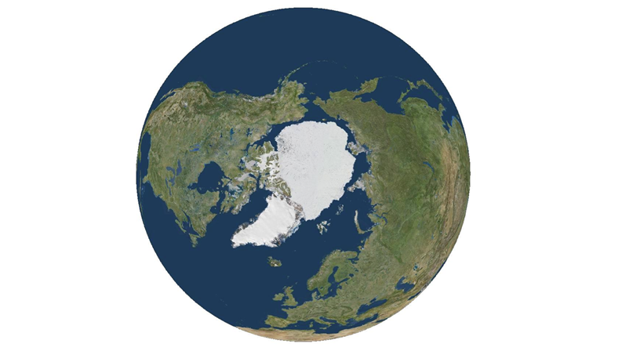



CONTENT

1. Introduction 3

1.1. Arctic SDI vision and project aim 4

1.2. The reasons behind the Arctic SDI 5

1.3. Short Background history 6

2. Arctic SDI – Data, infrastructure and technology 7

3. Arctic SDI Strategy 8

3.1. Arctic SDI strategic context 8

3.2. Arctic SDI Reference Model 9

3.3. Strategy for developing Arctic SDI cooperation and services 10

4. Arctic SDI - Governance, Organization and Operations 10

**Memorandum of Understanding and Implementing Arrangements** 10

4.1. Arctic Council and the Senior Arctic Officials 10

4.2. The Arctic SDI Board and the Board Executive 10

4.3. National Contact Point 11

4.4. Lead countries and support countries 11

5. Activities and division of work 12

5.1. Identified activities: 12

5.2. Identified lead countries and support countries: 12

*Appendix 1:* Arctic SDI – Data, infrastructure and technology 14

*Appendix 2:* Arctic SDI Reference Model Glossary 22

*Appendix 3:* Arctic SDI - Memorandum of Understanding 25

*Appendix 4:* Arctic SDI - Governance, Organization and Rules of Procedure 29

*Appendix 5*: Arctic SDI - Description of Activities 33

*Appendix 6*: Arctic SDI - Implementing Arrangements 35

*Appendix 7*: Arctic SDI - Operational Policies 36

*Appendix 8*: Arctic SDI - Terms of References 38

# Introduction

The *Arctic Spatial Data Infrastructure* – Arctic SDI - is cooperation between the 8 National Mapping Agencies of Canada, Finland, Iceland, Norway, Russia, Sweden, USA and Denmark (including the administrations of the Faroe Islands Home Rule and the Greenland Self-Government).

The aim of the Arctic SDI is to provide politicians, governments, policy makers, scientists, private enterprises and citizens in the Arctic with access to geographically related Arctic data, digital maps and tools to facilitate monitoring and decision making.

The main purpose of this document – ***the Arctic SDI Framework Document*** - is to describe the vision, strategy, context and scope, as well as to introduce the concept of the Arctic SDI, and the status of the cooperation and governance.

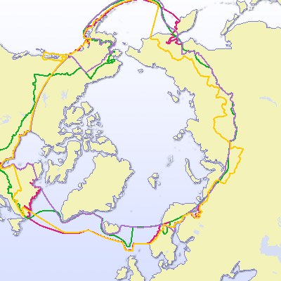

*Figure 1*. The Arctic SDI is to cover the Arctic regions of the involved participating countries, as defined by the countries themselves. It can be identified and defined in many different ways depending on the parameters used (tree line, climate, Arctic Circle, temperature, flora, fauna, jurisdiction). The examples above are used by some of the Working Groups of the Arctic Council. (© University of the Arctic International Secretariat 2009 in the UArctic Atlas ([www.uarctic.org](http://www.uarctic.org) )).

## Arctic SDI vision and project aim

The Arctic SDI **vision** was formulated in 2011:

***“An Arctic SDI – based on sustainable co-operation between mandated national mapping organisations – will provide for access to spatially related reliable information over the Arctic to facilitate monitoring and decision making”.***

**The aim** of the Arctic SDI is to jointly develop and administer an Arctic SDI over several phases. The initial phase includes the components noted below.

* Reference data as Web Map Services to establish a common image and vector base for the Arctic context at nominally 1:250,000-scale
* A searchable metadata-catalogue of map-able data resources (base maps and other geo-referenced thematic data and services)
* A Web portal as primary user interface to search the catalogue and enable visual analysis of multiple base maps, thematic maps, and geographic data
* Supporting tools, standards, operational policies and best practices.

Subsequent phases is expected to see greater linkages with international and national agencies, data access mechanisms, inclusion of earth observation imagery and other types of data, and emerging web services based on international standards.

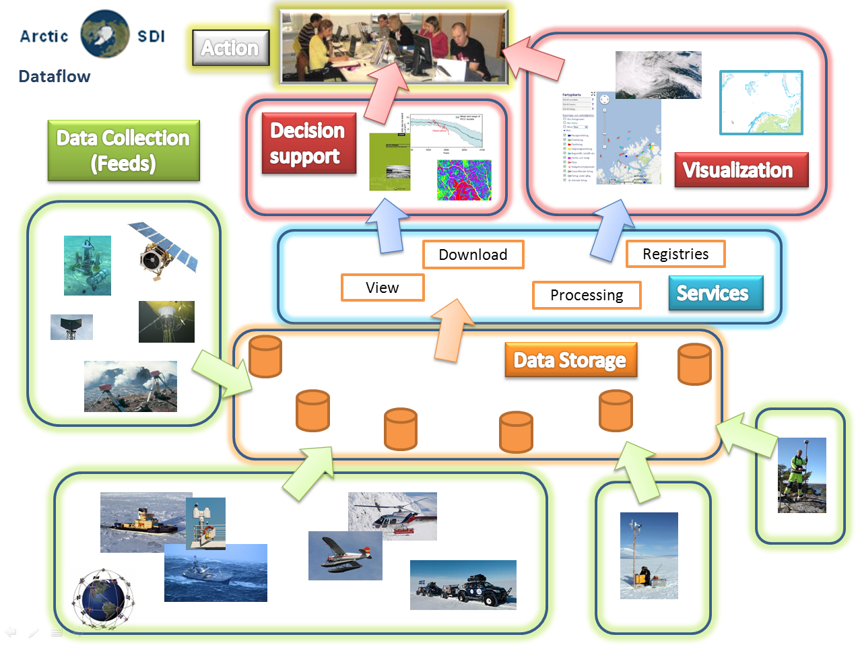

*Figure 2*. Data flow in the Arctic SDI from Collection to Action.

## The reasons behind the Arctic SDI

There is a need for an Arctic SDI, which provides for the development of the necessary standards and framework to promote and encourage more **efficient integration of and access to arctic related datasets**. It would allow for a more robust management and manipulation of data for research, planning, policy-making and operational purposes and contribute to more informed policy and adaptation strategies in the region.

A well-functioning exchange of spatial referenced data is an essential tool for successful conservation of the natural environment while allowing for economic development, at a circumpolar or regional circumpolar scale, especially for cross boundary activities. Furthermore, this infrastructure will foster integrated planning when developing the infrastructure, environment and economic activities and planning search and rescue operations.

Improved spatial related data handling includes the potential to provide tools that can clarify and explain **indigenous peoples** land use practices and thus improve presentation, communication and better integration of these issues.

The activities of the **Arctic Council and its working groups** require effective and coordinated data services. Sharing of geographic information between the circumpolar countries and efficient use of that information for presenting thematic data can prevent duplication of work and increase output and efficiency. Thus the first web service of The Arctic SDI is the harmonized map data covering the entire Arctic Region.

When operational, the Arctic SDI is expected to result in the following **benefits**:

* Users, such as the Arctic Council, the Arctic Council Working Groups, the Arctic research community, government institutions, Indigenous Peoples, NGO’s, private enterprises and individual citizens will have easy access to relevant and updated geographic and thematic information covering the entire circumpolar region – data that can be used for many purposes.
* Improved Arctic Council information management practices through the adoption of commonly accepted Spatial Data Infrastructure operational policies and technical standard
* A distributed regional Arctic infrastructure consisting of interlinked servers with high quality national geographic data will be located in each of the eight arctic countries.
* Possibilities will be created for users to connect to web map services and simultaneously access, view, and explore several types of geographic and thematic information concerning the Arctic Region.
* Daily use of the Arctic SDIs web map and other services by international and national authorities, schools and universities in the Arctic and elsewhere.
* Use of the Arctic SDI services by private enterprises when planning and developing business opportunities
* Use of the Arctic SDI by both public and private international projects and cross border cooperation.

## Short Background history

The first cross bordering geodata cooperation in the Arctic was the GIT Barents launched in the 1990’s by the national mapping agencies in Finland, Norway, Russia and Sweden. The purpose was to increase the ability to use spatial information within the Barents Region by producing a common geographic database covering the entire region and to make data available to users by establishing an internet-based infrastructure aligned with the principles of the EU INSPIRE Directive (EU Infrastructure for Spatial Information). The GIT Barents Service ([www.gitbarents.com](http://www.gitbarents.com)) facilitates cross-border cooperation, primarily in the fields of environmental planning, monitoring and protection, land use, physical planning, transports, natural resource management and development of cross-border tourism.

From 2007 a Spatial Data Infrastructure covering the entire Arctic was frequently discussed at conferences and in the context of the Arctic Council activities. At the *GeoNorth I* conference in Yellowknife, Canada in August 2007 the *Yellowknife Declaration* took form exploring the Arctic SDI. Following a request from the National Mapping Agencies from the Arctic countries, the Arctic Council gave its formal support to the Arctic SDI initiative at its Senior Arctic Officials meeting in November 2009.

In October 2011 the Arctic SDI was launched by representatives from all the 8 national mapping agencies of the Arctic countries and from the Arctic Council CAFF Working Group. A project management team with resources provided from Norway and Sweden has supported the Board, the Steering Committee and the Technical Working Group. In February 2014 the Arctic SDI Board established the present governance, organization and operation of the Arctic SDI.

# Arctic SDI – Data, infrastructure and technology

From a technical point of view the vision of the Arctic SDI is for the users to be able to easily access up-to-date spatial data from the National Mapping Agencies and from thematic data producers in the Arctic. The effort is to make this available with as little overhead as possible added to data and services. Data are published to a variety of web based services. These services are based on international standards and leverage spatial data infrastructure methods and operational policies.

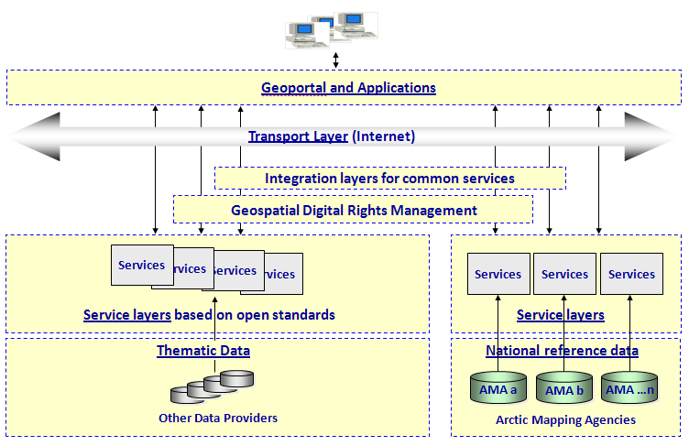

*Figure 3.* The Arctic SDI Technical Architecture.

For this purpose it is necessary to establish an enterprise architecture and infrastructure model where it is necessary to consider questions concerning metadata, data models, use of technology, user requirements for download, data combining, data analyzing and processing, operational policies etc.

Detailed considerations concerning the Arctic SDI Technical Architecture can be found in *Appendix 1: Arctic SDI - Data, Infrastructure and Technology.*

# Arctic SDI Strategy

## Arctic SDI strategic context

The Arctic SDI partnership between the national mapping agencies aims at building the services on the existing and future geospatial infrastructure in each of the 8 institutions. By leveraging previous and ongoing investments in their respective spatial data infrastructure initiatives, the incremental level of effort to build the Arctic SDI is anticipated to be marginal.

When working together in the Arctic SDI context it will be necessary for the eight mapping agencies to coordinate the effort to harmonize and standardize through common data services and/or models to ensure efficiency and avoid duplication. Doing so each of the national mapping agencies also depends on the cooperation of neighboring countries and regional level governments.

At the European level cooperation is a prerequisite within the *Infrastructure for Spatial Information in the European Community* (INSPIRE-directive). The ongoing EU-funded project European Location Framework (ELF) will deliver a pan-European cloud platform and Web services to build on existing work done in INSPIRE. ELF will enable access to harmonized data in cross border applications.

The United States’ National Spatial Data Infrastructure (NSDI) and the Canadian Geospatial Data Infrastructure (CGDI) contribute data, standards, web services, operational policies and governance models to Arctic SDI.

At the global level the United Nations Economic and Social Council in July 2011 established the *United Nations Committee of Experts on Global Geospatial Information Management* (UN-GGIM) as an official UN consultative mechanism. A key component of UN-GGIM is to regionalize the initiative through regional Committees, which is now in place for the Americas, Africa and Asia/Pacific and in progress for Europe.

The main purpose of the UN-GGIM is to provide a forum for coordination and dialogue among Member States as well as with relevant international organizations and to promote common principles, policies, methods, mechanisms and standards for the interoperability and inter-changeability of geospatial data and services.

The UN-GGIM has on request agreed to create a global map for sustainable development to provide the information base to inform sustainable development, so that the agenda, strategy and monitoring might be based on a body of trusted, reliable and authoritative geospatial data.

Other main objectives are to develop a global geodetic reference system, discuss future trends for geospatial information and develop a global geodata knowledge base.



*Figure 4.* The Arctic SDI must be seen in the context of domestic realities and complement the UN-GGIM, INSPIRE, ELF, NSDI and CGDI activities.

## Arctic SDI Reference Model

Part of the challenge of developing a Spatial Data Infrastructure is to clearly articulate what may be interpreted as an abstract concept. The Arctic SDI Reference Model graphically depicts an abstract framework of an interlinked set of clearly defined concepts in order to encourage clear communication (adapted from <http://en.wikipedia.org/wiki/Reference_model>). The Reference Model serves as a management tool to facilitate the development of a common understanding of the scope and strategic linkages for the Arctic SDI. The Model does not imply responsibilities, priority or resource requirements.

The Arctic SDI Reference Model defines categories that provide high level scoping for subsequent development of potential Arctic SDI activities. For example a "Data Program" would include a wide variety of Arctic data sources and interoperable projects. Some owned by mapping agencies, some not; however all linked via Arctic SDI standards and operational policies.

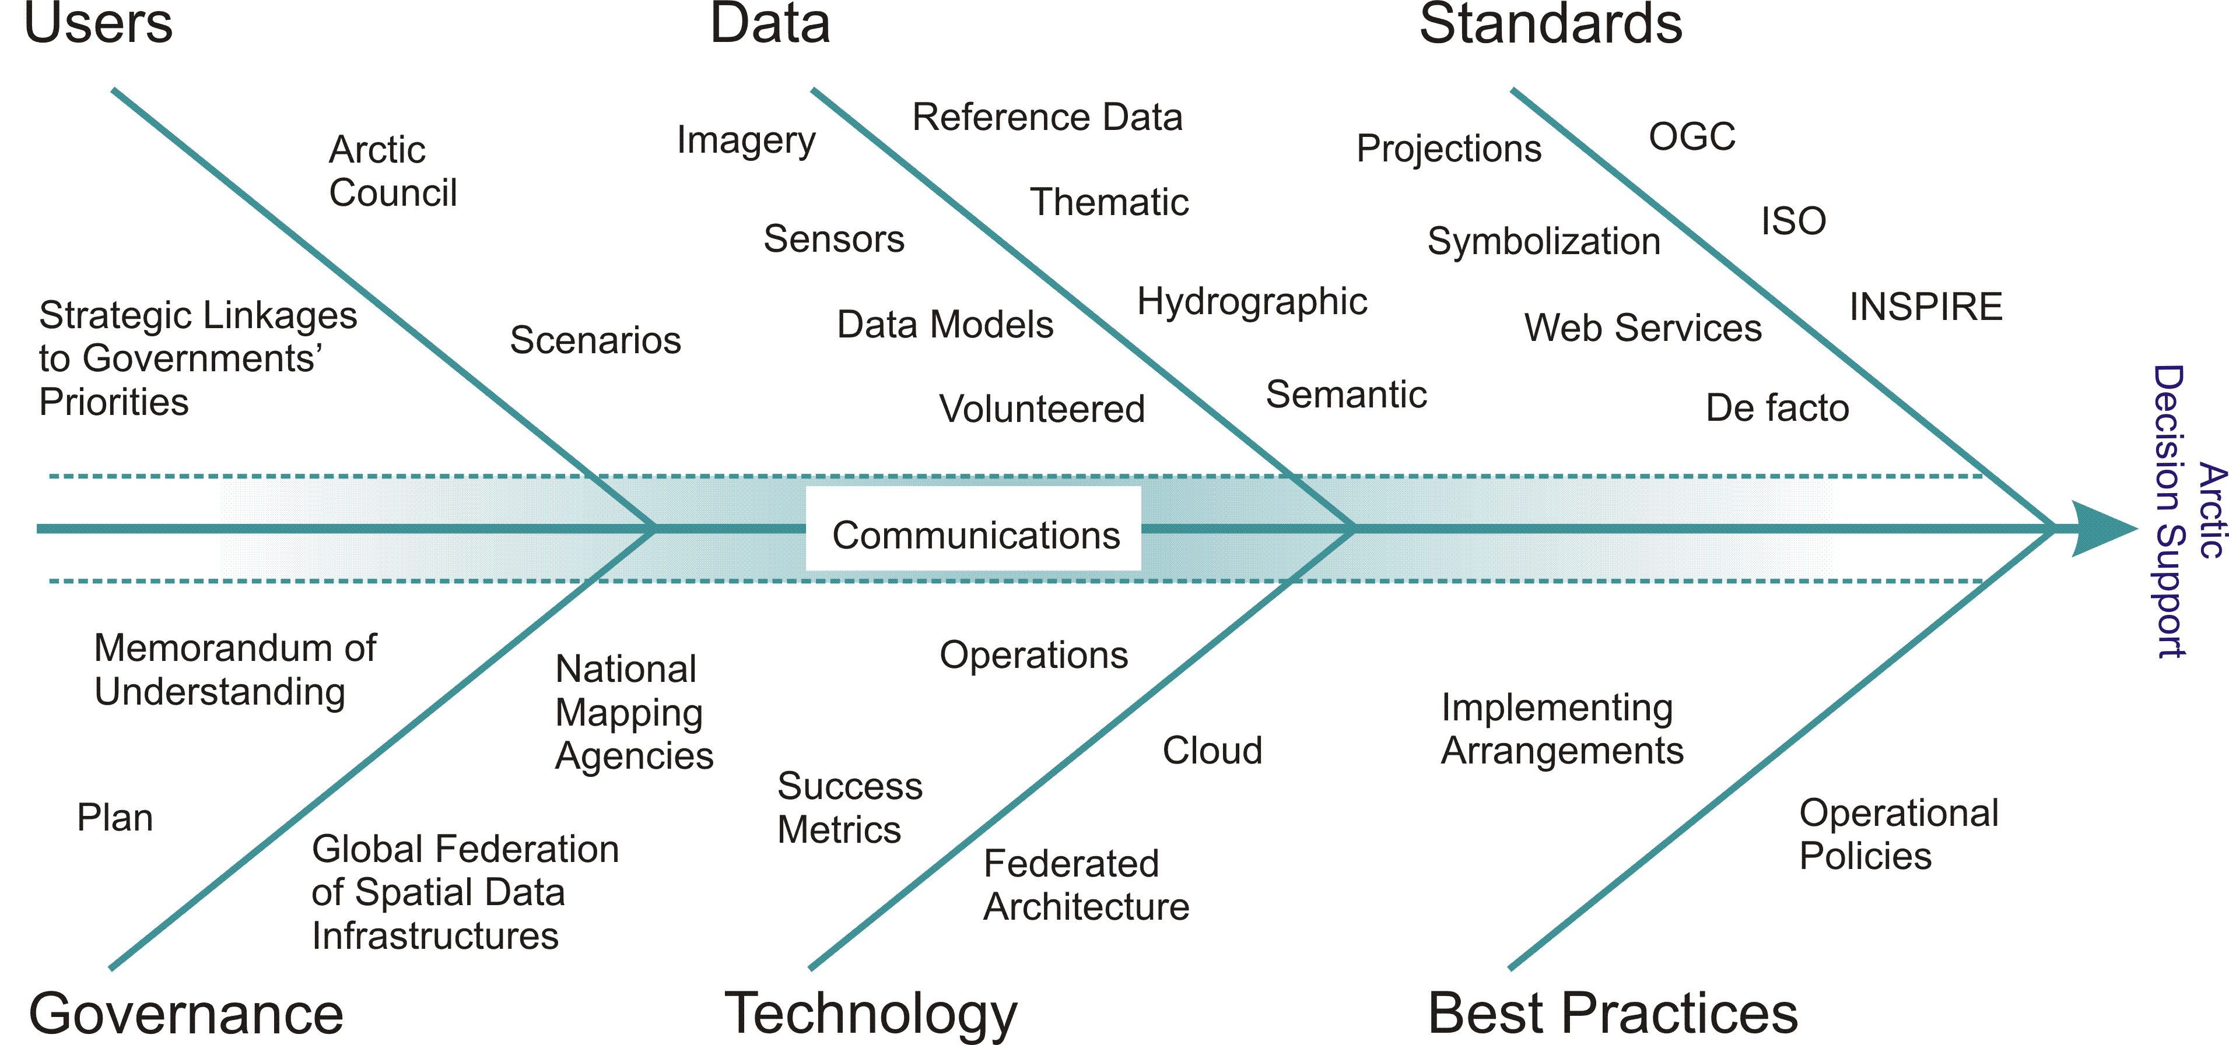

*Figure 5.* The Arctic SDI Reference Model with the purpose to aid strategic Arctic SDI discussions by grouping existing and potential SDI components. All Arctic SDI projects link to the Reference Model.

An Arctic SDI Reference Model Glossary can be found in Appendix 2.

## Strategy for developing Arctic SDI cooperation and services

Since the vision of the Arctic SDI was formulated in 2011 the cooperation between the 8 National Mapping Agencies has developed and resulted in signing of a Memorandum of Understanding. In parallel global and regional cooperation is developing under the umbrella of the United Nations and other forums.

Building an Arctic Spatial Data Infrastructure requires an ongoing development of the common understanding of the concept and a thorough understanding of the users, their needs and their position in the overall picture of stakeholders. Thus it will be possible to set the strategic direction for what dataset to develop and share and how to define the role of the thematic data providers. It also requires an ongoing development of the targeted infrastructure, technical opportunities and data sharing principles. The Arctic SDI cooperation also needs to look into its role in the Arctic Council cooperation and other existing pan Arctic cooperation’s as well as develop models for funding future activities.

In 2014/15 a new Arctic SDI strategy for the period 2015 – 2020 will be developed (p. 12 - 13).

# Arctic SDI - Governance, Organization and Operations

**Memorandum of Understanding and Implementing Arrangements**

The foundation for the Arctic SDI is the legally non-binding “Memorandum of Understanding” (MOU), which expresses the intention of the signatories to collaborate. The MOU is attached in Appendix 3.

To implement collaborative activities though, which require specific commitment, signatories of the MOU may enter into an Implementing Arrangement that can serve as legally or non-legally binding instrument(s). Examples of Implementing Arrangements range from financial arrangements, limitations of liability, copyright statements, Open Data approaches or special projects. All Implementing Arrangements will be added to Appendix 6.

## Arctic Council and the Senior Arctic Officials

To support the communication with the Arctic Council a link to the Senior Arctic Officials has been established through the secretariat of the Arctic Council working group *Conservation of Arctic Flora and Fauna* (CAFF).

## The Arctic SDI Board and the Board Executive

The decision-making body of the Arctic SDI cooperation is the **Arctic SDI Board**. The Board consist of one Director General or deputy Director General from each of the MOU signatories which countries are members of the Arctic Council. The Board meets at least once a year.

From 2014 the **Chair of the Arctic SDI Board** will rotate following the cycle of the Arctic Council chair:

|  |  |  |  |
| --- | --- | --- | --- |
| *1 Feb – 31 Jan* | ***Chair*** | *Previous Chair* | *Incoming Chair* |
| 2014 2015 | **Canada** | Iceland | USA |
| 2015 2017 | **USA** | Canada | Finland |
| 2017 2019 | **Finland** | USA | Iceland |
| 2019 2021 | **Iceland** | Finland | Russia |
| 2021 2023 | **Russia** | Iceland | Norway |
| 2023 2025 | **Norway** | Russia | Denmark |
| 2025 2027 | **Denmark** | Norway | Sweden |
| 2027 2029 | **Sweden** | Denmark | Canada |

**The Executive Board** consists of the previous Chair, the current Chair and the future Chair of the Board. The Executive Board assists the Chair of the Board as a consultation body on decisions that need to be taken between Board Meetings.

The guiding rules of procedure and terms of reference for the Board and the Execute Board are found in Appendix 4 and Appendix 8.

## National Contact Point

To prepare board-meetings and thus promote efficient decision making each Board Member appoints a representative from their institution to serve as the **Arctic SDI National Contact Point**. The national contact points also act as a point of liaison between their Board Member, the Arctic SDI fora and working groups and the National Mapping Institutions involved in the corporation. The national contact points communicate Board decisions as appropriate, and influence successfully delivery. The national contact points meet prior to Board meetings. The guiding rules of procedures and Terms of Reference can be found in Appendix 4 and Appendix 8.

## Lead countries and support countries

The present status of the Arctic SDI cooperation is a voluntary cooperation between national mapping agencies. As such the resources necessary for the activities of the Arctic SDI are composed by voluntary contributions from the participating institutions with the recognition of different levels of engagement.

The activities will be performed by **Lead Countries** joined by **Support Countries** unless otherwise agreed upon in Implementing Arrangements. This includes both administrative and technical activities and operations as well as development and strategic activities. **Lead Countries** have the responsibility for the operation and progress of the specific activity and refers directly to the Board.

The necessary cross cutting coordination of activities and processes are performed by the Lead Countries through mail, web conferences and joint working group meetings thus facilitating progress of work.

The guiding principles for organizing, managing and reporting can be found in Appendix 4 and the terms of references for the bodies and working groups of the Arctic SDI can be found in Appendix 8.

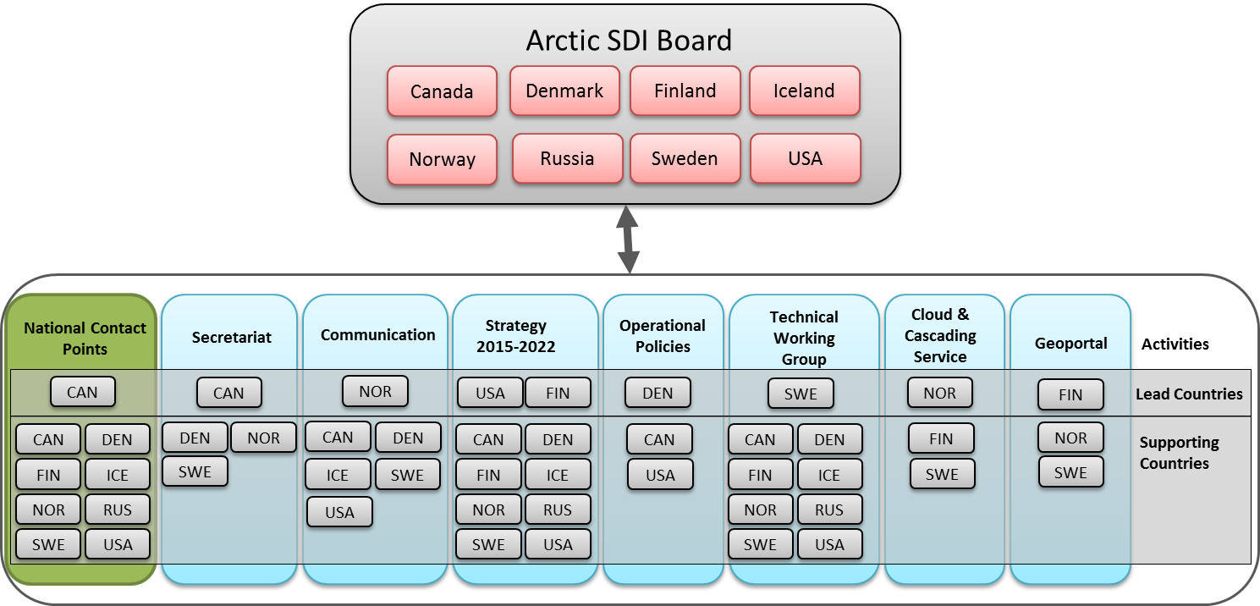

*Figure 6.* The Governance and Organisation of the Arctic SDI consist of the Board, the National Contact Points and Activities with responsible Lead Countries and Support Countries.

# Activities and division of work

## Identified activities:

* Secretariat for the Chair of the Board and Chair of the National Contact Point
* Arctic SDI Web Portal for reference map and thematic data
* Establish and operate Arctic SDI Web Map Service
* Technical Working Group – extracts from agreed Terms of Reference
* CAFF-proposal to distribute selected thematic data
* Development of Arctic SDI Strategy 2015 - 2020
* Development of legal/administrative operational Policies
* Communication, documentation, Website, Arctic SDI Point of Contact etc.

A more detailed description of the tasks within the activities can be found in Appendix 5 and Appendix 8.

## Identified lead countries and support countries:

|  |  |  |
| --- | --- | --- |
| **Activity** | **Lead Country** | **support countries** |
| Secretariat for the Chair of the Board and Chair of the National Contact Point | Country chairing the Board | *Denmark, Norway & Sweden* |
|  |  |  |
| Arctic SDI Web Portal for reference map and thematic data | Finland | *Norway & Sweden* |
|  |  |  |
| Establish and operate Arctic SDI Web Map Service | Norway | *Finland & Sweden* |
|  |  |  |
| Technical Working Group | Sweden | *All Countries* |
|  |  |  |
| CAFF-proposal to distribute selected thematic data | Canada | *Denmark, Norway & Sweden* |
|  |  |  |
| Development of Arctic SDI Strategy 2015 – 2020 | USA & Finland (Finland co-lead) | *All countries indicated interest in contributing* |
|  |  |  |
| Development of legal/ administrative operational Policies | Denmark | *Canada & USA* |
|  |  |  |
| Communication, documentation, Website, Arctic SDI Point of Contact etc. | Norway | *Canada, Denmark & Sweden* |

# *Appendix 1:* Arctic SDI – Data, infrastructure and technology

1. **Introduction**

This chapter intends to describe Arctic SDI from a more technical point of view with the focus on the use cases and the system designed to support these.

The system in the Arctic SDI context is a range of components and activities that together constitute the response from the National Mapping Agencies in cooperation with the Arctic Council. The aim is to build an SDI, serving governments, scientists, businesses and citizens in the Arctic with geographically related data, digital maps and tools, for better planning and decision making. The SDI must be interoperable with the National SDIs in the Arctic region which also consequently means it must be interoperable with INSPIRE, CM-GGIM.



Figure 1 - Data flow in the Arctic SDI from Collection to Action

The vision of the Arctic SDI technical architecture is for the actors to be able to easily access up-to-date spatial data from Arctic Mapping Agencies in the Arctic, from Arctic Council Working Groups and from other thematic data producers and providers in the Arctic. It should be done in such a way that as little overhead as possible is added to data and services. The goal is to make it possible to access reference data through a cartographically homogenous Pan-Arctic background map distributed as a Web Map Service but also to give access to all kind of location based data, raster as well as vector data, from the entire Arctic region.

1. **Arctic Spatial Data Infrastructure**

The Arctic SDI architecture is described in figure 2. The reference data from the participating Arctic Mapping Agencies will be made available through a number of services established in each of the Arctic countries' own spatial data infrastructures. Also the thematic information should be made available in the same way.  Figure 2 - Arctic SDI Technical Architecture

If there are special needs for users of the Arctic SDI, it may be necessary that common services are being developed to support these requirements. E.g. a common digital background map is a key component in a SDI. Such a product, which supplies reference data updated in close to real time, is impossible for a single country to provide. The main focus in the phase when the Arctic SDI was established was therefore to build this common Web Map Service. Another need that might emerge in the future is services covering the need of common authentication and authorization and also tools for digital licensing (the Geospatial Digital Rights Management layer in the figure).

The services from the National SDIs’ as well as the common Arctic SDI services will serve as a platform or framework to build applications or dynamic webpages for specific identified needs and use cases in the Arctic.

1. **General, overall Use cases**

As we have mentioned previously, the purpose of the infrastructure is to enable the different actors in the Arctic, to consume up-to-date spatial information. Figure 3 shows the actors and the general overall use cases the Arctic SDI must be able to handle in the future. The concept **use case** refers to how a user uses the system to achieve a particular goal.

The National Mapping Agencies have taken a major responsibility in the work to establish Arctic SDI, but for the infrastructure to get its full potential requires engagement from other owners and managers of spatial information, but also from other stakeholders in the Arctic. The dashed boundary in the figure is pointing out the responsibilities of the mapping agencies. The use cases that are partially or completely outside of this boarder identify responsibilities of other actors in the Arctic.

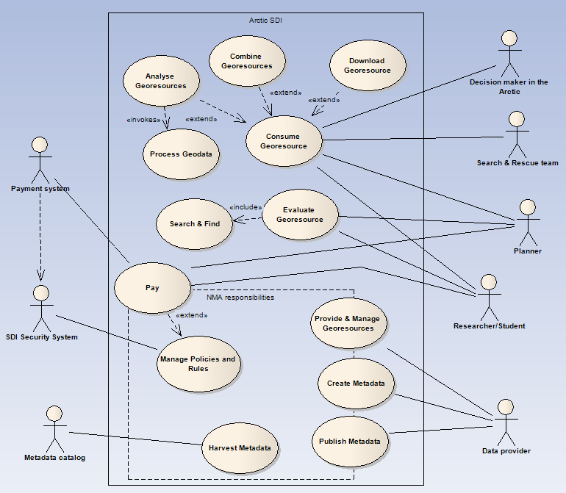

Figure 3 - Actors and use cases in the Arctic SDI

* 1. **Provide & Manage Geo-resources**

Providing and managing spatial data in a standardized way is the very foundation for a useful spatial data infrastructure. To cover the need of spatial data in the Arctic, the Arctic Mapping Agencies, but also other data owners need to distribute their data through standardized services. When the Arctic SDI is fully operational many different both governmental and non-governmental bodies will be represented with their data in the SDI.

Providing and managing spatial data in this context is not a simple task. For data to work seamlessly across the Arctic they need to be harmonized or at least formatted in a standardized way so as to ensure that they can be used or consumed in combination by actors within the SDI. For this to fully work, the mapping agencies need to harmonize their data models. The same applies to other data owners for data to be used and analyzed across borders. This being so large a task it is recommended that it is broken into sub-tasks:

1. Create a common, basic digital background map
2. Create a common data model that each Country can easily translate their output data into

The last step is a future vision where we will have harmonized vector based reference data over the entire Arctic. The possibilities for this does not look so promising today but the pursuit in the Arctic and in other cross boarder context is to standardize the information in the databases so that it can be understood and used in the same way in different tools even though the data come from different countries. If ever happens, this journey will take many years.

* 1. **Create Metadata**

As more and more data is added to the SDI, being able to search among all datasets and services becomes more and more important. For this purpose metadata about data and services are created and managed by the data-owners. But for metadata to really work in a search engine they also need to be created in a uniformed way. To achieve this there is an important and non-trivial task of creating a harmonized format of the metadata in the SDI including the use of harmonized keywords so they can work within the same context, spanning the Arctic.

* 1. **Publish Metadata**

Once metadata has been created they need to be published to a catalogue so that they can be searched and found in standardized way. The publish use case handles the ability for users to store their metadata documents in the common metadata catalog and by doing so making it searchable in a search engine. The publishing process in this context can be realized in three different ways, either by creating metadata using specific metadata editors and then publish the information directly into the metadata catalog (using the CSW interface), or by uploading the metadata as an XML file. The third possibility is to harvest metadata from other metadata catalogs and publish the metadata to the Arctic SDI metadata catalog.

The last publishing process is very important for Arctic SDI because it is based on the national SDIs’ with their datasets and services. With a specific thesaurus for Arctic SDI, keywords can be added to already existing metadata. The combination of the Arctic SDI thesaurus and the used keywords can then be used when filtering the data in the harvest process from the national SDIs’ to Arctic SDI. All the relevant metadata for the Arctic region will in this way be searchable from one single point.

* 1. **Harvest Metadata**

The Harvest metadata use case opens the possibility for other metadata catalogs to harvest the Arctic SDI metadata catalogs in the same way as is described for the third possibility in the publishing process above.

* 1. **Search & Find**

This use case makes it possible to search among all metadata in the catalog for relevant geo resources for the users. The Search & Find use case is the first step in an evaluation process. When an interesting resource is found the user can continue to evaluate the resource with the included preview tools.

* 1. **Evaluate Geo-resources**

When an interesting Geo-resource is found in the Geoportal, the user can extract the metadata document, read metadata and with other tools in the portal evaluate the resource to find out if it fits the need.

* 1. **Consume Geo-resources**

To consume or use the geo-resources is probably the most basic of the all the general use cases. Here an actor (decision maker, planner, etc.) uses data in applications, webpages or in other forms for their special needs.

* 1. **Download Geo-resource**

Every now and then an actor needs to do more with data than just use it as a backdrop for their on-line activities. In this case it is necessary for the user to retrieve even the vector data either for usage offline or for doing analysis in his or her environment. In this case the actor needs the possibility to download data. This can be done by downloading predefined datasets or via download services for direct access to data.

* 1. **Combine Geo-resource**

Sometimes the user needs to combine spatial data from more than one provider. E.g. this could be combining a background map with an overlay of winds together with migratory birds. This could be done by downloading data and doing the overlay on a local pc, but in this context “Combining Geo-resource” is describing the case of combining data “on the fly” using web services. The user simply defines what data to combine and the service then provide the result directly.

* 1. **Analyze Geo-resource**

Just like combining geo-resources, the user sometimes needs to do analysis on the provided spatial data. As for combining geo-resources analyzing the geo-resources is also done server side by accessing a service which provides the result directly.

* 1. **Process Geodata**

Lastly a user might need to process data. This could e.g. be the necessity to transform data from one projection to another. In this case the user would send a request to a web processing service, the backend server will transform the dataset and return the result directly.

* 1. **Manage Policies and Rules**

In many cases the data being shared is governed by rules and policies as to who can use them, under which restrictions and possible pricing. To ensure that all data is handled correctly there is a need of managing these policies and rules also in the system. This task is an integral part of any data infrastructure and is important if the infrastructure is to encompass even data with certain restrictions. To reach full potential of Arctic SDI, attention shall be paid to data sharing principles and best practices of thematic data among stakeholders and their different types of data, e.g. operational data and re-search data. Only if the data owners are confident that their data is being used in a safe way will make them share their data. One of the most important aspects of policy management is to ensuring the users credentials and then linking this to his or her privileges. In most cases this is handled by the data owners themselves but there might be a need for a central technical solution at least to handle authentication federation and Single-Sign-On in the system.

* 1. **Pay**

Payment is a special part of the policies and rules. The special thing about payment is that it needs to connect to an external payment authority that can handle payment transactions. So although this use case is placed on the edge of the tasks managed by the Arctic Mapping Agencies it is in fact something that is run by a third party financial service provider E.g. a bank or so. The Pay use case has been included to clarify the need for a payment system that allows users to order and pay for datasets that are available only on payment.

1. **Data, technology and standards**

**Reference Data** are provided by the involved mapping organizations, covering the arctic region as defined by each organization. In this context, reference data means a least common multiple of map layers, serving as a background map for the entire Arctic region.

Each mapping organization is responsible for providing data through a **Web Map Service (WMS)** that meets the requirements of a common cartographic specification. A WMS is an **Open Geospatial Consortium (OGC)** standard and delivers geo-referenced map *images* from its source. No actual data are transferred, only a cartographic snapshot of the national database it references.

Reference data may be delivered to consuming applications in a number of ways by different types of web services. To provide a seamless background map of the entire Arctic cross borders, the project uses a **Cascading Web Map Service**. This service collects input from the national web map services, and provides applications with a geo-referenced map image of the requested area. To ensure that map images are delivered a fast as possible, pre-caching of map tiles is required.

The OGC interface standard **Web Feature Services (WFS)** could be used in the future to deliver geographical features (actual data). The **Representational State Transfer API** **(REST API)** gives a standardized way for applications to communicate with the reference data services. Metadata for the reference data are published through a standard called **Transactional Catalog Service for the Web (CSW-T)**, which is compliant with the OGC specifications. Metadata for the reference data are published in a common **Metadata Catalog**, providing searchable data set information for application users.

**Thematic Data** are spatial datasets of interest in the Arctic region, organized as thematic layers. Dataset providers could be governmental or interest organizations, companies etc. These datasets and metadata could be delivered and harvested using the same service alternatives as described for the reference data.

For end users, **Arctic SDI Applications** provides access to discover and view the underlying datasets. Different applications with different **Graphical User Interfaces (GUI)** could present the datasets in numerous ways, according to independent needs and hardware/software platform. The searchable metadata catalog will be a central part of the applications, and thematic data from external partners will be combined with the seamless background map from the mapping organizations. **Data processing** and overlay analysis could also be combined with the existing datasets.

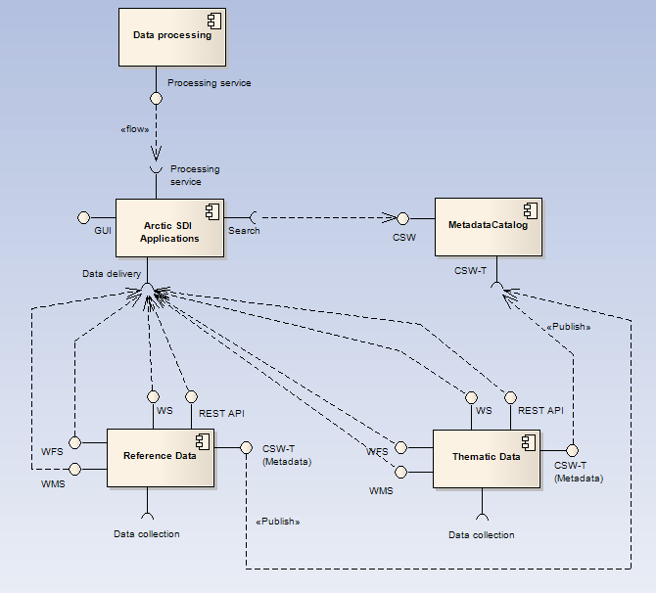

1. **Deployment**

The deployment environments described here is only covering the work of responsibility of the Arctic Mapping Agencies and no other actors in the infrastructure.

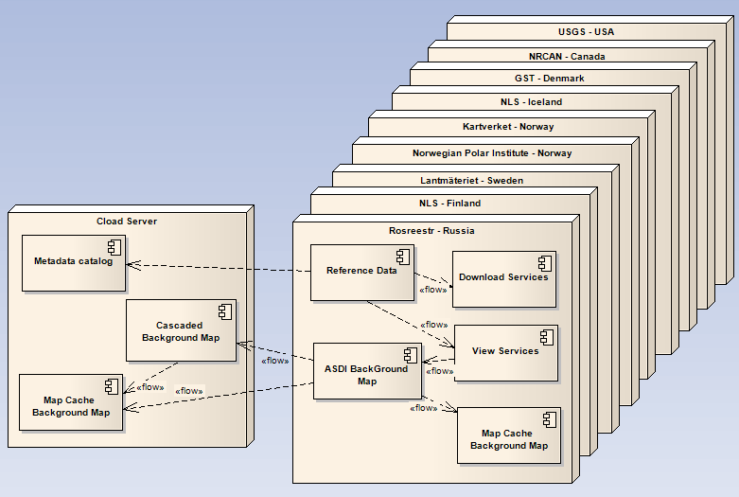 Figure 5 - Physical distribution environments of the Arctic SDI components

On the national level each Mapping Agency is responsible for storing their reference data and to set up view and download services for the distribution of reference data covering the own country as images, raster and vector data. This can include a Map Cache on to improve performance.

A common background map and a metadata catalogue require a platform to collect the needed information from all Arctic countries to one single point of contact. The recommended solution is to use a server in the cloud, which means a server provided by a commercial supplier as a service on internet. This server will run the Metadata catalogue and the Cascading service, which is the service that builds together the reference data from all countries to a common map of the Arctic region. For the users to get better performance there will also be a predefined cache of maps-tiles on the cloud server. It will be the responsibility of the Arctic SDI to run the cloud services.

Because of the fact that the region covers all the time zones it is important that the services are up and running 24 hours a day, 7 days a week. This is a challenge and especially for the common central services where there currently are no designated operating personnel with round the clock preparedness. What is perhaps more realistic to deliver is services that are running 24 - 7, but if something happens there is no assurance of action until the staff is available during regular office hours.

# *Appendix 2:* Arctic SDI Reference Model Glossary

1. **Reference Model**

The purpose of the Reference Model is to aid strategic Arctic SDI discussions by grouping existing and potential SDI components. The Reference Model is the basis to implement the Vision through a consistent understanding of what needs to be done. All Arctic SDI projects link to the Reference Model.

A reference model in enterprise engineering parlance is an abstract framework consisting of an interlinked set of clearly defined concepts produced by an expert or body of experts in order to encourage clear communication.

The Organization for the Advancement of Structured Information Standards states that a reference model is "*an abstract framework for understanding significant relationships among the entities of some environment, and for the development of consistent standards or specifications supporting that environment.*

*A reference model is based on a small number of unifying concepts and may be used as a basis for education and explaining standards to a non-specialist. A reference model is not directly tied to any standards, technologies or other concrete implementation details, but it does seek to provide a common semantics that can be used unambiguously across and between different implementations*."

<http://en.wikipedia.org/wiki/Reference_model>

**Arctic SDI Reference Model of current and potential activities.**



1. **Arctic SDI Reference Model Categories**

**2.1. Users**

a. Arctic Council – Respond to Arctic Council needs through the use and promotion of location based data, visualization and analysis through commonly accepted spatial data infrastructure constructs.

b. Strategic Linkages to Governments’ Priorities – Investments in Arctic SDI are linked to each country’s respective domestic priorities

c. Scenarios – Use case scenarios are built to guide development. These use case scenarios may originate from any source.

**2.2 Governance**

a. Memorandum of Understanding – instrument of co-operation between member countries

b. Arctic Plan – A plan that outlines at both strategic and operational levels the scope, governance, outputs. Details from a variety of working groups are found in Annexes.

c. Global Federation of Spatial Data Infrastructures – Where practical, linkages made between the collective vision of Arctic SDI and those related SDI efforts that we participate in as respective nations , for example global, regional, domestic and thematic geospatial forums, standards bodies and communications.

1. **Data**

a. Imagery – raster data from sensors on satellite, plane or ship platforms; e.g. multispectral, passive or active.

b. Sensors – data from in-situ sensors, for example water buoys, weather stations, etc.

c. Volunteered – data collected and offered by the public typically via mobile applications.

d. Data Model – over time striving towards common data models and data integration

e. Reference Data – vector data used in creation of reference or base map of the Arctic. The base will form the backdrop for thematic data. Includes place names, projections, and symbology.

f. Thematic – data related to a theme of physical or human geographies, e.g. statistical, transportation, ice extent normals, etc.

g. Hydrographic: data that records “the measurement and description of the physical features of oceans, seas, coastal areas, lakes and rivers” (http://en.wikipedia.org/wiki/Hydrography)

h. Semantic – common ontologies in support of semantic web

1. **Technology**

a. Operations – day to day operations of web services and portal

b. Cloud - Private or Public providers that exhibit the 5 characteristics of Cloud computing as published by the National Institute of Standards and Technology: on-demand self-service, broad network access, resource pooling, rapid elasticity and measured service. Details and complimentary criteria are published at http://en.wikipedia.org/wiki/Cloud_computing#Characteristics

c. Success Metrics – reports on content and traffic

d. Federated Architecture – technical linkages to global, regional and domestic SDI initiatives

1. **Standards**

a. Projections – polar projections supporting multiple views of arctic data

b. Symbolization- common map symbolization, colours, etc.

c. De facto – selected standards that are in common use but not ISO or OGC. For example geographic information system and remote sensing analysis vendor formats

d. Web Services – input to OGC and other web service specifications

e. OGC – Open Geospatial Consortium

f. ISO – International Organization for Standardization

g. INSPIRE – European SDI and European Location Framework (ELF)

1. **Best Practices**

a. Operational Policies that publish spatial data infrastructure guidelines on protected information, access methods, data management and dissemination. Best practices and SDI Cookbooks drawn from similar initiatives.

b. Implementing Arrangements are specific agreements that have legal, financial or extensive in-kind commitments executed under the umbrella of the Memorandum of Understanding.

1. **Communications**

a. Runs across all categories of Arctic SDI. Strategic and multi-perspective key messages that can be re-used. To ensure consistent strategic communications across a wide variety of situations, for example at standards bodies, with other SDI initiatives, with Arctic Council and with one’s own government

b. Outreach communications via Arctic SDI website to engage users and practitioners.

# *Appendix 3:* Arctic SDI - Memorandum of Understanding

*The document is originally established and elaborated in English language and then translated into French and Russian languages.*

The MOU in the three languages has been signed between February and May 2014 by the participating organizations. The *signed* documents are available on the Arctic SDI Web Site.

_______________________

**MEMORANDUM OF UNDERSTANDING**

between

The Earth Sciences Sector of the Department of Natural Resources Canada,  
the Danish Geodata Agency, the National Land Survey of Finland, the Government of Greenland, the National Land Survey of Iceland, the Norwegian Mapping Authority, the Federal Service for State Registration, Cadastre and Mapping of the Russian Federation,   
the Swedish Mapping, Cadastral and Land Registration Authority, the United States Geological Survey

concerning

*CO-OPERATION IN THE DEVELOPMENT OF AN ARCTIC SPATIAL DATA INFRASTRUCTURE*

The Earth Sciences Sector of the Department of Natural Resources Canada,  
the Danish Geodata Agency, the National Land Survey of Finland, the Government of Greenland, the National Land Survey of Iceland, the Norwegian Mapping Authority, the Federal Service for State Registration, Cadastre and Mapping of the Russian Federation,   
the Swedish Mapping, Cadastral and Land Registration Authority, the United States Geological Survey

hereinafter referred to as the “Participants”

Considering that the Arctic Spatial Data Infrastructure (Arctic-SDI) is a complex of spatial information resources, organizational structures, technologies of creation, processing and exchange of spatial data, that provides broad access and efficient use of spatial data for the Arctic,

Considering that mutual benefits would result from the establishment of a cooperative framework providing national geospatial map data for the analysis and monitoring of the Arctic environment and resources,

Having determined that the primary objectives of their co-operation are the access and distribution of national geospatial datasets through an Arctic-SDI,

Stating their mutual desire to develop, maintain and administer the Arctic-SDI and provide national geospatial information and associated systems for the sharing of relevant reference data,

Wishing to contribute to the advancement of scientific co-operation and reinforcing and strengthening the links among them,

Have reached the following understanding:

1. The objective of this Memorandum of Understanding (MOU) is the access and distribution, of national geospatial datasets through an Arctic-SDI on the basis of equality and mutual benefit.

2. The Participants understand that data under this MOU may include the following:

(a) relevant national cartographic data;

(b) other types of data (such as land cover & hydrology);

(c) other areas of mutual interest within the framework of development of the Arctic-SDI as they may determine.

3. The Participants understand that their co-operation in the development, maintenance and administration of the Arctic-SDI may include the following forms:

(a) exchange of cartographic and other necessary information;

(b) education and training for work with the Arctic-SDI;

(c) liaison with industrial, academic, professional and other organizations that participate in the Arctic-SDI;

(d) organizational and support of technical seminars and meetings;

(e) encouragement of co-operation regarding consulting services, technology assessment and applications development; and

(f) other forms of co-operation as they may determine.

4. The Participants intend to designate appropriate representatives to identify co-operative activities and details of implementation of this MOU.

5. The Participants intend to conclude Implementing Arrangements for each of their activity of co-operation identified in paragraph 3 that will set forth the timing and scope of the specific forms of co-operation and any other matters on which their consent may be desirable.

6. (a) Each Participant intends to pay for the cost it incurs in the application of this MOU unless otherwise decided upon in writing under an Implementing Arrangement.

(b) The Participants intend to ensure that all costs or estimated costs are detailed in the Implementing Arrangements.

(c) The Participants understand that their activities are subject to the availability of their respective funds and resources.

7. (a) This MOU will enter into operation upon signature by all Participants and will remain in operation for five (5) years, unless extended or discontinued by the Participants.

(b) The Participants may amend this MOU or extend its application upon their mutual consent in writing.

(c) A Participant may cease its cooperation under this MOU by giving a three (3) months written notice to the other Participants.

(d) This MOU is not legally binding.

Signed in nine (9) originals at……………………in the English, French and Russian languages.

*For the Earth Sciences Sector of the Department of Natural Resources Canada*

|  |  |  |
| --- | --- | --- |
|  |  |  |
| Date |  | Signature & clarification of signature |

*For Geodatastyrelsen- The Danish Geodata Agency*

|  |  |  |
| --- | --- | --- |
|  |  |  |
| Date |  | Signature & clarification of signature |

*For Maanmittauslaitos - National Land Survey of Finland*

|  |  |  |
| --- | --- | --- |
|  |  |  |
| Date |  | Signature & clarification of signature |

*For the Government of Greenland*

|  |  |  |
| --- | --- | --- |
|  |  |  |
| Date |  | Signature & clarification of signature |

*For Landmælingar Íslands - National Land Survey of Iceland*

|  |  |  |
| --- | --- | --- |
|  |  |  |
| Date |  | Signature & clarification of signature |

*For Kartverket– Norwegian Mapping Authority*

|  |  |  |
| --- | --- | --- |
|  |  |  |
| Date |  | Signature & clarification of signature |

*For Rosreestr - The Federal Service for State Registration, Cadastre and Mapping   
(the Russian Federation)*

|  |  |  |
| --- | --- | --- |
|  |  |  |
| Date |  | Signature & clarification of signature |

*For Lantmäteriet - the Swedish mapping, cadastral and land registration authority*

|  |  |  |
| --- | --- | --- |
|  |  |  |
| Date |  | Signature & clarification of signature |

*For U.S. Geological Survey – Office of the Director*

|  |  |  |
| --- | --- | --- |
|  |  |  |
| Date |  | Signature & clarification of signature |

===============

# *Appendix 4:* Arctic SDI - Governance, Organization and Rules of Procedure

1. **Memorandum of Understanding**

The foundation for the Arctic SDI is the “Memorandum of Understanding” (MOU) in which the spirit of the cooperation is detailed. The MOU expresses the intention of the signatories to collaborate and describes the objectives, the areas of interest and the forms under which the cooperation will be performed. Through the MOU, the signing participants will designate appropriate representatives to identify cooperative activities and details of implementations. The MOU is a **legally non-binding** instrument covering a period of five years from the date of signature. It may be amended or extended by written agreement. The MOU is attached in Appendix 3.

1. **Implementing Arrangements**

For collaborative activities which require specific commitment between participants or participants and third parties, the participants of the MOU may enter into an Implementing Arrangement (IA) that can act as a legally binding or non-legally binding instrument. An IA provides the necessary framework for legally binding issues such as intellectual property, liability and copyright as well as long term commitment of resources and funding. It is recommended that legally binding IA’s be selected for any arrangement which involve financial transfers between participants and/or third parties. If the contributions are going to be only “in-kind” and do not involve transfer of funds, then a legally non-binding IA is the recommended option. Depending on the areas of cooperation, it may also not be necessary for all the participants to contribute to an IA, however all participants should provide “tacit approval” (e.g. via email) for the IAs. All IAs will be added to the Appendix in chronological order.

1. **Arctic Council and the Senior Arctic Officials**

To support the communication and to clarify the future affiliation with the Arctic Council it has been agreed to establish the link to the Senior Arctic Officials through the secretariat of the Arctic Council working group Conservation of Arctic Flora and Fauna (CAFF).

1. **Arctic SDI governance and organization**

The governance and organisation of the Arctic SDI consist of the Board, the national contact points, lead countries and support countries.

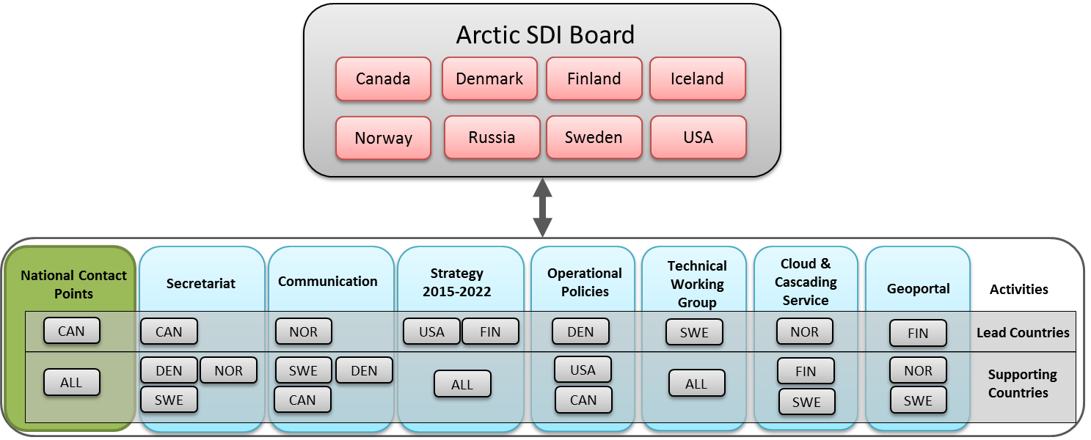

*Figure 6.* The Governance and Organisation of the Arctic SDI consist of the Board, the National Contact Points and Activities with responsible Lead Countries and Support Countries.

* 1. **The Arctic SDI Board**

The decision-making body of the Arctic SDI cooperation is the **Arctic SDI Board**.

The Board formulates the vision, goals and strategy for the development of the Arctic SDI, organizes the affiliation with the Arctic Council and prepares the necessary Implementing Arrangements. The Board also identifies the tasks of the cooperation, organizes the work and provides the necessary resources, governance and competences to support the implementation of decisions.

The Board consist of one Director General / deputy Director General from each of the MOU signatories which countries are members of the Arctic Council.

The **Chair of the Arctic SDI Board** rotates every second year following the cycle of the Arctic Council chairmanship. The Chair is the board-member representing the National Mapping Agency from the same country that holds the Chair of the Arctic Council. The cycle of the Arctic SDI Board chairmanship begins 1 February of the year where the chair of the Arctic Council changes in May.

|  |  |  |  |
| --- | --- | --- | --- |
| 1 Feb – 31 Jan | **Chair** | Previous Chair | Future Chair |
| 2014 2015 | **Canada** | Iceland | USA |
| 2015 2017 | **USA** | Canada | Finland |
| 2017 2019 | **Finland** | USA | Iceland |
| 2019 2021 | **Iceland** | Finland | Russia | |
| 2021 2023 | **Russia** | Iceland | Norway | |
| 2023 2025 | **Norway** | Russia | Denmark | |
| 2025 2027 | **Denmark** | Norway | Sweden | |
| 2027 2029 | **Sweden** | Denmark | Canada | |

The Board shall meet no less than once a year. The board otherwise decides the frequency of meetings as appropriate.

The chair shall notify the board members of the date, venue and provisional agenda at least 4 month before the meeting is due to commence and at the same time set the deadline for submission of proposals or documents for discussion from the Board Members. The Board can decide on general procedures for the preparations and the conduct of board meetings as well as specific procedures for one specific board meeting. Being an equal cooperation between national agencies all decisions are made in consensus.

An Implementing Arrangement can mandate the Board to make decisions following special rules of procedures.

The board can invite observers to attend the board meetings and to make presentations as well as answer questions under specific agenda items.

* 1. **The Executive Board**

The Board Executives consist of the Chair, the previous Chair and the future Chair of the Board.

The Executive Board assists the Chair of the Board as a consultation body on decisions that need to be taken between Board Meetings.

The Board Executives can

* be mandated by the Board to make decisions and launch actions concerning specific items in between the board meetings,
* implement a written decision procedure or to convene an extraordinary Board Meeting including the necessary preparatory meetings.
  1. **National Contact Points**

To prepare board-meetings and thus promote efficient corporation each Board Member appoints representative(s) from their institution to serve as the **Arctic SDI National Contact Point**.

The national contact points also act as a point of liaison between their Board Member, the Arctic SDI fora and working groups and the National Mapping Institutions involved in the corporation. The national contact points communicate Board decisions as appropriate, and influence successfully delivery.

The National Contact Points act on behalf of the board members and prepare the board meetings by proposing items to the agenda and by clarifying issues and differences in opinions in relation to meeting documents and draft decisions presented either by a Lead Country or a National Contact Point.

The National Contact Points meet prior to the board meetings no later than 2 weeks before the final deadline for submitting documents and proposals to the Board. The meeting are chaired by the National Contact Point representing the Chair of the Board.

Lead country representatives not also serving as National Contact Points attends the meeting of the National Contact Points to facilitate the preparation of a Board Meeting.

* 1. **Lead countries and support countries**

The present status of the Arctic SDI cooperation is a voluntary cooperation between national mapping agencies. As such the resources necessary for the activities of the Arctic SDI are composed by voluntary contributions from the participating institutions with the recognition of different level of engagement.

The activities will be performed by **lead countries** joined by **support countries** unless otherwise agreed in implementing arrangements. This includes both administrative and technical activities and operations as well as development and strategic activities. The activities will be organized in working groups or otherwise.

**A Lead Country** has the responsibility for the operation and progress of the activity. The tasks within the activities can be divided between the Lead Country and the support countries and managed through meetings, web meetings and mail.

The lead countries refer to the Board. This includes the responsibility to report and submit documents and draft decisions to the Board, including compliance with deadlines and reflecting on the opinions expressed by the national contact points in the process of preparing the Board Meeting.

The necessary cross cutting coordination of activities and working group processes are performed by the lead countries through mail, web meetings and joint working group meetings thus facilitating the overall progress of the activities and contribution to the preparation of board meetings.

# *Appendix 5*: Arctic SDI - Description of Activities

The following activities have been identified:

1. **Secretariat for the Chair of the Board and Chair of the National Contact Point**

* logistics and practicalities in relation to Board Meeting
* preparation of the provisional agenda, the annotated agenda and documents for Board Meetings in cooperation with the national contact points and the lead countries
* convene and chair national contact points meetings
* record minutes of Board meetings and follow up
* general assistance to the Chair of the Board

1. **Arctic SDI Geo Portal for WMS Map Service and thematic data**

* Develop, build and operate the Arctic SDI interface to Arctic Web Map Service, thematic data, Metadata Catalogue and future Arctic SDI services.
* Deadline 1. December 2014

1. **Establish and operate Arctic SDI Web Map Service**

* Build and operate the Arctic SDI Web Map Service
* Deadline 1. December 2014

1. **Technical Working Group – extracts from agreed Terms of Reference**

* Infrastructure and technology
* Design, architecture and standards
* Data models and metadata
* Technical proposals for establishing Arctic SDI WMS, the Web portal as the primary Arctic SDI interface and for other coming services

1. **CAFF Thematic Data**

* Implement access through the Geo Portal to CAFF thematic remote sensing data on land cover change
* Deadline 1. December 2014

1. **Development of Arctic SDI Strategy 2015 - 2020**

Prepare for the Board a draft strategy 2015 – 2020 including considerations concerning

* User needs
* Thematic datasets for Arctic SDI and role of other data providers
* Data sharing Principles
* Arctic Council and other stakeholders
* Resources and financing
* Arctic SDI and the role on the international Geodata scene
* Prioritized proposal for activities with reference to the Arctic SDI Reference Model
* Common understanding of Arctic SDI and revision of Arctic SDI Vision

First draft of strategy is to be presented to the Board in 2014.

1. **Development of legal/administrative operational Policies**

* Implementing Arrangements
* Licensing
* Property Rights
* Contracts
* Policies and legal framework

1. **Communication, documentation, Website, Arctic SDI Point of Contact etc.**

* Point of contact for stakeholders, users and the public in general
* Arctic SDI official Website – operation, updating and editing
* Information and key, strategic messages (presentations, pamphlets, posters)
* Coordinate information within the groups of lead and support countries
* Documentation – documents, protocoles etc. from the Board meetings, national contact point activities etc.
* Representation in international forums when agreed with the Chair of the Board

# *Appendix 6*: Arctic SDI - Implementing Arrangements

*This Appendix is reserved for forthcoming Implementing Arrangements.*

# *Appendix 7*: Arctic SDI - Operational Policies

1. **What are geospatial operational policies?**

Geospatial operational policies are a broad range of practical instruments such as guidelines, best practices, directives, procedures and manuals that address topics related to the lifecycle of geospatial information (i.e., collection, management, dissemination, and use) and help facilitate access to and use of location-based information. These policies apply to the day-to-day business of organizations and address legal and administrative requirements, and make issues such as data access, quality, ownership and integrity easier to manage.

1. **Importance of geospatial operational policies**

Geospatial operational policies are essential to eliminating barriers and enabling users to exchange location-based information effectively and efficiently. Technology and standards have removed many of the technical barriers to sharing geospatial data. However, some operational policies have not kept pace with the demands of a changing environment. New practical instruments on key topics that impact geospatial information are needed to promote data exchange and integration and to ensure that social and economic decisions are taken with the benefit of the best available information.

The following key policy topics and trends impact spatial data infrastructures:

|  |  |
| --- | --- |
| **Legal/Administrative** | **Technological/Trends** |
| * Ethical Legal Practices * Confidential, Secure, and Sensitive Information * Privacy * Intellectual Property * Licensing * Data Sharing * Liability * Archiving and Preservation * Data Quality | * Open Data * Volunteered Geographic Information (VGI) * Open Source Software * Web 2.0 and the GeoWeb * Cloud Computing * Mobile and Location-based Services * High Resolution Imagery * Mass Market Geomatics * Data Integration |

1. **Operational Policy Documents:**

[**Protected Information**](http://www.nrcan.gc.ca/earth-sciences/geomatics/canadas-spatial-data-infrastructure/8904)

* Confidential information
* Sensitive Information
* Private information
* Intellectual Property

[**Access, Management and Dissemination**](http://www.nrcan.gc.ca/earth-sciences/geomatics/canadas-spatial-data-infrastructure/8904)

* Archiving and Preservation
* Data Integration
* Data Sharing
* Licensing
* Volunteered Geographic Information (VGI)
* Cloud Computing
* Free and Open Source Software (FOSS)
* Licensing

Source: <http://www.nrcan.gc.ca/earth-sciences/geomatics/canadas-spatial-data-infrastructure/8902>

# *Appendix 8*: Arctic SDI - Terms of References

**Arctic SDI Working Groups – in general**

**Introduction**

The Arctic SDI Board has decided to establish the following working groups:

* Governance (Board, Execute Board, National Contact Points and the Lead Countries)
* Secretariat for the Chair of the Board
* Communication
* Technical Activity Working Group
* Cloud and Cascading Web Map Service
* Arctic Geoportal
* Arctic SDI Strategy 2015 – 2022
* Operational Policies

**Objective**

The objective of each Activity Working Group is described in a “Terms of Reference”, which includes consideration concerning organization, governance, operations and activity planning.

All Terms of References are attached as appendixes to the *Arctic SDI Framework Document*.

**Organization**

When establishing a working group the Board nominates a *lead country* and *support* countries.

The Lead Country has the responsibility for the operation and progress of the activity. The tasks within the activities can be divided between the Lead Country and the Support Countries. The Lead Country is also responsible for the planning of meetings, web meetings, correspondence and communication.

The Lead Country refers to the Board. This includes the responsibility to report and submit documents and draft decisions to the Board, including compliance with deadlines and reflecting on the opinions expressed by the National Contact Points in the process of preparing the Board Meeting and respecting the schedule for the preparation of Board Meetings.

**Activity plan**

The work in the working groups is described in dynamic activity plans that will be available via the Arctic SDI Web Site.

**Transparency and interaction**

The work will be performed in an open and transparent manner and meetings as well as documentation will be open to all representatives from the signatories of the Memorandum of Understanding.

The lead country has the responsibility to coordinate and communicate any necessary cross cutting issues concerning operations and planning of processes with the lead countries of the other Arctic SDI working groups.

**Resources**

The Arctic SDI activities are based on voluntary cooperation between the national mapping agencies

.

**Arctic SDI Governance**

**Terms of Reference for the Board, Executive Board, National Contact Points and the Lead Countries**

**Introduction**

The Arctic SDI Governance consist of

* the Board,
* the Executive Board,
* the National Contact Points,
* the Lead Countries

**Objective**

The objective of the Arctic SDI Governance is to build and operate Arctic SDI based on the principles of accountability, effectiveness and flexibility.

**The Arctic SDI Board**

The decision-making body of the Arctic SDI cooperation is the Arctic SDI Board.

The Board formulates the vision, goals and strategy for the development of the Arctic SDI, organizes the affiliation with the Arctic Council and prepares the necessary Implementing Arrangements. The Board also identifies the tasks of the cooperation, organizes the work and provides the necessary resources, governance and competences to support the implementation of decisions.

The Board consist of one Director General / deputy Director General from each of the MOU signatories which countries are members of the Arctic Council.

The Chair of the Arctic SDI Board rotates every second year following the cycle of the Arctic Council chairmanship. The Chair is the board-member representing the National Mapping Agency from the same country that holds the Chair of the Arctic Council. The cycle of the Chair of the Arctic SDI Board begins 1 February of the year where the chair of the Arctic Council changes in May.

|  |  |  |  |
| --- | --- | --- | --- |
| 1 Feb – 31 Jan | **Chair** | Previous Chair | Future Chair |
| 2014 2015 | **Canada** | Iceland | USA |
| 2015 2017 | **USA** | Canada | Finland |
| 2017 2019 | **Finland** | USA | Iceland |
| 2019 2021 | **Iceland** | Finland | Russia |
| 2021 2023 | **Russia** | Iceland | Norway |
| 2023 2025 | **Norway** | Russia | Denmark |
| 2025 2027 | **Denmark** | Norway | Sweden |
| 2027 2029 | **Sweden** | Denmark | Canada |

The Board shall meet no less than once a year. The board otherwise decides the frequency of meetings as appropriate.

The chair shall notify the board members of the date, venue and provisional agenda at least 4 month before the meeting is due to commence and at the same time set the deadline for submission of proposals or documents for discussion from the Board Members. The Board can decide on general procedures for the preparations and the conduct of board meetings as well as specific procedures for one specific board meeting. Being an equal cooperation between national agencies all decisions are made in consensus.

An Implementing Arrangement can mandate the Board to make decisions following special rules of procedures.

The board can invite observers to attend the board meetings and to make presentations as well as answer questions under specific agenda items.

**The Executive Board**

The Board Executives consist of the previous Chair, the current Chair and the future Chair of the Board.

The Executive Board assists the Chair of the Board as a consultation body on decisions that need to be taken between Board Meetings. The Board Executives can:

* be mandated by the Board to make decisions and launch actions concerning specific items between the board meetings,
* convene an extraordinary Board Meeting including the necessary preparatory meetings
* ask the board to take decisions through written procedure

**Arctic SDI National Contact Point**

To prepare board-meetings and thus promote efficient corporation each Board Member appoints representative(s) from their institution to serve as the Arctic SDI National Contact Point (NCP).

The national contact points act as a point of liaison between their Board Member, Arctic Council, working groups, Lead Countries and other National Mapping Agencies. The national contact points communicate Board decisions as appropriate, and influence successfully delivery.

Thus the NCP’s prepare the board meetings by proposing items to the agenda and by clarifying issues and differences in opinions in relation to meeting documents and draft decisions presented either by a Lead Country or a NCP.

The NCP’s meet prior to the board meetings no later than 2 weeks before the final deadline for submitting documents and proposals to the Board. The meeting are chaired by the NCP representing the Chair of the Board.

Lead Country representatives that are not also serving as NCP’s attends the meeting of the NCP’s to facilitate the preparation of a Board Meeting.

The NCP are responsible for briefing the Board Member they represent on matters of relevance and serves as the point of contact of the participating institutions for questions raised by Board Members or by the Lead Countries of the Arctic SDI Working Groups. The NCP are responsible for briefing the Board Member they represent on basis of information on an updated Arctic SDI Web Site or briefing notes produced by the Lead Countries.

**Working groups, lead countries, support countries and coordination of activities and processes**

Activities will be organized in working groups or otherwise as decided by the Board.

When establishing a working group the Board nominates a *Lead Country* and *support* countries.

The activities will be performed by lead countries joined by support countries unless otherwise agreed in Implementing Arrangements. This includes both administrative and technical activities and operations as well as development and strategic activities.

A Lead Country has the responsibility for the operation and progress of the activity. The tasks within the activities can be divided between the Lead Country and the support countries and managed through meetings, web meetings and mail.

The lead countries refer to the Board. This includes the responsibility to report and submit documents and draft decisions to the Board, including compliance with deadlines and reflecting on the opinions expressed by the national contact points in the process of preparing the Board Meeting.

The necessary cross cutting coordination of activities and working group processes are performed by the lead countries through mail, web meetings and joint working group meetings thus facilitating the overall progress of the activities and contribution to the preparation of board meetings.

**Transparency and interaction**

The work of the activity working groups will be performed in an open and transparent manner and meetings as well as documentation will be open to all representatives from the signatories of the Memorandum of Understanding.

The Lead Country has the responsibility to coordinate and communicate any necessary cross cutting issues concerning operations and planning of processes with the lead countries of the other Arctic SDI working groups.

**Resources**

The Arctic SDI activities are based upon voluntary cooperation between the National Mapping Agencies.

**Arctic SDI**

**Secretariat for the Chair of the Arctic SDI Board**

**Terms of Reference**

**Introduction**

The Arctic SDI Board has decided to establish the Secretariat for the Chair of the Board.

**Objective**

The Secretariat for the Chair of the Board is responsible for

* logistics and practicalities in relation to Board Meeting
* preparation of the preliminary agenda, the annotated agenda and the documents for Board Meetings in cooperation with the National Contact Points and the Lead Countries
* convene and chair National Contact Points Meetings
* record minutes of Board Meetings and follow up
* general assistance to the Chair of the Board

**Organization and general obligations**

The institution holding the Chair of the Board is the *Lead Country* for the Secretariat for the Chair of the Board. *Support Countries* are Denmark, Norway and Sweden.

The Lead Country has the responsibility for the operation and progress of the activities assigned to the Secretariat. The tasks within the activities can be divided between the Lead Country and the Support Countries. The Lead Country is responsible for the planning of meetings, web meetings, correspondence and communication.

The Lead Country refers to the Board. This includes the responsibility to report and submit documents and draft decisions to the Board, including compliance with deadlines and reflecting on the opinions expressed by the National Contact Points in the process of preparing the Board Meeting and respecting the schedule for the preparation of Board Meetings.

**The preparation of Board Meetings**

The Secretariat is responsible for the preparation process of the Board Meetings, which are held no less than once a year.

No later than 4 month before the Board Meeting is due to commence the Secretariat on behalf of the Chair notifies the Board Members, the National Contact Points and the Lead Countries of

* the date, venue and provisional agenda of the Board Meeting
* the deadline for submission of proposals or documents to be included in the agenda for the Board Meeting
* the date, venue and provisional agenda of the National Contact Point Meeting

The Secretariat

* chairs the meeting of the National Contact Points and records the decisions taken at the meeting
* records the minutes of the Board Meeting focusing on decisions and how to follow up
* manage the consultation process of the minutes of the Board Meeting and activate the necessary follow up activities by informing the National Contact Points and the Lead Countries
* cooperate closely with the Lead Country for the Communication Working Group on issues concerning developing key messages and decisions concerning Arctic SDI representation at international conferences and meetings.

**Activity plan**

The work in the Secretariat is described in dynamic Activity Plan which will be available at the Arctic SDI Web Site.

**Transparency and interaction**

The work will be performed in an open and transparent manner and meetings as well as documentation will be open to representatives from all the signatories of the Memorandum of Understanding.

The Lead Country has the responsibility to coordinate and communicate any necessary cross cutting issues concerning operations and planning of processes with the Lead Countries of the other Arctic SDI Working Groups.

**Resources**

The Arctic SDI activities are based upon voluntary cooperation between the National Mapping Agencies.

**Arctic SDI**

**Working** **Group on Communication**

**Terms of Reference**

**Introduction**

The Arctic SDI Board has decided to establish a Working Group on Communication*.*

**Objective**

The Working Group on Communication is responsible for:

* Point of contact for stakeholders, users and the public in general
* Arctic SDI official Website – operation, updating and editing
* Information and key messages (presentations, pamphlets, posters)
* Coordinate information within the groups of Lead and Support Countries
* Documentation – documents, protocoles etc. from the Board meetings, National Contact Point activities etc.
* Representation in international forums in agreement with the Chair of the Board

**Organization**

Norway has volunteered as *Lead Country* for the Activity Working Group on Communication.

*Support Countries* are Canada, Denmark and Sweden.

The Lead Country has the responsibility for the operation and progress of the activity. The tasks within the activities will be divided between the Lead Country and the Support Countries. The Lead Country is also responsible for the planning of meetings, web meetings, correspondence and communication.

The Lead Country refers to the Board. This includes the responsibility to report and submit documents and draft decisions to the Board, including compliance with deadlines and reflecting on the opinions expressed by the National Contact Points in the process of preparing the Board Meeting and respecting the schedule for the preparation of Board Meetings.

**Activity plan**

The work within the Working Group on Communication is described in a dynamic activity plan which will be available via the Arctic SDI Web Site.

**Transparency and interaction**

The work will be performed in an open and transparent manner and meetings as well as documentation will be open to all representatives from the signatories of the Memorandum of Understanding.

The Lead Country has the responsibility to coordinate and communicate any necessary cross cutting issues concerning operations and planning of processes with the lead countries of the other Arctic SDI working groups.

**Resources**

The Arctic SDI activities are based upon voluntary cooperation between the National Mapping Agencies.

**Arctic SDI**

**Technical Working** **Group**

**Terms of Reference**

**Introduction**

The Arctic SDI Board has decided to maintain the Technical Working Group with Terms of Reference adjusted to the organizational changes of the Arctic SDI Cooperation. The general background for the work of the Technical Working Group is the Arctic SDI Framework Document chapter 2 and the Appendix 1 on Data, Technology and Infrastructure.

**Objective**

The Arctic SDI Technical Working Group is responsible for:

* Infrastructure and technology
* Design, architecture and standards
* Data models and metadata
* Technical guidelines for establishing Arctic SDI WMS, the Geo-portal and for other coming services

**Organization**

The Board approved the recommendation for Sweden to be the *Lead Country* for the Technical Working Group. *Support Countries* are all participating countries.

The Lead Country has the responsibility for the implementation, operation and progress of the activities. The Lead Country is also responsible for the planning of meetings, video meetings and further communication. The tasks within the activities are undertaken by the Lead Country and the Support Countries.

The Lead Country reports to the Board. This includes the responsibility to submit documents and draft decisions to the Board, including compliance with deadlines and reflecting on the opinions expressed by the National Contact Points in the process of preparing Board Meetings and respecting the schedule for the preparation of Board Meetings.

**Activity plan**

The work within the Technical Working Group is described in a dynamic Activity Plan which will be available via the Arctic SDI Web Site.

**Transparency and interaction**

The work will be performed in an open and transparent manner. Meetings and documentation will be open to all representatives from the signatories of the Memorandum of Understanding.

The Lead Country has the responsibility to coordinate and communicate any necessary cross cutting issues concerning operations and planning of processes with the lead countries of the other Arctic SDI working groups. In principle the Technical Working Group has the main responsibility for new technical development activities. Additional working groups may be created for specific functions as part of the Technical Working Group.

**Resources**

The Arctic SDI activities are based upon voluntary cooperation between the National Mapping Agencies. The participating countries appoint their member(s) of the Technical Activity Working Group

**Arctic SDI**

**Working Group on Cloud and Cascading WMS service**

**Terms of Reference**

**Introduction**

The Arctic SDI Board has decided to establish an Activity Working Group on Cloud/WMS*.*

**Objective**

The Activity Group on Cloud, WMS and Cascading Services is responsible for:

* Cloud platform
* Cascading WMS service

**Organization**

Norway has volunteered as *Lead Country* for the Activity Group on Cloud and Cascading WMS service.

*Supporting this activity are Finland and Sweden.*

The Lead Country has the responsibility for the operation and progress of the activity. The tasks within the activities can be divided between the Lead Country and the Support Countries. The Lead Country is also responsible for the planning of meetings, video meetings, correspondence and communication.

The Lead Country refers to the Board. This includes the responsibility to report and submit documents and draft decisions to the Board, including compliance with deadlines and reflecting on the opinions expressed by the National Contact Points in the process of preparing the Board Meeting and respecting the schedule for the preparation of Board Meetings.

**Activity plan**

The work within the Working Group on Cloud and Cascading WMS service is described in a dynamic Activity Plan which will be available at the Arctic SDI Web Site.

**Division of work**

Division of work between the Lead Country and Support countries was agreed in the working group meeting on 20th March 2014: Norway: Cloud platform, Cascading WMS service

**Transparency and interaction**

The work of the activity working group will be performed in an open and transparent manner and meetings as well as documentation will be open to all representatives from the signatories of the Memorandum of Understanding.

The Lead Country has the responsibility to coordinate and communicate any necessary cross cutting issues concerning operations and planning processes with the lead countries of the other Arctic SDI working groups.

**Resources**

The Arctic SDI activities are based upon voluntary cooperation between the national mapping agencies.

**Arctic SDI**

**Working Group on Geoportal**

**Terms of Reference**

**Introduction**

The Arctic SDI Board has decided to establish an Activity Group on Geoportal*.*

**Objective**

The Activity Group on Geoportal is responsible for:

* Oskari software for the Arctic SDI Geoportal
* Connecting compliant WMS services to the Geoportal
* Metadata catalogue

**Organization**

Finland has volunteered as *Lead Country* for the Activity Group on Geoportal.

*Supporting this activity are Norway and Sweden.*

The Lead Country has the responsibility for the operation and progress of the activity. The tasks within the activities can be divided between the Lead Country and the Support Countries. The Lead Country is also responsible for the planning of meetings, video meetings, correspondence and communication.

The Lead Country refers to the Board. This includes the responsibility to report and submit documents and draft decisions to the Board, including compliance with deadlines and reflecting on the opinions expressed by the National Contact Points in the process of preparing the Board Meeting and respecting the schedule for the preparation of Board Meetings.

**Activity plan**

The work within the Activity Working Group on Geoportal is described in a dynamic Activity Plan which will be available at the Arctic SDI Web Site.

**Division of work**

Division of work between the Lead Country and Support countries was agreed in the Activity Group meeting on 20th March 2014:

* Finland: Oskari software and Connecting WMS services to the Geoportal
* Sweden: Metadata catalogue

**Transparency and interaction**

The work of the activity working group will be performed in an open and transparent manner and meetings as well as documentation will be open to all representatives from the signatories of the Memorandum of Understanding.

The lead country has the responsibility to coordinate and communicate any necessary cross cutting issues concerning operations and planning processes with the other Arctic SDI working groups.

**Resources**

The Arctic SDI activities are based upon voluntary cooperation between the National Mapping Agencies.

**Arctic SDI**

**Working Group on Strategy**

**Terms of Reference**

**Introduction**

The Arctic SDI Board has decided to establish a Working Group on Strategy.

**Objective**

The Working Group on Strategy is responsible for:

* Furtherance of the Arctic SDI Strategy 2015-2020
* Develop action items to achieve goals and action items of the Strategy in concert with the Working Groups

**Organization**

United States has volunteered as *Lead Country* supported, if needed, by Finland. *All countries will be supporting this activity as desired.*

The Lead Country has the responsibility for the operation and progress of the activity. The tasks within the activities can be divided between the Lead Country and the Support Countries. The United States will be responsible for the planning of meetings, video meetings, correspondence and communication.

The Lead Country refers to the Board. This includes the responsibility to report and submit documents and draft decisions to the Board, including compliance with deadlines and reflecting on the opinions expressed by the National Contact Points in the process of preparing the Board Meeting and respecting the schedule for the preparation of Board Meetings.

**Activity Plan**

The work within the Working Group on Strategy is described in a dynamic Activity Plan which will be available at the Arctic SDI Web Site.

**Division of Work**

Division of work between the Lead Country and Support Countries will be agreed upon at each Working Group meeting.

**Transparency and Interaction**

The work of the Working Group will be performed in an open and transparent manner and meetings as well as documentation will be open to all representatives from the signatories of the Memorandum of Understanding.

The Lead Country has the responsibility to coordinate and communicate any necessary cross cutting issues concerning operations and planning processes with the other Arctic SDI Working Groups.

**Resources**

The Arctic SDI activities are based upon voluntary cooperation between the National Mapping Agencies.

**Arctic SDI**

**Working Group on Operational Policies**

**Terms of Reference**

**Introduction**

The Arctic SDI Board has decided to establish a Working Group on Operational Policies.

**Objective**

According to the Arctic SDI Framework Document, Appendix 5, the Working Group on Operational Policies is responsible for:

* Implementing Arrangements
* Licensing
* Property Rights
* Contracts
* Policies and legal framework

**Organization**

Denmark has volunteered as *Lead Country* for the Activity Group on Operational Policies.

*Support Countries* are Canada and USA.

The Lead Country has the responsibility for the operation and progress of the activity. The tasks within the activities can be divided between the Lead Country and the Support Countries. The Lead Country (Denmark) is responsible for the planning of meetings, web-meetings, correspondence and communication.

The Lead Country refers to the Board. This includes the responsibility to report and submit documents and draft decisions to the Board, including compliance with deadlines and reflecting on the opinions expressed by the National Contact Points in the process of preparing the Board Meeting and respecting the schedule for the preparation of Board Meetings.

**Activity plan**

The work within the Activity Working Group on Operational Policies is described in a dynamic Activity Plan which will be available at the Arctic SDI Web Site.

**Transparency and interaction**

The work will be performed in an open and transparent manner and meetings as well as documentation will be open to all representatives from the signatories of the Memorandum of Understanding.

The Lead Country has the responsibility to coordinate and communicate any necessary cross cutting issues concerning operations and planning processes with the other Arctic SDI working groups.

**Resources**

The Arctic SDI activities are based upon voluntary cooperation between the National Mapping Agencies.