F

Arctic SDI Working Group on Strategy

June 2015

Arctic Spatial Data Infrastructure Strategic Plan

2015-2020



**Table of Contents**

Strategic Plan Overview and Additional Documentation 1

Introduction and Background: From Idea to MOU and Strategy 1

Arctic SDI Vision and Mission 2

Guiding Principles and Reference Model 2

Arctic SDI Strategy, 2015-2020 3

Technical Vision 3

Objectives and Anticipated Outcomes 3

Acronym List 5

Additional Resources 5

# Strategic Plan Overview and Additional Documentation

This Arctic Spatial Data Infrastructure (Arctic SDI) Strategic Plan contains a high-level overview of the background, organization and philosophy of the Arctic SDI, and it provides a mid-range vision identifying the primary strategic objectives of the Arctic SDI over the five year span from 2015 to 2020. Additional documents, including the *Arctic SDI Roadmap Document* and *Arctic SDI Implementation Plan* contain further details capturing where and how resources could be best spent to develop and implement the Arctic SDI. Those documents relate each of the strategic objectives listed below to actions to accomplish the objectives, their anticipated outcomes, and the relationships between the strategic objectives and Arctic SDI Working Group activities to ensure agreement on responsibilities, coherence and timing for deliverables. In addition, The *Arctic SDI Framework Document* and *Arctic SDI Governance Document* provide thorough documentation on the background, history, specifications and governance of the organization.

# Introduction and Background: From Idea to MOU and Strategy

The Arctic SDI is a voluntary, multilateral cooperation between the National Mapping Agencies in the Arctic (see sidebar). A Spatial Data Infrastructure (SDI) can be described as the technology, policies, standards and people necessary to promote geospatial data sharing in an efficient and flexible way. The purpose of the Arctic Spatial Data Infrastructure is to support the Arctic Council and other users and stakeholders in meeting their goals and objectives by using reliable and interoperable geospatial data of the Arctic, accessible via the Arctic SDI Geoportal.

**Arctic SDI Participating**

**National Mapping Agencies**

* Earth Sciences Sector of the Department of Natural Resources Canada
* Danish Geodata Agency
* National Land Survey of Finland
* National Land Survey of Iceland
* Norwegian Mapping Authority
* Federal Service for State Registration, Cadastre and Mapping of the Russian Federation
* Swedish Mapping, Cadastral and Land Registration Authority
* U.S. Geological Survey

The first Arctic cross-border geospatial data cooperation, the Geographic Information Technology within the Barents Region Project (GIT Barents), was launched in the 1990s by the National Mapping Agencies of Finland, Norway, Russia and Sweden and laid the foundation for the Arctic SDI. In 2007, the Arctic SDI concept was introduced at the GeoNorth I conference in Yellowknife, Canada. Following a request from the National Mapping Agencies of the Arctic Council Member States, the Arctic Council Senior Arctic Officials unanimously gave formal support to the Arctic SDI initiative in 2009. In 2014, the signing of a Memorandum of Understanding (MOU) led to demonstrable progress toward building the Arctic SDI, including the creation of the Arctic SDI Geoportal and Arctic Reference Map Web Map Service (WMS), and this Strategic Plan.

The policy drivers for the Arctic SDI originate from several sources including the Arctic Council, domestic policy priorities, internal jurisdictions, non-governmental organizations and industry. Understanding this diversity of long-term stakeholders, the Arctic SDI strategy will first focus on the Arctic Council and use this work to inform future work to serve the larger community of users and stakeholders. The Arctic SDI aims to improve the infrastructure for public access to and distribution of geospatial data that can help understand the impacts of a changing Arctic, support and facilitate monitoring, management and decision making, and support sustainable development in the Arctic.

The primary contact to liaise between the Arctic Council and Arctic SDI, as well as to explore possibilities for pilot activities, has been the Arctic Council Conservation of Arctic Flora and Fauna (CAFF) Working Group. Engagement with other Arctic Council Working Groups is emerging and promising.

The Arctic SDI governance model is based on cooperation on prioritized activities where, as agreed to in the Arctic SDI MOU, activities are developed and managed through the voluntary commitment of each agency. The agencies have taken on dual responsibilities in the Arctic SDI to 1) provide stakeholders access to a coherent and authoritative Arctic reference map through the publication of selected data from their respective holdings, and 2) lead and guide the development of an Arctic SDI further spatial data infrastructure best practices.

# Arctic SDI Vision and Mission

**Vision:** *Please see Vision and Mission Memorandum*

**Mission:** *Please see Vision and Mission Memorandum*

# Guiding Principles and Reference Model

The following guiding principles are used to assess proposed activities and priorities when formulating and communicating the strategy of the Arctic SDI:

The Arctic Spatial Data Infrastructure:

* Is a voluntary, multilateral cooperation overseen by the participant National Mapping Agencies and involving a community of users, data providers and stakeholders
* Is focused principally on the relevant Arctic Council users and stakeholders
* Reflects user and stakeholder needs to enable interoperability via standardization
* Remains focused on its strategic plan while developing infrastructure and services
* Leverages existing participant National Mapping Agency SDI investments
* Identifies each component in the Reference Model (Figure 1) to facilitate parallel developments amongst stakeholders

The Reference Map:

* Is created from accessible, authoritative geospatial reference data
* Is flexible, acknowledging that the ability to deliver reference data varies between the participating National Mapping Agencies

The Geoportal:

* Is aligned with the global, regional and national geodata context – e.g. UN-GGIM, OGC, ISO, INSPIRE and ELF, GEOSS, NSDI, CGDI
* Adheres to Open Data principles, including facilitation of open and interoperable data based on OGC and ISO standards, specifications, architecture and software
* Capitalizes on previous spatial data infrastructure work and the evolution of standards

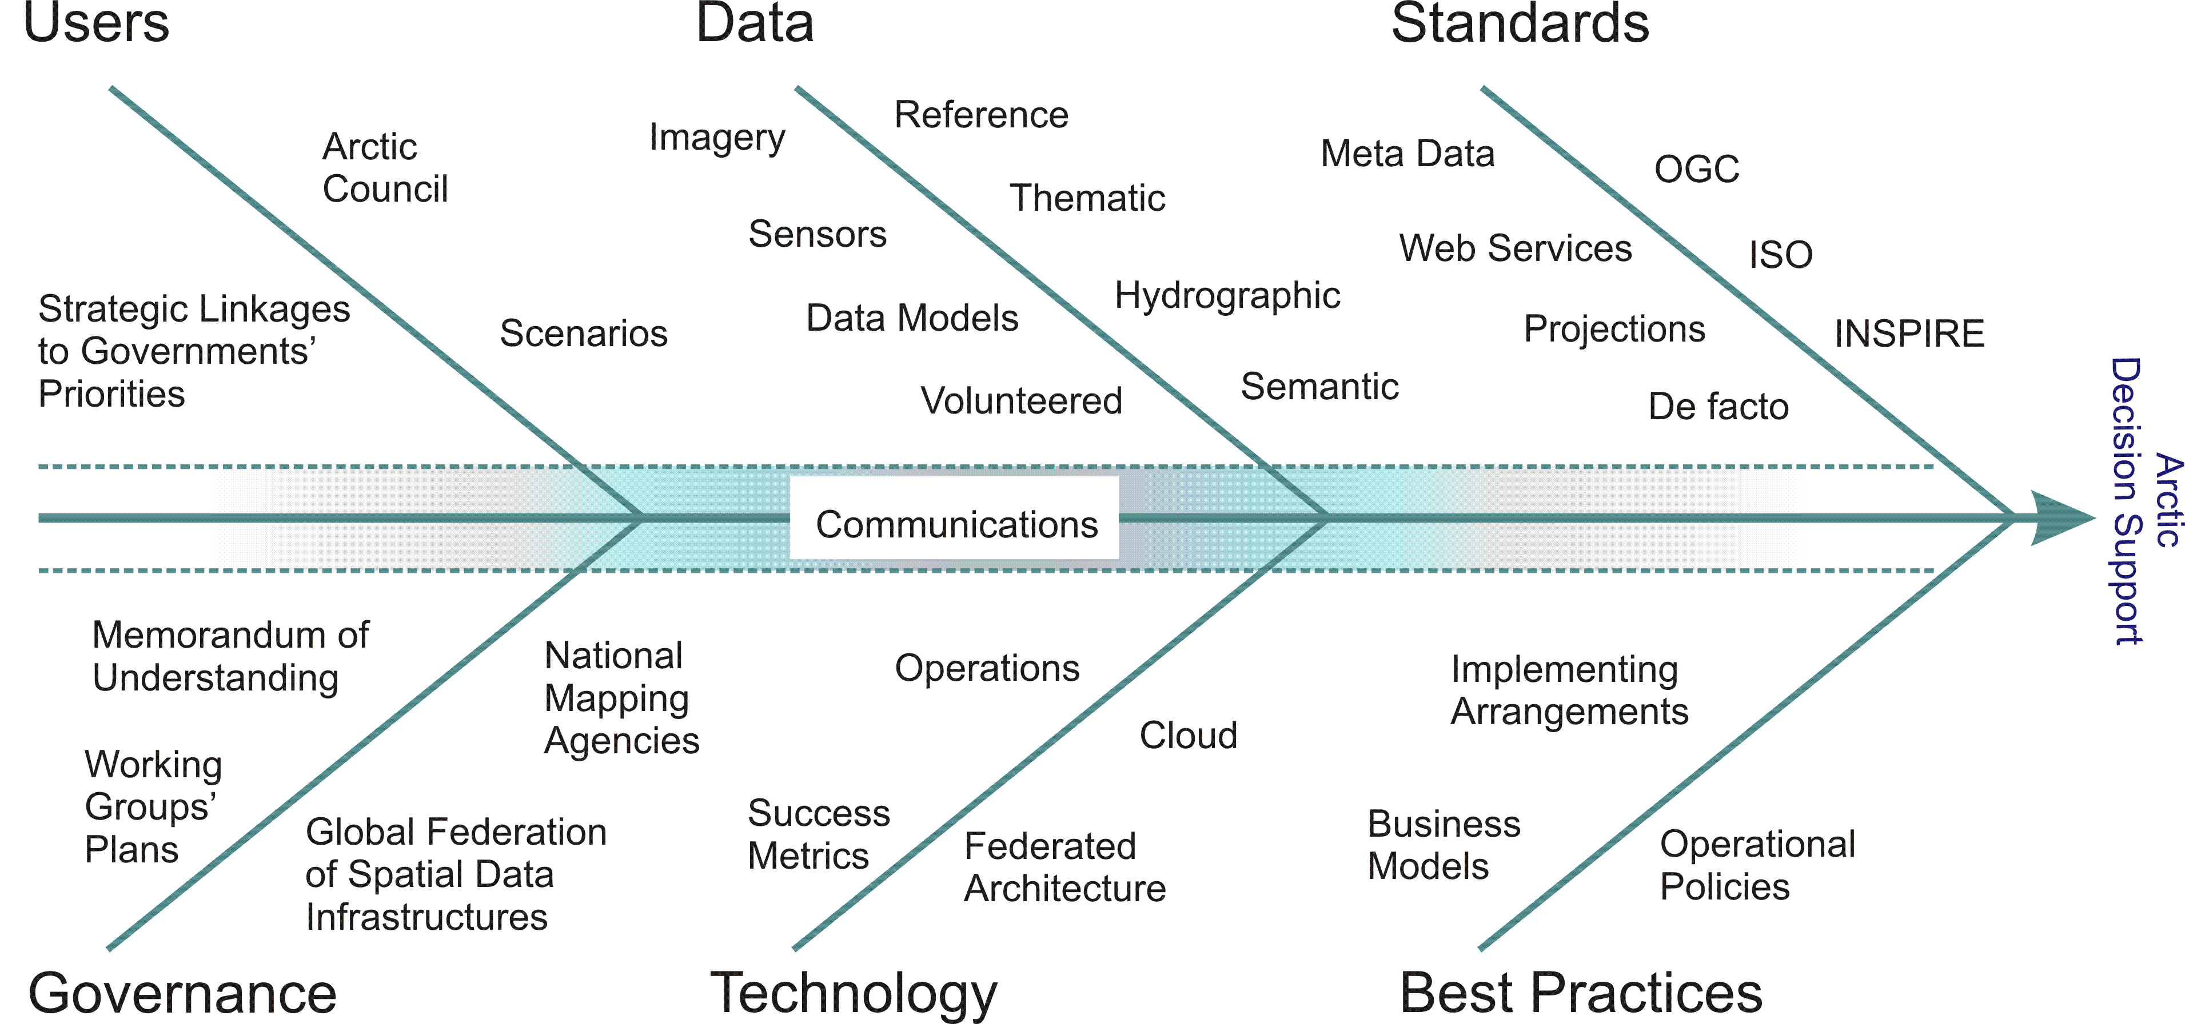

Figure 1. The Arctic SDI Reference Model defines categories that provide high level scoping for potential Arctic SDI components, thus guiding the priorities of the strategy.

# Arctic SDI Strategy, 2015-2020

## Technical Vision

Spatial Data Infrastructures are based on adoption of common technical standards and protocols that enable data from numerous sources to be discovered, accessed and combined. The focus of the first phase of Arctic SDI had two principal components. The first was to stitch together reference data from the participant National Mapping Agencies and make them available through standardized services. The second was a geoportal including a web map viewer and metadata catalogue, built on open standards with descriptions of data and data services.

By voluntarily investing in the establishment of the Arctic SDI, the National Mapping Agencies have demonstrated their willingness, ability and commitment to the future of the Arctic SDI. By 2020, the Arctic SDI will expand to include a host of specifications to enable access to and distribution of other significant geospatial data in the Arctic, data provided by both the participant National Mapping Agencies as well as other providers. The business requirements of users and stakeholders will drive the selection of which technical enhancements will be adopted in the future. Similarly, these requirements will guide the evolution of reference data and operational policies.

## Objectives and Anticipated Outcomes

The table below lists six strategic objectives that have been identified as primary to development of the Arctic SDI. Each strategic objective is detailed as a separate item in the *Arctic SDI Roadmap Document* and *Arctic SDI Implementation Plan*.

In order to have a constructive dialogue with users and stakeholders, it will be necessary for the National Mapping Agencies to further define their roles and responsibilities in the Arctic SDI (Objective 5). This will enable the National Mapping Agencies more clearly to communicate what the Arctic SDI, as an “MOU-consortium,” plans to offer users and stakeholders over time in the way of reference and thematic datasets (Objectives 2 and 3). It also enables the National Mapping Agencies to convey and manage users’ and stakeholders’ expectations, and to understand the kind of demands, contributions and commitment expected from the various users and stakeholders participating in the Arctic SDI (Objective 1).

It is also important for the Arctic SDI to communicate how users can benefit from robust information management policies that are based on SDI principles of open standards, operational policies and a suite of technical components (Objectives 5 and 6). Based on international standards, the Arctic SDI has produced and maintains an Arctic reference map and is working with partners to facilitate access to and distribution of thematic datasets, including identifying which immediate user needs they meet (Objectives 1, 2 and 3). This will enable a constructive dialogue identifying the gaps between the services currently available and basic user needs as well as their need for access to and distribution of thematic data (Objectives 1, 2, 3 and 4).

The Arctic SDI is a long-term investment with ongoing improvements and enhancements. The Arctic SDI Strategy 2015–2020 is the first step to engage the stakeholders with focus on the Arctic Council activities and identify user needs in terms of geospatial reference data, tools, services, and applications (Objective 1), promote Arctic SDI policies and guidelines for reference and thematic geospatial data (Objectives 2 and 3); and to assess the organization, standards, and governance of this endeavor (Objective 5). It is important for the Arctic SDI to remain committed to pursuing Open Data standards, emerging technologies and industry best practices to remain relevant and interoperable (Objective 4).

This effort requires committed partners within the Arctic Council and demands a realistic prioritization, efficient communication and relies on effective use of existing work in the field of spatial data infrastructures. The strategy process also demands the firm determination from the National Mapping Agencies to cooperate and engage meaningfully for a long period.

| **Objective** | **Objective Description** | **Primary Arctic SDI Working Group** |
| --- | --- | --- |
| Objective 1 | User and Stakeholder Needs and Requirements | Strategy Working Group |
| Objective 2 | Reference Datasets | Technical Working Group |
| Objective 3 | Thematic Datasets | Technical Working Group |
| Objective 4 | Data and Technical Interoperability | Technical Working Group |
| Objective 5 | Spatial Operational Policies | Operational Policies Working Group |
| Objective 6 | Communications | Communication Working Group |

Table 1. Arctic SDI Strategic Plan 2015-2020 objectives including the primary Arctic SDI Working group responsible for implementing the actions described in the Arctic SDI Strategic Plan Implementation Plan.

# Acronym List

|  |  |
| --- | --- |
| CAFF | Conservation of Arctic Flora and Fauna |
| CGDI | Canadian Geospatial Data Infrastructure |
| ELF | European Location Framework |
| GEOSS | Global Earth Observation System of Systems |
| INSPIRE | Infrastructure for Spatial Information in Europe |
| ISO | International Organization for Standardization |
| MOU | Memorandum Of Understanding |
| NMA | National Mapping Agencies |
| NSDI | National Spatial Data Infrastructure (USA) |
| OGC | Open Geospatial Consortium |
| SAO | Senior Arctic Official |
| SDI | Spatial Data Infrastructure |
| UNGGIM | United Nations Geospatial Information Management |

# Additional Resources

Arctic SDI Main Website: <http://arctic-sdi.org/>

Arctic SDI Geoportal: <http://159.162.102.133/oskari-map>

Arctic SDI Documentation: <http://arctic-sdi.org/index.php/strategic-documents/>

Arctic SDI Signed MOU: <http://arctic-sdi.org/wp-content/uploads/2014/07/Appendix1_Signed-ALL-Lang-MOU_5-29-14.pdf>

Arctic Council Main Website: <http://www.arctic-council.org/index.php/en/>