Arctic SDI Working Group on Strategy

June 2015

ARCTIC SPATIAL DATA INFRASTRUCTURE STRATEGIC PLAN

2015-2020



Roadmap

**Table of Contents**

Roadmap Overview 2

Arctic SDI Strategy Abstract 2

Complex Workflows Diagram 4

Objective Actions Tables 5

Objective 1. User and Stakeholder Needs and Requirements 6

Objective 2. Reference Data 7

Objective 3. Thematic Data 8

Objective 4. Data and Technical Interoperability 9

Objective 5. Spatial Operational Policies 10

Objective 6. Communication 11

Reference: Arctic SDI Organizational Structure Diagram 12

# Roadmap Overview

This *Arctic SDI Strategic Plan 2015-2020 Roadmap* addresses the need to have a high-level abstract of the Arctic SDI 2015-2020 strategy, describe the complex and interrelated workflows between strategic objectives, and clearly and concisely articulate the cross-cutting actions of the strategic objectives outlined in the *Arctic SDI Strategic Plan 2015-2020* and *Arctic SDI Strategic Plan 2015-2020 Implementation Plan*, including noting the lead, coordinating and supporting Working Groups and participant National Mapping Agencies for the actions under each objective.

# Arctic SDI Strategy Abstract

The six objectives listed in the table below are introduced in the *Arctic SDI Strategic Plan 2015-2020* and detailed in the *Arctic SDI Strategic Plan 2015-2020 Implementation Plan*. These objectives highlight the most important work the Arctic SDI will undertake in the coming years from 2015 to 2020. These objectives will be implemented within Arctic SDI Working Groups, and the specific tasks for implementing these objectives will be specified in the *Arctic SDI Working Group Activity Plans*, to be written yearly by each of the Working Groups and coordinated across the Working Groups by Working Group Leads in accordance with the Arctic SDI 2015-2020 strategy.

| **Objective** | **Objective Description** | **Primary Arctic SDI Working Group** |
| --- | --- | --- |
| Objective 1 | Address Needs of Arctic Council and Other Users | Strategy Working Group |
| Objective 2 | Provide Reference Datasets | Technical Working Group |
| Objective 3 | Facilitate Access to Thematic Datasets | Technical Working Group |
| Objective 4 | Data and Technical Interoperability | Technical Working Group |
| Objective 5 | Spatial Operational Policies | Operational Policies Working Group |
| Objective 6 | Communications | Communication Working Group |

Below is an abstracted diagram of the major work to be undertaken by the Arctic SDI from 2015-2020 (*Figure 1*). It gives a generalized view of the primary initiatives, from those taking place in 2015 including the creation of the Arctic SDI strategy and strategic plan documents, to outreach with Arctic Council groups and integration of their data over the following years, out to the evaluation of the Arctic SDI through key performance indicators and the creation of a subsequent strategic plan in 2020.

Figure 1. Arctic SDI 2015-2020 strategy diagram

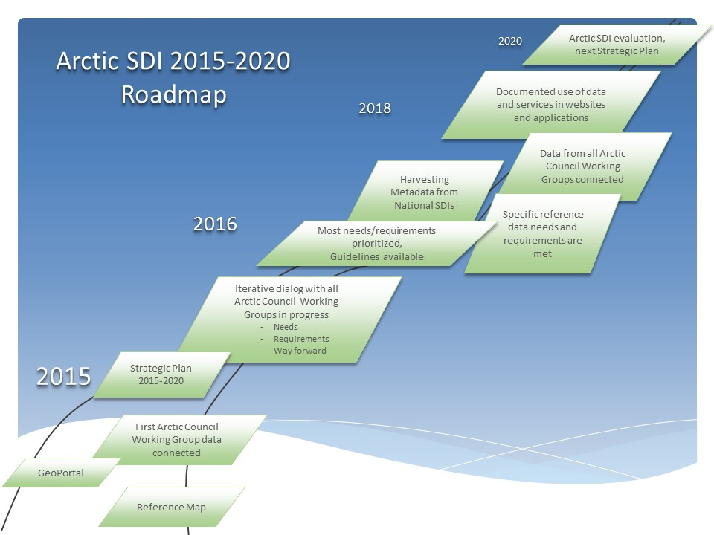

# Complex Workflows Diagram

Many actions of the Arctic SDI Working Groups are self-contained within the Working Groups. However, a series of objective actions are interrelated and cross-cut several Working Groups. The relationships between them have been diagrammed below.

The workflow below describes how information regarding user and stakeholder needs and requirements will flow between the objectives and through the Working Groups. The first series of boxes related to Objective 1 describe a set of questions being developed to guide conversations with user groups and stakeholders regarding their needs and requirements, coordination by several Working Groups on outreaching separately to Arctic Council Working Groups and additional users and stakeholders, and the documentation and prioritization of the information gathered. These needs and requirements will then be communicated to the appropriate Working Groups to implement actions in Objectives 2, 3, 4, 5 and 6. There are several feedback loops in the process to ensure quality improvement and internal communication. More details on these objectives can be found in the Objective Actions Tables section below and the *Arctic SDI Strategic Plan 2015-2020 Implementation Plan*.

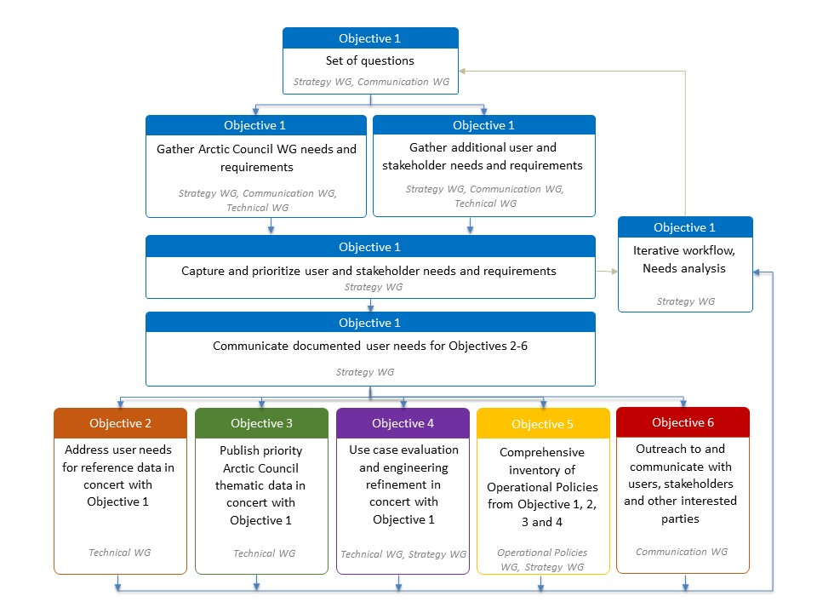

Figure 2. User and Stakeholder Needs and Requirements Workflow

# Objective Actions Tables

To facilitate a high-level view of the actions undertaken in the six strategic objectives, six tables containing detailed information about the objectives are provided below. Each table contains details regarding the nature of the actions for the objective, a general schedule, a list of lead and supporting Arctic SDI Working Groups, and which countries are participating on specific actions including in what capacity they are planning to participate. The table is meant to be a quick way to view information about each objective, its actions and the level of engagement of each participant National Mapping Agency.

Descriptions for the table headings are as follows:

**Actions:** A listing of the actions under a given objective.

**Years:** The shading in the boxes under the years represent the approximate timeline of when the actions will be scheduled.

**Lead Working Group:** The *Lead Working Group* is the primary Arctic SDI Working Group coordinating the action.

**Supporting Working Group:** The *Supporting Working Group* includes any Arctic SDI Working Groups assisting with the implementation of the action.

**Primary Country:** The *Primary Country* column indicates the National Mapping Agency country which has taken a lead or coordination role for the action (type of role described in Country Columns below). It may be a different country than the Working Group Lead.

**Participating/Supporting Countries:** The *Participating/Supporting Countries* column indicates National Mapping Agency countries which are assisting on the specific action either because of their participation on a Working Group or because they specifically volunteered to assist with an action.

**Country Columns**: Below is a description of the symbols used in the columns listing the three letter county codes

|  |  |
| --- | --- |
| L | National Mapping Agency listed as **Primary Country is leading** the specific action |
| C | National Mapping Agency listed as **Primary Country is coordinating** the action as a part of Working Group Lead responsibilities rather than leading the specific action |
|  | Participating/Supporting Country is assisting with the action |

## Objective 1. User and Stakeholder Needs and Requirements

|  |  |  |  |  |  |  |  |  |  |  |  |  |  |  |  |  |  |  |
| --- | --- | --- | --- | --- | --- | --- | --- | --- | --- | --- | --- | --- | --- | --- | --- | --- | --- | --- |
|  | Actions | 2015 | 2016 | 2017 | 2018 | 2019 | 2020 | Lead Working Group - Supporting Working Group | Primary Country | Participating /  Supporting Countries | CAN | DEN | FIN | ICE | NOR | RUS | SWE | USA |
| 1.1 | Develop a set of questions to be used to document user and stakeholder needs and requirements |  |  |  |  |  |  | Strategy / Communication | USA / NOR | All |  |  |  |  | C |  |  | C |
| 1.2 | Gather needs and requirements from Arctic Council Working Groups |  |  |  |  |  |  | Strategy / Communication - Technical | USA / NOR | All |  |  |  |  | C |  |  | C |
| 1.3 | Gather needs and requirements from additional users and stakeholders |  |  |  |  |  |  | Strategy / Communication - Technical | USA / NOR | All |  |  |  |  | C |  |  | C |
| 1.4 | Capture user and stakeholder needs and requirements, including into a user needs matrix |  |  |  |  |  |  | Strategy / Communication | USA / NOR | All |  |  |  |  | C |  |  | C |
| 1.5 | Analyze and prioritize user requirements for Objectives 2, 3, 4, 5 and 6 implementation using an iterative workflow |  |  |  |  |  |  | Strategy / Communication | USA / NOR | All |  |  |  |  | C |  |  | C |
| 1.6 | Communicate documented user needs to other Arctic SDI Working Groups for Objectives 2, 3, 4, 5 and 6 |  |  |  |  |  |  | Strategy / Communication | USA / NOR | All |  |  |  |  | C |  |  | C |

## Objective 2. Reference Data

|  |  |  |  |  |  |  |  |  |  |  |  |  |  |  |  |  |  |  |
| --- | --- | --- | --- | --- | --- | --- | --- | --- | --- | --- | --- | --- | --- | --- | --- | --- | --- | --- |
|  | Actions | 2015 | 2016 | 2017 | 2018 | 2019 | 2020 | Lead Working Group - Supporting Working Group | Primary Country | Participating / Supporting Countries | CAN | DEN | FIN | ICE | NOR | RUS | SWE | USA |
| 2.1 | Address user needs for reference data |  |  |  |  |  |  | Technical | SWE | All |  |  |  |  |  |  | C |  |
| 2.2 | Update, maintain and improve the Arctic SDI reference dataset tiled Web Map Service (WMTS) |  |  |  |  |  |  | Cloud and Cascading Service - Technical, Geoportal | NOR | All |  |  |  |  | L |  |  |  |
| 2.3 | Harvest or provide access to reference dataset metadata in catalogue |  |  |  |  |  |  | Technical | SWE | CAN |  |  |  |  |  |  | L |  |
| 2.4 | Review and, as needed, refine the Arctic SDI list of reference datasets |  |  |  |  |  |  | Strategy | USA | All |  |  |  |  |  |  |  | C |
| 2.5 | Work with reference data providers to determine efficient means to interact with their reference datasets and metadata |  |  |  |  |  |  | Technical | SWE | All |  |  |  |  |  |  | C |  |
| 2.6 | Develop enhanced access to reference data (e.g. place names) |  |  |  |  |  |  | Technical | SWE | All |  |  |  |  |  |  | C |  |

## Objective 3. Thematic Data

|  |  |  |  |  |  |  |  |  |  |  |  |  |  |  |  |  |  |  |
| --- | --- | --- | --- | --- | --- | --- | --- | --- | --- | --- | --- | --- | --- | --- | --- | --- | --- | --- |
|  | Actions | 2015 | 2016 | 2017 | 2018 | 2019 | 2020 | Lead Working Group - Supporting Working Group | Primary Country | Participating / Supporting Countries | CAN | DEN | FIN | ICE | NOR | RUS | SWE | USA |
| 3.1 | Conduct a survey of datasets available from the Arctic area through Web services |  |  |  |  |  |  | Technical | CAN | ICE, SWE | L |  |  |  |  |  |  |  |
| 3.2 | Perform integration pilots using various software to demonstrate the breadth of thematic data available through services |  |  |  |  |  |  | Technical | CAN / ICE | SWE | L |  |  | L |  |  |  |  |
| 3.3 | Provide advisory role to with Arctic Council WGs (e.g. CAFF) and additional stakeholders to publish data via open data standards |  |  |  |  |  |  | Technical - Communication | SWE | All |  |  |  |  |  |  | C |  |
| 3.4 | Create and maintain links in the metadata catalogue to thematic datasets |  |  |  |  |  |  | Technical | SWE |  |  |  |  |  |  |  | L |  |
| 3.5 | Make thematic data layers accessible in the Geoportal Web Map Viewer |  |  |  |  |  |  | Geoportal - Technical | FIN | SWE |  |  | L |  |  |  |  |  |
| 3.6 | Assess the feasibility to include additional stakeholder thematic datasets (e.g. Int. Hydrographic Org (IHO) data) |  |  |  |  |  |  | Strategy / Technical | USA / SWE | All |  |  |  |  |  |  | C | C |

## Objective 4. Data and Technical Interoperability

|  |  |  |  |  |  |  |  |  |  |  |  |  |  |  |  |  |  |  |
| --- | --- | --- | --- | --- | --- | --- | --- | --- | --- | --- | --- | --- | --- | --- | --- | --- | --- | --- |
|  | Actions | 2015 | 2016 | 2017 | 2018 | 2019 | 2020 | Lead Working Group - Supporting Working Group | Primary Country | Participating / Supporting Countries | CAN | DEN | FIN | ICE | NOR | RUS | SWE | USA |
| 4.1 | Use case evaluation and engineering refinement |  |  |  |  |  |  | Technical - Strategy | SWE | All |  |  |  |  |  |  | C |  |
| 4.2 | Explore and employ new geoportal and showcase technologies and standards as needed |  |  |  |  |  |  | Technical - Geoportal, Cloud & Cascading Service | SWE | FIN, NOR |  |  |  |  |  |  | C |  |
| 4.3 | Support stakeholder application development, specifically Arctic Council Working Groups |  |  |  |  |  |  | Technical | SWE | All |  |  |  |  |  |  | C |  |
| 4.4 | Identify and address technology gaps |  |  |  |  |  |  | Technical | SWE | All |  |  |  |  |  |  | C |  |
| 4.5 | Undertake an Open Geospatial Consortium pilot and video |  |  |  |  |  |  | Technical | CAN / USA |  | L |  |  |  |  |  |  | L |
| 4.6 | Address user needs regarding standardized cartographic representations (e.g. SLD and Context Document Library) |  |  |  |  |  |  | Technical | ICE | CAN, FIN |  |  |  | L |  |  |  |  |

## Objective 5. Spatial Operational Policies

|  |  |  |  |  |  |  |  |  |  |  |  |  |  |  |  |  |  |  |
| --- | --- | --- | --- | --- | --- | --- | --- | --- | --- | --- | --- | --- | --- | --- | --- | --- | --- | --- |
|  | Actions | 2015 | 2016 | 2017 | 2018 | 2019 | 2020 | Lead Working Group - Supporting Working Group | Primary Country | Participating / Supporting Countries | CAN | DEN | FIN | ICE | NOR | RUS | SWE | USA |
| 5.1 | Develop a comprehensive inventory of potential Operational Policies based on the analysis and decisions deriving from Objective 1, 2, 3 and 4 |  |  |  |  |  |  | Operational Policies - Strategy | DEN | CAN, USA |  | C |  |  |  |  |  |  |
| 5.2 | Evaluate and analyze the Arctic Council Working Group CAFF/Arctic SDI experience to identify needs for guidelines for Arctic Council Working Groups |  |  |  |  |  |  | Operational Policies | DEN | CAN, ICE, USA |  | L |  |  |  |  |  |  |
| 5.3 | Develop Operational Policies based on Arctic SDI Board direction |  |  |  |  |  |  | Operational Policies | DEN | CAN, USA |  | C |  |  |  |  |  |  |
| 5.4 | Create an Arctic SDI manual containing Spatial Operational Policies including technical guidelines |  |  |  |  |  |  | Operational Policies - Technical, Communication | DEN | All |  | C |  |  |  |  |  |  |

## Objective 6. Communication

* The asterisk (*) in Action 6.8 denotes that the leadership role in the Secretariat will change from the United States to Finland and then to Iceland over time period covered by the Arctic SDI Strategic Plan 2015-2020.

|  |  |  |  |  |  |  |  |  |  |  |  |  |  |  |  |  |  |  |
| --- | --- | --- | --- | --- | --- | --- | --- | --- | --- | --- | --- | --- | --- | --- | --- | --- | --- | --- |
|  | Actions | 2015 | 2016 | 2017 | 2018 | 2019 | 2020 | Lead Working Group - Supporting Working Group | Primary Country | Participating / Supporting Countries | CAN | DEN | FIN | ICE | NOR | RUS | SWE | USA |
| 6.1 | Create an external general presentation to be used in multiple settings |  |  |  |  |  |  | Communication | NOR | CAN, DEN, ICE, SWE, USA |  |  |  |  | L |  |  |  |
| 6.2 | Create external technical presentation to be used in multiple settings |  |  |  |  |  |  | Communication | NOR | CAN, DEN, ICE, SWE, USA |  |  |  |  | L |  |  |  |
| 6.3 | Create an Arctic SDI fact sheet handout |  |  |  |  |  |  | Communication | NOR | CAN, DEN, ICE, SWE, USA |  |  |  |  | L |  |  |  |
| 6.4 | Advise and educate data providers on requirements and standards for data acquisition and delivery |  |  |  |  |  |  | Technical | SWE | All |  |  |  |  |  |  | C |  |
| 6.5 | Coordinate outreach and act as point of contact for stakeholders, users and the public in general |  |  |  |  |  |  | Communication | NOR | CAN, DEN, ICE, SWE, USA |  |  |  |  | C |  |  |  |
| 6.6 | Coordinate development of information and key messages |  |  |  |  |  |  | Communication | NOR | CAN, DEN, ICE, SWE, USA |  |  |  |  | C |  |  |  |
| 6.7 | Coordinate information  across NCPs, WG Leads and Arctic SDI Working Groups |  |  |  |  |  |  | Communication | NOR | CAN, DEN, ICE, SWE, USA |  |  |  |  | C |  |  |  |
| 6.8 | Maintain the Calendar of Events |  |  |  |  |  |  | Secretariat - Communication, Strategy | USA / FIN / ICE | All |  |  | L* | L* |  |  |  | L* |
| 6.9 | Identify and coordinate representation in international forums |  |  |  |  |  |  | Communication | NOR | CAN, DEN, ICE, SWE, USA |  |  |  |  | C |  |  |  |
| 6.10 | Operate, update, edit and maintain the Arctic SDI official Website |  |  |  |  |  |  | Communication | NOR | CAN, DEN, ICE, SWE, USA |  |  |  |  | C |  |  |  |

# Reference: Arctic SDI Organizational Structure Diagram

The Arctic SDI Organizational Structure Diagram below is taken from the *Arctic SDI Framework Document*.

