The Arctic Spatial Data Infrastructure

**Framework Document**

Draft Version 1.13

May 2015

www. arctic-sdi.org

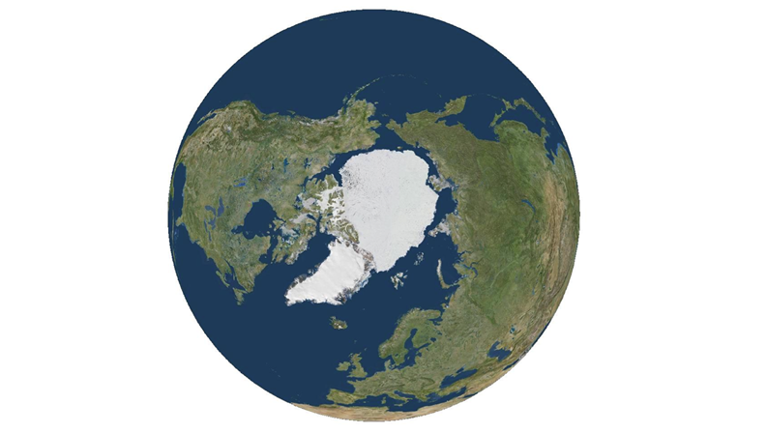

Arctic SDI National Contact Points



# Document History & Version Control

|  |  |  |
| --- | --- | --- |
| **Document Version Number** | **Date Approved** | **Brief Description of Change** |
| 1.0 | February 2014 | ***Arctic SDI Plan Draft/Version 1.0, 31 January* 2014** is approved with comments by the Arctic SDI Board. The plan is considered to be more of a framework document. |
| 1.00_20141111 | November 2014 | ***Arctic-SDI-Framework-Document_V1.00_20141111***is approved by the Arctic SDI Board with comments: The document will provide historical context for the Arctic SDI with technical details, background, strategy and governance information through 2014. Updated strategy and governance information should be taken out and presented in separate documents. |
| 1.13 | June 2014 | ***Arctic-SDI-Framework-Document_Draft_V1.13***, ispresented to the Arctic SDI Board for June 2014 Board Meeting: **Upon approval the Document version will be updated to Final Version 2.0 and this row will be removed** as version 1.13 has not been published to the Arctic SDI website. |
| 2.0 | June 2014 | ***Arctic-SDI-Framework-Document_V2.0 Approved by the Arctic SDI Board at June 2014 Board Meeting.*** The Arctic SDI Framework document version 2.0 is a foundational document meant to provide Arctic SDI stakeholders and users the historical background and details necessary to understand how and why the Arctic SDI Geoportal is being developed. |

# Table of Contents

Table of Contents 4

1. Introduction 6

1.1. Arctic SDI vision and project aim 7

1.2. Strategy for developing Arctic SDI cooperation and services 7

1.3. The reasons behind the Arctic SDI 8

1.4. Short Background history 9

2. Arctic SDI – Data, Infrastructure and Technology 10

2.1. Background 10

2.2. pIntroduction 10

2.3. Arctic Spatial Data Infrastructure 12

2.4. General Use Cases 12

2.4.1. Provide & Manage Geo-resources 13

2.4.2. Create Metadata 14

2.4.3. Publish Metadata 14

2.4.4. Harvest Metadata 15

2.4.5. Search & Find 15

2.4.6. Evaluate Geo-resources 15

2.4.7. Consume Geo-resources 15

2.4.8. Download Geo-resources 15

2.4.9. Combine Geo-resources 15

2.4.10. Analyze Geo-resources 16

2.4.11. Process Geodata 16

2.4.12. Manage Policies and Rules 16

2.4.13. Pay 16

2.5. Data, technology and standards 16

2.6. Deployment 18

3. Arctic SDI Strategic context and Reference model 19

3.1. Arctic SDI strategic context 19

3.2. Arctic SDI Reference Model 20

3.2.1. Reference Model 20

3.2.2. Arctic SDI Reference Model Categories and Glossary 21

3.2.3. Data 22

3.2.4. Technology 22

3.2.5. Standards 23

3.2.6. Best Practices 23

3.2.7. Communications 23

4. Arctic SDI - Operational Policies 23

4.1. What are geospatial operational policies? 23

4.2. Importance of geospatial operational policies 24

4.3. Operational Policy Documents: 24

5. Arctic SDI - Governance, Organization, Activities and Operations 25

5.1. Arctic Council and the Senior Arctic Officials 25

5.2. The Arctic SDI Board 25

5.3. National Contact Point 25

5.4. Arctic SDI Working Groups and Activities through 2014 26

5.4.1. Secretariat for the Chair of the Board and Chair of the National Contact Point 26

5.4.2. Arctic SDI Geo Portal for WMS Map Service and thematic data 26

5.4.3. Technical Working Group 26

5.4.4. CAFF Thematic Data 26

5.4.5. Initial Development of Arctic SDI Strategy 2015 - 2020 26

5.4.6. Development of legal/administrative operational Policies 27

5.4.7. Significant Communication, Documentation, Development of Arctic SDI Website 27

6. Current updated documents 27

# Introduction

The *Arctic Spatial Data Infrastructure* – Arctic SDI - is based on formal cooperation between the 8 participating National Mapping Agencies of Canada, Finland, Iceland, Norway, Russia, Sweden, USA and Denmark (including the administrations of the Faroe Islands Home Rule and the Greenland Self-Government).

The aim of the Arctic SDI is to provide politicians, governments, policy makers, scientists, private enterprises and citizens in the Arctic with access to geographically related Arctic data, digital maps and tools to facilitate monitoring and decision-making.

The main purpose of this document – ***the Arctic SDI Framework Document*** - is to introduce the concepts behind a well-functioning Arctic SDI, provide the background vision and strategy, and the status of the cooperation and governance from 2008 through 2014. [1]

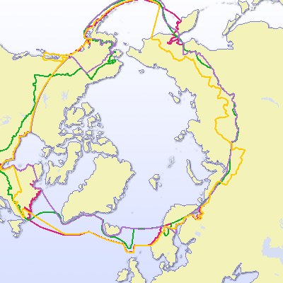

*Figure 1*. The Arctic SDI is to cover the Arctic regions of the involved participating countries, as defined by the countries themselves. It can be identified and defined in many different ways depending on the parameters used (tree line, climate, Arctic Circle, temperature, flora, fauna, jurisdiction). The examples above are used by some of the Working Groups of the Arctic Council. (© University of the Arctic International Secretariat 2009 in the UArctic Atlas ([www.uarctic.org](http://www.uarctic.org))).

## Arctic SDI vision and project aim

The Arctic SDI **vision** was formulated in 2011:

***“An Arctic SDI – based on sustainable co-operation between mandated national mapping organisations – will provide for access to spatially related reliable information over the Arctic to facilitate monitoring and decision making”.***

**The aim** of the Arctic SDI is to jointly develop and administer an Arctic SDI over several phases. The initial phase includes the components noted below.

* Reference data as Web Map Services to establish a common image and vector base for the Arctic context at nominally 1:250,000-scale
* A searchable metadata-catalogue of map-able data resources (base maps and other geo-referenced thematic data and services)
* A Web portal as primary user interface to search the catalogue and enable visual analysis of multiple base maps, thematic maps, and geographic data
* Supporting tools, standards, operational policies and best practices.

Subsequent phases are expected to bring greater linkages with international and national agencies, data access mechanisms, inclusion of earth observation imagery and other types of data, and emerging web services based on international standards.

## Strategy for developing Arctic SDI cooperation and services

Since the vision of the Arctic SDI was formulated in 2011 the cooperation between the 8 participating National Mapping Agencies has been formalized by the signing of a Memorandum of Understanding.[2] In parallel global and regional cooperation is developing under the umbrella of the United Nations, the Arctic Council and other forums.

Building an Arctic Spatial Data Infrastructure requires an ongoing development of the common understanding of the concept and a thorough understanding of the users, their needs and their position in the overall picture of relevant Arctic SDI stakeholders. This understanding will allow the Arctic SDI to 1) set the strategic direction for focus on prioritized development of datasets for inclusion in the Geoportal via direct access to data layers or access via the Metadata Catalog, and 2) identify engagement opportunities to educate users and stakeholders, and 3) define the role of the thematic data providers. It also requires an ongoing development of the targeted infrastructure, technical opportunities and data sharing principles. The Arctic SDI cooperation also needs to look into its role in the Arctic Council cooperation and other existing pan Arctic cooperation’s as well as develop models for funding future activities.

In 2014 the Arctic SDI Board decided to document a strategic plan for the period 2015 – 2020 with objectives, a roadmap and implementation plans that will be carried out the by the Arctic SDI Working Groups.[3]

## The reasons behind the Arctic SDI

There is a need for an Arctic SDI, which provides for the development of the necessary standards and framework to promote and encourage more **efficient integration of, and access to, arctic related datasets**. It would allow for more robust management and manipulation of data for research, planning, policy-making and operational purposes and contribute to more informed policy and adaptation strategies in the region.

A well-functioning exchange of spatially referenced data is an essential tool for successful conservation of the natural environment while allowing for economic development, at a circumpolar or regional circumpolar scale, especially for cross boundary activities. Furthermore, this SDI will foster integrated planning when developing infrastructure, environmental and economic activities and planning search and rescue operations.

Improved spatially referenced data handling includes the potential to provide tools that can clarify and explain **indigenous peoples** land use practices and thus improve presentation, communication and better integration of these issues.

The activities of the **Arctic Council and its working groups** require effective and coordinated data services. Sharing of geographic information between the circumpolar countries and efficient use of that information for presenting thematic data can prevent duplication of work and increase output and efficiency. Thus the first web service of The Arctic SDI is the harmonized map data covering the entire Arctic Region.

When operational, the Arctic SDI is expected to result in the following **benefits**:

* Users, such as the Arctic Council, the Arctic Council Working Groups, the Arctic research community, government institutions, Indigenous Peoples, NGO’s, private enterprises and individual citizens will have easy access to relevant and updated geographic and thematic information covering the entire circumpolar region – data that can be used for many purposes.
* Improved Arctic Council information management practices through the adoption of commonly accepted Spatial Data Infrastructure operational policies and technical standards
* A distributed regional Arctic infrastructure consisting of interlinked servers with high quality national geographic data will be located in each of the eight arctic countries.
* Possibilities will be created for users to connect to web map services and simultaneously access, view, and explore several types of geographic and thematic information concerning the Arctic Region.
* Daily use of the Arctic SDIs web map and other services by international and national authorities, schools and universities in the Arctic and elsewhere.
* Use of the Arctic SDI services by private enterprises when planning and developing business opportunities
* Use of the Arctic SDI by both public and private international projects and cross border cooperative efforts.

## Short Background history

The first cross bordering geodata cooperation in the Arctic was the GIT Barents launched in the 1990’s by the participating national mapping agencies in Finland, Norway, Russia and Sweden. The purpose was to increase the ability to use spatial information within the Barents Region by producing a common geographic database covering the entire region and to make data available to users by establishing an Internet-based infrastructure aligned with the principles of the EU INSPIRE Directive (EU Infrastructure for Spatial Information). The GIT Barents Service ([www.gitbarents.com](http://www.gitbarents.com)) facilitates cross-border cooperation, primarily in the fields of environmental planning, monitoring and protection, land use, physical planning, transports, natural resource management and development of cross-border tourism.

From 2007 a Spatial Data Infrastructure covering the entire Arctic was frequently discussed at conferences and in the context of the Arctic Council activities. At the *GeoNorth I* conference in Yellowknife, Canada in August 2007 the *Yellowknife Declaration* took form exploring the Arctic SDI. Following a request from the participating National Mapping Agencies from the Arctic countries, the Arctic Council gave its formal support to the Arctic SDI initiative at its Senior Arctic Officials meeting in November 2009.

In October 2011 the Arctic SDI was launched by representatives from all the 8 participating National Mapping Agencies of the Arctic countries and from the Arctic Council CAFF Working Group. A project management group with resources provided from Norway and Sweden has supported the Board, the Steering Committee and the Technical Working Groups. In February 2014 the Arctic SDI Board established the governance, organization and operation of the Arctic SDI as presented in this document.

# Arctic SDI – Data, Infrastructure and Technology

## Background

From a technical point of view the vision of the Arctic SDI is for the users to be able to easily access up-to-date spatial data from the National Mapping Agencies and from thematic data producers in the Arctic. The effort is to make this available with as little overhead as possible added to data and services. Data are published to a variety of web-based services. These services are based on international standards and leverage spatial data infrastructure methods and operational policies.

In order to succeed, it is necessary to establish an enterprise architecture and infrastructure model which considers questions concerning metadata, data models, use of technology, user requirements for download, data combining, data analyzing and processing, operational policies etc.

## Introduction

This chapter intends to describe Arctic SDI from a more technical point of view with the focus on the use cases and the system designed to support these.

The system in the Arctic SDI context is a range of components and activities that together constitute the response from the participating National Mapping Agencies in cooperation with the Arctic Council. The aim is to build an SDI, serving governments, scientists, businesses and citizens in the Arctic with geographically related data, digital maps and tools, for better planning and decision-making. The Arctic SDI must be interoperable with other SDIs using or delivering data for the Arctic region and also with UN-GGIM.

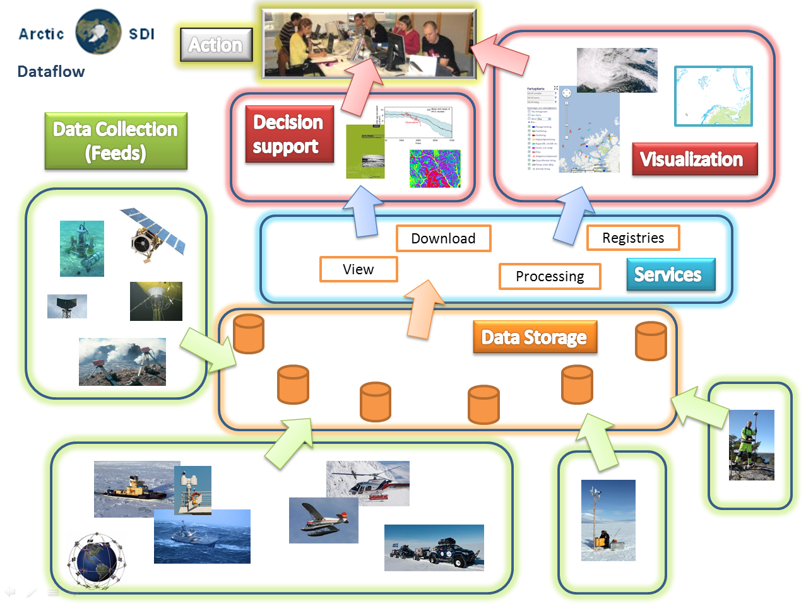

*Figure 2*. **Data flow in the Arctic SDI from Collection to Action**. This Arctic SDI architecture depicts data being made available through a number of services, with reference data being delivered from the participating Arctic Mapping Agencies own spatial data infrastructures and thematic information being delivered from the distributed data owners infrastructures*.*

The idea of the Arctic SDI technical architecture is for users and participants to easily access up-to-date spatial data from Arctic Mapping Agencies in the Arctic, from Arctic Council Working Groups and from other thematic data producers and providers in the Arctic. It should be done in such a way that as little overhead as possible is added by taking advantage of, and incorporating, existing data and services, but potentially incorporating controlled vocabulary to facilitate filtering from various metadata catalogues, or other methods to ensure efficient access to data. The goal is to make it possible to access reference data through a cartographically homogenous Pan-Arctic background map distributed as a Web Map Service but also to give access to all kind of location based data (raster, vector and time-series) from the entire Arctic region.

## Arctic Spatial Data Infrastructure

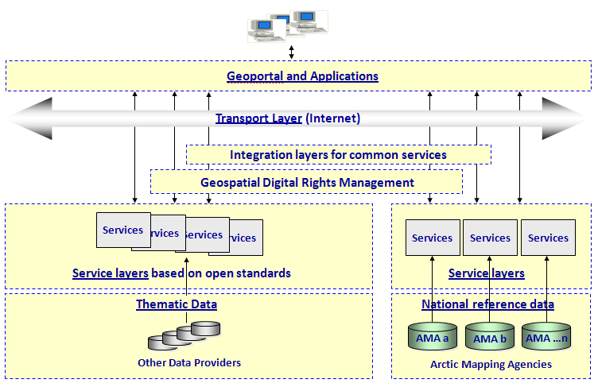 *Figure 3* – **Delivering Arctic Spatial Data from Multiple Sources.**  This Arctic SDI technical architecture depicts source data, housed and managed within federated environments, being delivered to users through a single infrastructure.

If there are special needs for users of the Arctic SDI, it may be necessary that common services are developed to support these requirements. E.g. a common digital background map is a key component in an SDI. Such a product, which supplies reference data updated in close to real time, is impossible for a single country to provide. Therefore, the initial focus when the Arctic SDI was established was to build this common Web Map Service. Other needs, such as the need for common authentication and authorization or tools for digital licensing (the Geospatial Digital Rights Management layer in Figure 3), will emerge and be documented and prioritized as the Arctic SDI takes on the strategic objective to thoroughly understand users and user needs.

The services from the participating SDIs’ as well as the common Arctic SDI services will serve as a platform or framework to build applications or dynamic webpages for specific identified needs and use cases in the Arctic.

## General Use Cases

As we have mentioned previously, the purpose of the infrastructure is to enable the different users and participant organizations, to consume up-to-date spatial information. Figure 3 shows these users and participants and the general use cases the Arctic SDI must be able to support in the future. The concept **use case** refers to how a user, or data provider, uses the system to achieve a particular goal. Below you will find sections describing each of the Use Cases found in Figure 3.

The participating National Mapping Agencies have taken a major responsibility in the work to establish Arctic SDI, but for the infrastructure to get its full potential requires engagement from other owners and managers of spatial data and information, but also from other stakeholders. The dashed boundary in the figure is pointing out the responsibilities of the mapping agencies. The use cases that are partially or completely outside of this border identify responsibilities of users of the Arctic SDI.

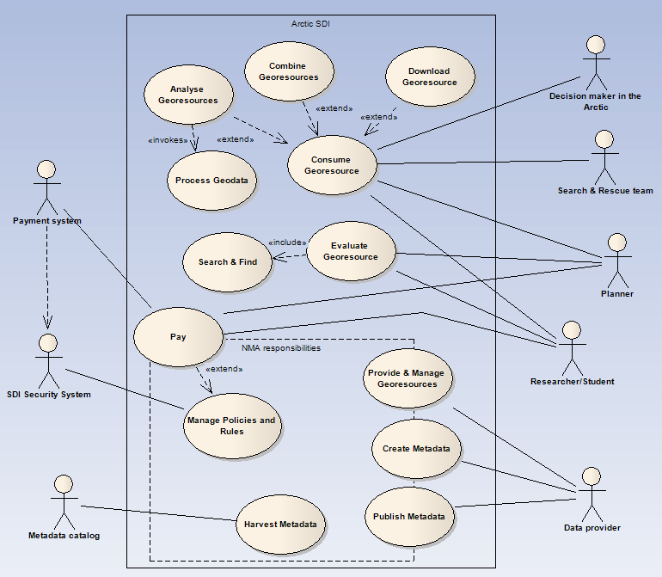

***Figure 4***. Use cases for user and participant organizations for successful delivery of Arctic SDI data

### Provide & Manage Geo-resources

Providing and managing spatial data in a standardized way is the very foundation for a useful spatial data infrastructure. The goal is to meet the needs for Arctic spatial data for users and the Arctic Mapping Agencies, but also other data owners need to distribute their data through standardized services. When the Arctic SDI is fully operational many different governmental and non-governmental bodies will be represented with data in the SDI.

Providing and managing spatial data in this context is not a simple task. For data to work seamlessly across the Arctic they need to be harmonized or at least formatted in a standardized way so as to ensure that they can be used or consumed in combination by any user of the Arctic SDI. For this to fully work, the Arctic Mapping Agencies need to harmonize their data models. The same applies to other data owners in order for data to be used and analyzed across borders. This being so large a task it was broken into sub-tasks:

1. Create a common, basic digital background map
2. Create a common data model that each Country can easily translate their output data into

The last step is a future vision where we will have harmonized vector based reference data over the entire Arctic. This journey may take many years, but the pursuit of this vision for the Arctic and other cross border areas is to standardize information in distributed databases so that it can be understood and used by different tools regardless of where the data resides.

### Create Metadata

As more and more data is added to the SDI, being able to search among all datasets and services becomes more and more important. For this purpose metadata, a set of data describing data and services, are created and managed by the data-owners. But for metadata to really work in a search engine they also need to be created in a uniformed way. To achieve this there is an important and non-trivial task of creating a harmonized format of the metadata in the SDI including the use of harmonized keywords, or controlled vocabulary, so they can work within the same context, spanning the Arctic.

### Publish Metadata

Once metadata has been created they need to be published to a catalogue so that they can be searched and found in standardized way. The publish use case handles the ability for users, as data providers, to store their metadata documents in the common metadata catalog and by doing so make it searchable in a search engine. The publishing process in this context can be realized in three ways, either by

1. creating metadata using specific metadata editors and then publish the information directly into the metadata catalog (using the Open Geospatial Consortium (OGC) Catalog Service for the Web Transaction (CSW-T) interface[4]), or
2. by uploading the metadata as an XML file, or
3. harvesting metadata from other metadata catalogs and publishing the metadata to the Arctic SDI metadata catalog.

The third method for publishing and managing the Arctic SDI metadata catalog is very important because it is based on the datasets and services provided through the SDIs of the participating national mapping agencies. Using a specific thesaurus, or controlled vocabulary for the Arctic SDI, keywords can be added to already existing metadata. The combination of the Arctic SDI thesaurus and the applied controlled vocabulary keywords can then be used when filtering the data in the harvest process from the national SDIs’ to Arctic SDI. All the relevant metadata for the Arctic region will in this way be searchable from one single point.

### Harvest Metadata

Supporting the Open Geospatial Consortium (OGC) Catalog Service for the Web (CSW) interface opens the possibility for other metadata catalogs to harvest the Arctic SDI metadata catalogs in the same way as described for the third method of publishing metadata described above.

### Search & Find

Allowing users to search among all metadata in the catalog for relevant geo-resources.is the first step in an evaluation process. When an interesting data resource is found the user can view the available resource with the Arctic SDI Geoportal preview tools.

### Evaluate Geo-resources

Next, the user can extract the metadata document for an interesting data resource and read the metadata and use other tools in the portal evaluate the resource to find out if it fits the user’s need.

### Consume Geo-resources

To consume or use geo-resources is probably the most basic of the all the general use cases. Here a user (decision maker, planner, etc.) is provided access to identified, relevant source data for use in applications, webpages or in other forms for their special needs.

### Download Geo-resources

Every now and then an actor needs to do more with data than just use it as a backdrop for their on-line activities. In this case it is necessary for the user to retrieve even the vector data either for usage offline or for doing analysis in his or her environment. In this case the actor needs to download data. This can be done by downloading predefined datasets or via download services for direct access to source data.

### Combine Geo-resources

Sometimes the user needs to combine spatial data from more than one provider. For example this could be combining a background map with an overlay of winds together with migratory birds. This could be accomplished by downloading the data and doing the overlay on a local computer, but in this context “combining geo-resources” is describing combining data “on the fly” using web services. The user simply defines what data to combine and the service then provides the result directly via the Geoportal or a GIS-client (e.g. QGIS).

### Analyze Geo-resources

Just like combining geo-resources, the user sometimes needs to do analysis on the provided spatial data. This can be done directly in the Geoportal, in another GIS-client or by downloading the data to a local computer.

### Process Geodata

Lastly a user might need to process data. This could be, for example, the necessity to transform data from one projection to another. In this case the user would send a request to a web processing service, the backend server would transform the dataset and return the result directly.

### Manage Policies and Rules

In many cases the data being shared is governed by rules and policies as to who can use them, under which restrictions and possible costs. To ensure that all data is handled correctly there is a need for ensuring access to the policies and data use restrictions. This task is an integral part of any data infrastructure and is important if the infrastructure is to include access to both open and restricted data. For Arctic SDI to reach its full potential attention shall be paid to data sharing principles and best practices of thematic data among stakeholders and their different types of data holdings. Data owners are more likely to share their data if they are confident that the restrictions, limits or other factors associated with their datasets is available for users. One of the most important aspects of policy management is validation of user’s credentials and then linking this to his or her privileges. In most cases the data owners themselves handle this, but there might be a need for a central technical solution at least to handle federated authentication and Single-Sign-On in the system.

### Pay

Payment is a special part of the policies and rules. The special thing about payment is that it needs to connect to an external payment authority that can handle payment transactions. So although this use case is placed on the edge of the tasks managed by the Arctic Mapping Agencies it is in fact something that is run by a third party financial service provider e.g. a bank or so. The Pay use case has been included to clarify the need for a payment system that allows users to order and pay for datasets that are available only on payment.

## Data, technology and standards

**Reference Data** are provided by the involved mapping organizations, covering the arctic region as defined by each organization. In this context, reference data means a least common multiple of map layers, serving as a background map for the entire Arctic region.

Each mapping organization is responsible for providing data through a **Web Map Service (WMS)** that meets the requirements of a common cartographic specification. A WMS is an **Open Geospatial Consortium (OGC)** standard and delivers geo-referenced map *images* from its source. No actual data are transferred, only a cartographic snapshot of the national database it references.

Reference data may be delivered to consuming applications in a number of ways by different types of web services. To provide a seamless background map of the entire Arctic cross borders, the project uses a **Cascading Web Map Service**. This service collects input from the national web map services, and provides applications with a geo-referenced map image of the requested area. To ensure that map images are delivered a fast as possible, pre-caching of map tiles is required.

The OGC interface standard **Web Feature Services (WFS)** could be used in the future to deliver geographical features (actual data). The **Representational State Transfer API** **(REST API)** gives a standardized way for applications to communicate with the reference data services. Metadata for the reference data are published through a standard called **Transactional Catalog Service for the Web (CSW-T)**, which is compliant with the OGC specifications. Metadata for the reference data are published in a common **Metadata Catalog**, providing searchable data set information for application users.

**Thematic Data** are spatial datasets of interest in the Arctic region, organized as thematic layers. Dataset providers could be governmental or interest organizations, companies etc. These datasets and metadata could be delivered and harvested using the same service alternatives as described for the reference data.

For end users, **Arctic SDI Applications** provides access to discover and view the underlying datasets. Different applications with different **Graphical User Interfaces (GUI)** could present the datasets in numerous ways, according to independent needs and hardware/software platform. The searchable metadata catalog will be a central part of the applications, and thematic data from external partners will be combined with the seamless background map from the mapping organizations.

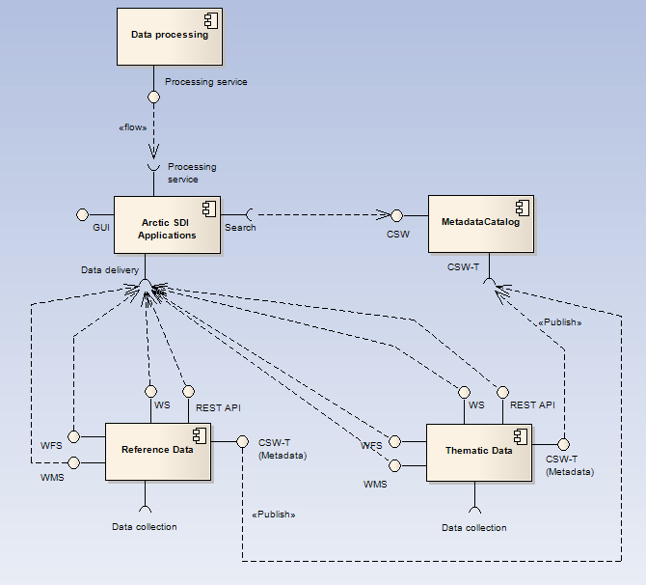

Figure 5 - **Data processing** and overlay analysis could also be combined with the existing datasets.

## Deployment

The deployment environments described here only cover the work and responsibilities of the 8 participating mapping agencies and no other actors in the infrastructure.

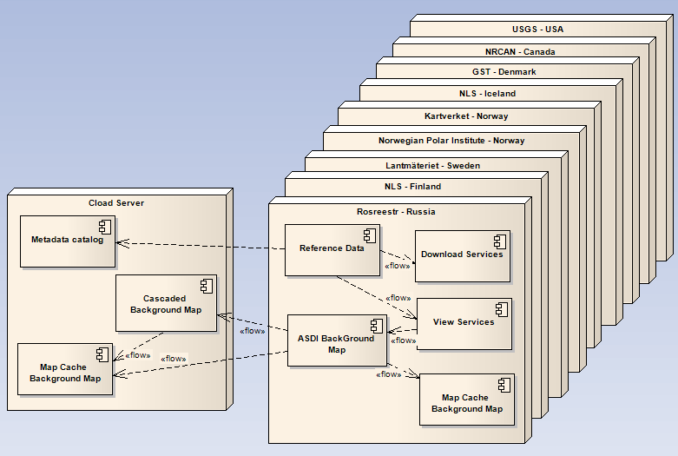 Figure 6 - Physical distribution environments of the Arctic SDI components

On the national level each Mapping Agency is responsible for delivering access to identified data stored by their countries, setting up view and download services for the distribution of identified data covering their own country as images, raster and vector data. This can include a Map Cache to improve performance.

A common background map and a metadata catalogue require a platform to collect the needed information from all Arctic countries to one single environment. The recommended solution is to use Infrastructure as a Service in the cloud, which means a server provided by a commercial supplier as a service on Internet. This server will run the metadata catalogue, the cascading web map service, which is the service that builds together the reference data from all countries to a common map of the Arctic region. For the users to get better performance there will also be a predefined cache of map-tiles on the cloud server; a web map tile service (WMTS). It will be the responsibility of the Arctic SDI to run the cloud services.

Because the arctic region covers all the time zones it is important that the services are up and running 24 hours a day, 7 days a week. This is a challenge and especially for the common central services where there currently are no designated operating personnel with round the clock preparedness. What is perhaps more realistic to deliver is services that are running 24 - 7, but if something happens there is no assurance of action until the staff is available during regular office hours.

# Arctic SDI Strategic context and Reference model

The following sections of this Framework document provide the strategic context, reference model, reference model categories and glossary which provide context for the 2008 – 2014 and beyond vision and activities upon which the Arctic SDI have been based.

In 2014, Arctic SDI Board actions and decisions were made which resulted in the development of an updated suite of documents. This suite includes the Arctic SDI Governance, Arctic SDI Strategic Plan 2015-2020, Strategic Plan 2015-2020 Implementation Plan, Strategic Plan 2015-2020 Roadmap and a Glossary of Terms. These up-to-date documents are available through the [Arctic SDI Portal Website](http://arctic-sdi.org).

## Arctic SDI strategic context

The Arctic SDI partnership between the participating national mapping agencies aims to build on the existing and future geospatial infrastructure and services in each of the 8 participating mapping agencies. By leveraging previous and ongoing investments in their respective spatial data infrastructure initiatives, the incremental level of effort to build the Arctic SDI is anticipated to be marginal.

When working together in the Arctic SDI context it will be necessary for the eight participating mapping agencies to coordinate the effort to harmonize and standardize through common data services and/or models to ensure efficiency and avoid duplication. Doing so each of the participating national mapping agencies also depends on the cooperation of neighboring countries and regional level governments.

At the European level cooperation is a prerequisite within the *Infrastructure for Spatial Information in the European Community* (INSPIRE-directive). The ongoing EU-funded project European Location Framework (ELF) will deliver a pan-European cloud platform and Web services to build on existing work done in INSPIRE. ELF will enable access to harmonized data in cross border applications.

The United States’ National Spatial Data Infrastructure (NSDI) and the Canadian Geospatial Data Infrastructure (CGDI), which also cross boundaries within their states and provinces, contribute data, standards, web services, operational policies and governance models to Arctic SDI.

At the global level the United Nations Economic and Social Council in July 2011 established the *United Nations Committee of Experts on Global Geospatial Information Management* (UN-GGIM) as an official UN consultative mechanism. A key component of UN-GGIM is to regionalize the initiative through regional Committees, which is now in place for the Americas, Africa and Asia/Pacific and in progress for Europe.

The main purpose of the UN-GGIM is to provide a forum for coordination and dialogue among Member States as well as with relevant international organizations and to promote common principles, policies, methods, mechanisms and standards for the interoperability and inter-changeability of geospatial data and services.

The UN-GGIM has agreed to create a global map for sustainable development so that the agenda, strategy and monitoring might be based on a body of trusted, reliable and reference geospatial data.

Other objectives of the UN-GGIM are to develop a global geodetic reference system, discuss future trends for geospatial information and develop a global geodata knowledge base.



*Figure 7.* The Arctic SDI must be seen in the context of each participating country’s domestic realities and complement the UN-GGIM, INSPIRE, ELF, NSDI and CGDI activities.

## Arctic SDI Reference Model

### Reference Model

The purpose of the Reference Model is to aid strategic Arctic SDI discussions by grouping existing and potential SDI components. The Reference Model is the basis to implement the Vision through a consistent understanding of what needs to be done. All Arctic SDI projects link to the Reference Model. This reference model is also incorporated into the 2015-2020 Arctic SDI Strategic Plan.[5]

A reference model in enterprise engineering parlance is an abstract framework consisting of an interlinked set of clearly defined concepts produced by an expert or body of experts in order to encourage clear communication.

The Organization for the Advancement of Structured Information Standards states that a reference model is "*an abstract framework for understanding significant relationships among the entities of some environment, and for the development of consistent standards or specifications supporting that environment.*

*A reference model is based on a small number of unifying concepts and may be used as a basis for education and explaining standards to a non-specialist. A reference model is not directly tied to any standards, technologies or other concrete implementation details, but it does seek to provide a common semantics that can be used unambiguously across and between different implementations*."

<http://en.wikipedia.org/wiki/Reference_model>

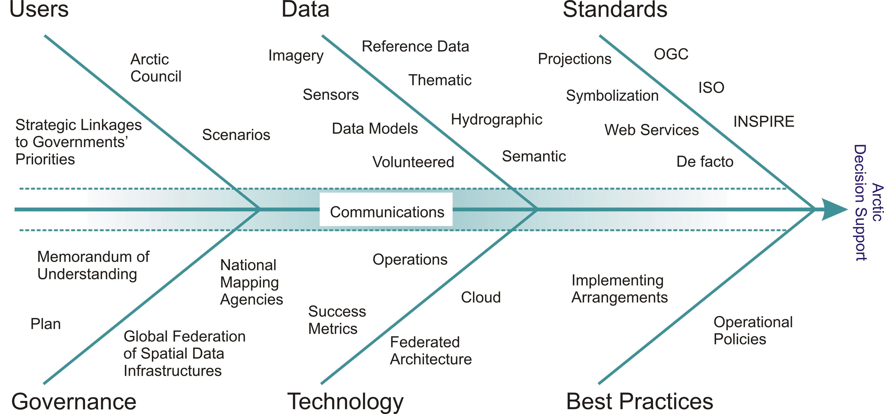

*Figure 8.* The Arctic SDI Reference Model with the purpose to aid strategic Arctic SDI discussions by grouping existing and potential SDI components which combine to support data-driven decision making for the Arctic. All Arctic SDI projects link to the Reference Model.

### Arctic SDI Reference Model Categories and Glossary

#### 3.2.2.1. Users

a. Arctic Council – Respond to Arctic Council needs through the use and promotion of location based data, visualization and analysis through commonly accepted spatial data infrastructure constructs.

b. Strategic Linkages to Governments’ Priorities – Investments in Arctic SDI are linked to each country’s respective domestic priorities

c. Scenarios – Use case scenarios are built to guide development. These use case scenarios may originate from any source.

#### 3.2.2.1 Governance

a. Memorandum of Understanding – instrument of co-operation between member countries

b. Arctic Plan – A plan that outlines at both strategic and operational levels the scope, governance, and outputs. Details from a variety of working groups are found in Annexes.

c. Global Federation of Spatial Data Infrastructures – Where practical, linkages made between the collective vision of Arctic SDI and those related SDI efforts that we participate in as respective nations, for example global, regional, domestic and thematic geospatial forums, standards bodies and communications.

## Data

a. Imagery – raster data from sensors on satellite, plane or ship platforms; e.g. multispectral, passive or active.

b. Sensors – data from in-situ sensors, for example water buoys, weather stations, etc.

c. Volunteered – data collected and offered by the public typically via mobile applications.

d. Data Model – over time striving towards common data models and data integration

e. Reference Data – vector data used in creation of reference or base map of the Arctic. The base will form the backdrop for thematic data. Includes place names, projections, and symbology.

f. Thematic – data related to a theme of physical or human geographies, e.g. statistical, transportation, ice extent normals, etc.

g. Hydrographic: data that records “the measurement and description of the physical features of oceans, seas, coastal areas, lakes and rivers” (http://en.wikipedia.org/wiki/Hydrography)

h. Semantic – common ontologies in support of semantic web

### Technology

a. Operations – day-to-day operations of web services and portal

b. Cloud - Private or Public providers that exhibit the 5 characteristics of Cloud computing as published by the National Institute of Standards and Technology: on-demand self-service, broad network access, resource pooling, rapid elasticity and measured service. Details and complimentary criteria are published at [http://en.wikipedia.org/wiki/Cloud_computing#Characteristics](http://en.wikipedia.org/wiki/Cloud_computing" \l "Characteristics)

c. Success Metrics – reports on content and traffic

d. Federated Architecture – technical linkages to global, regional and domestic SDI initiatives

### Standards

a. Projections – polar projections supporting multiple views of arctic data

b. Symbolization- common map symbolization, colors, etc.

c. De facto – selected standards that are in common use but not ISO or OGC. For example geographic information system and remote sensing analysis vendor formats

d. Web Services – input to OGC and other web service specifications

e. OGC – Open Geospatial Consortium

f. ISO – International Organization for Standardization

g. INSPIRE – European SDI and European Location Framework (ELF)

### Best Practices

a. Operational Policies that publish spatial data infrastructure guidelines on protected information, access methods, data management and dissemination. Best practices and SDI Cookbooks drawn from similar initiatives.

b. Implementing Arrangements are specific agreements that have legal, financial or extensive in-kind commitments executed under the umbrella of the Memorandum of Understanding.

### Communications

a. Runs across all categories of Arctic SDI. Strategic and multi-perspective key messages that can be re-used. To ensure consistent strategic communications across a wide variety of situations, for example at standards bodies, with other SDI initiatives, with Arctic Council and with one’s own government

b. Outreach communications via Arctic SDI website to engage users and practitioner

# Arctic SDI - Operational Policies

## What are geospatial operational policies?

Geospatial operational policies are a broad range of practical instruments such as guidelines, best practices, directives, procedures and manuals that address topics related to the lifecycle of geospatial information (i.e., collection, management, dissemination, and use) and help facilitate access to and use of location-based information. These policies apply to the day-to-day business of organizations and address legal and administrative requirements, and make issues such as data access, quality, ownership and integrity easier to manage.

## Importance of geospatial operational policies

Geospatial operational policies are essential to eliminating barriers and enabling users to exchange location-based information effectively and efficiently. Technology and standards have removed many of the technical barriers to sharing geospatial data. However, some operational policies have not kept pace with the demands of a changing environment. New practical instruments on key topics that impact geospatial information are needed to promote data exchange and integration and to ensure that decisions are taken with the benefit of the best available information.

The following key policy topics and trends impact spatial data infrastructures:

|  |  |
| --- | --- |
| **Legal/Administrative** | **Technological/Trends** |
| * Ethical Legal Practices * Confidential, Secure, and Sensitive Information * Privacy * Intellectual Property * Licensing * Data Sharing * Liability * Archiving and Preservation * Data Quality | * Open Data * Volunteered Geographic Information (VGI) * Open Source Software * Web 2.0 and the GeoWeb * Cloud Computing * Mobile and Location-based Services * High Resolution Imagery * Mass Market Geomatics * Data Integration |

## Operational Policy Documents:

Protected Information

* Confidential information
* Sensitive Information
* Private information
* Intellectual Property

Access, Management and Dissemination

* Archiving and Preservation
* Data Integration
* Data Sharing
* Licensing
* Volunteered Geographic Information (VGI)
* Cloud Computing
* Free and Open Source Software (FOSS)

Source: <http://www.nrcan.gc.ca/earth-sciences/geomatics/canadas-spatial-data-infrastructure/8902>

# Arctic SDI - Governance, Organization, Activities and Operations

For current detailed information on the Arctic SDI governance and organization including its Board, National Contact Points and Working Groups please see the *Arctic SDI Governance Document found on [the Arctic SDI Web site](http://arctic-sdi.org).*

**Memorandum of Understanding and Implementing Arrangements**

The foundation for the Arctic SDI is the legally non-binding “Memorandum of Understanding” (MOU) that was signed in 2014, which expresses the intention of the signatories to collaborate.[6]

## Arctic Council and the Senior Arctic Officials

To support the communication with the Arctic Council a link to the Senior Arctic Officials has been established through the secretariat of the Arctic Council working group *Conservation of Arctic Flora and Fauna* (CAFF).

## The Arctic SDI Board

The decision-making body of the Arctic SDI cooperation is the **Arctic SDI Board**. The Board consists of one Director General or equivalent Executive from each of the 8 participating mapping agencies.

## National Contact Point

Each Board Member appoints a representative from their institution to serve as the **Arctic SDI National Contact Point**. The national contact points acts as a point of liaison between their Board Member, the Arctic SDI fora and working groups and the National Mapping Institutions involved in the cooperative efforts.

## Arctic SDI Working Groups and Activities through 2014

Following is a representative sampling of the work that has been accomplished by the Arctic SDI to date. The vision, strategy, implementation plan and roadmap for the Arctic SDI 2015-2020 build on the significant foundational work that has been accomplished through 2014.

## Secretariat for the Chair of the Board and Chair of the National Contact Point

## Arctic SDI Geo Portal for WMS Map Service and thematic data

By December 2014:

* Develop, build and operate the Arctic SDI interface to Arctic Web Map Service, thematic data, Metadata Catalogue and future Arctic SDI services.
* Establish and operate Arctic SDI Web Map Service
* Build and operate the Arctic SDI Web Map Service

## Technical Working Group

Responsible for:

* Infrastructure and technology
* Design, architecture and standards
* Data models and metadata
* Technical proposals for establishing Arctic SDI WMS, the Web portal as the primary Arctic SDI interface and for other coming services

## CAFF Thematic Data

By December 2014 the Arctic SDI Working Groups will implement access through the Geo Portal to CAFF thematic remote sensing data on land cover change

## Initial Development of Arctic SDI Strategy 2015 - 2020

A draft strategy 2015 – 2020 was presented to the Board in 2014. The first draft included the following considerations:

* User needs
* Thematic datasets for Arctic SDI and role of other data providers
* Data sharing Principles
* Arctic Council and other stakeholders
* Resources and financing
* Arctic SDI and the role on the international Geodata scene
* Prioritized proposal for activities with reference to the Arctic SDI Reference Model
* Common understanding of Arctic SDI and revision of Arctic SDI Vision

## Development of legal/administrative operational Policies

* Implementing Arrangements and contracts, etc.
* Policies and legal framework

## Significant Communication, Documentation, Development of Arctic SDI Website

# Current updated documents

A new suite of Arctic SDI documents build on this foundational Framework to document the next phase of priorities and activities for the Arctic SDI:

The Arctic SDI Strategic Plan 2015-2020

Objective Implementation Plans

Arctic SDI Roadmap

Governance.

The Arctic SDI Web Portal is the best source for up-to-date documents: <http://arctic-sdi.org/>

1. A nimately there is no guarantee ofthe ldersparticipants. ey follow through.arting points, but ultimately there is no guaranteeA new suite of Arctic SDI documents build on this foundational Framework to document the next phase of priorities and activities for the Arctic SDI: The Arctic SDI Strategic Plan 2015-2020, Objective Implementation Plans, an Arctic SDI Roadmap and a Governance. The Arctic SDI Web Portal is the best source for up-to-date documents: <http://arctic-sdi.org/>
2. See the Arctic SDI Governance Document for a copy of the Memorandum of Understanding (<http://arctic-sdi.org>)
3. See the Arctic SDI Website for access to the 2015-2020 Strategic Plan, Objective Implementation Plan and Roadmap documents (<http://arctic-sdi.org>)
4. http://en.wikipedia.org/wiki/Catalog_Service_for_the_Web
5. See the Arctic SDI Website for access to the 2015-2020 Strategic Plan, Objective Implementation Plan and Roadmap documents (<http://arctic-sdi.org>)
6. Visit the Arctic SDI Web site and the Governance Document to obtain a copy of the Memorandum of Understanding <http://arctic-sdi.org>.