**Appendix 1**

# Arctic SDI – Data, infrastructure and technology

## Introduction

This chapter intends to describe Arctic SDI from a more technical point of view with the focus on the use cases and the system designed to support these.

The system in the Arctic SDI context is a range of components and activities that together constitute the response from the National Mapping Agencies in cooperation with the Arctic Council. The aim is to build an SDI, serving governments, scientists, businesses and citizens in the Arctic with geographically related data, digital maps and tools, for better planning and decision making. The SDI must be interoperable with the National SDIs in the Arctic region which also consequently means it must be interoperable with INSPIRE, CM-GGIM.

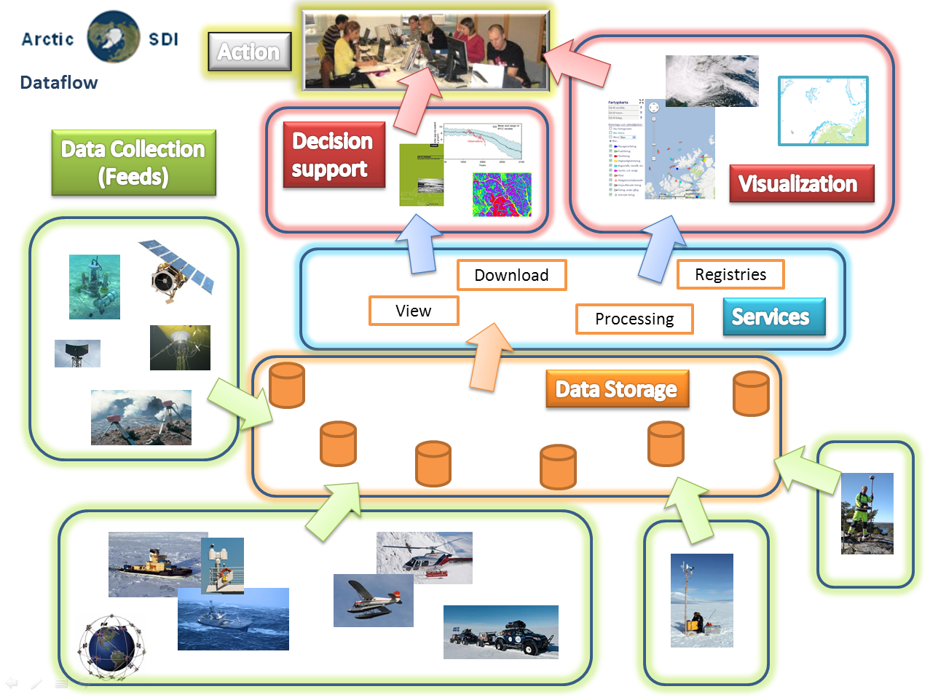

Figure 1 - Data flow in the Arctic SDI from Collection to Action

The vision of the Arctic SDI technical architecture is for the actors to be able to easily access up-to-date spatial data from Arctic Mapping Agencies in the Arctic, from Arctic Council Working Groups and from other thematic data producers and providers in the Arctic. It should be done in such a way that as little overhead as possible is added to data and services. The goal is to make it possible to access reference data through a cartographically homogenous Pan-Arctic background map distributed as a Web Map Service but also to give access to all kind of location based data, raster as well as vector data, from the entire Arctic region.

## Arctic Spatial Data Infrastructure

The Arctic SDI architecture is described in figure #. The reference data from the participating Arctic Mapping Agencies will be made available through a number of services established in each of the Arctic countries' own spatial data infrastructures. Also the thematic information should be made available in the same way. 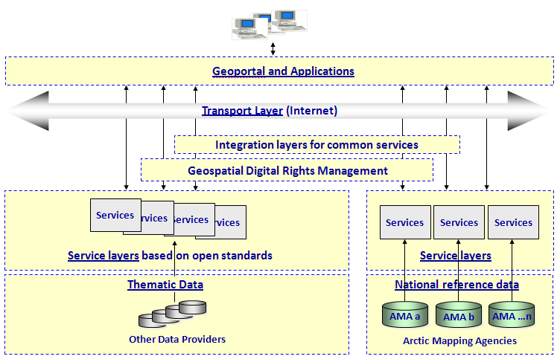 Figure 2 - Arctic SDI Technical Architecture

If there are special needs for users of the Arctic SDI, it may be necessary that common services are being developed to support these requirements. E.g. a common digital background map is a key component in a SDI. Such a product, which supplies reference data updated in close to real time, is impossible for a single country to provide. The main focus in the phase when the Arctic SDI was established was therefore to build this common Web Map Service. Another need that might emerge in the future is services covering the need of common authentication and authorization and also tools for digital licensing (the Geospatial Digital Rights Management layer in the figure).

The services from the National SDIs’ as well as the common Arctic SDI services will serve as a platform or framework to build applications or dynamic webpages for specific identified needs and use cases in the Arctic.

## General, overall Use cases

As we have mentioned previously, the purpose of the infrastructure is to enable the different actors in the Arctic, to consume up-to-date spatial information. Figure 3 shows the actors and the general overall use cases the Arctic SDI must be able to handle in the future. The concept **use case** refers to how a user uses the system to achieve a particular goal.

The National Mapping Agencies have taken a major responsibility in the work to establish Arctic SDI, but for the infrastructure to get its full potential requires engagement from other owners and managers of spatial information, but also from other stakeholders in the Arctic. The dashed boundary in the figure is pointing out the responsibilities of the mapping agencies. The use cases that are partially or completely outside of this boarder identify responsibilities of other actors in the Arctic.

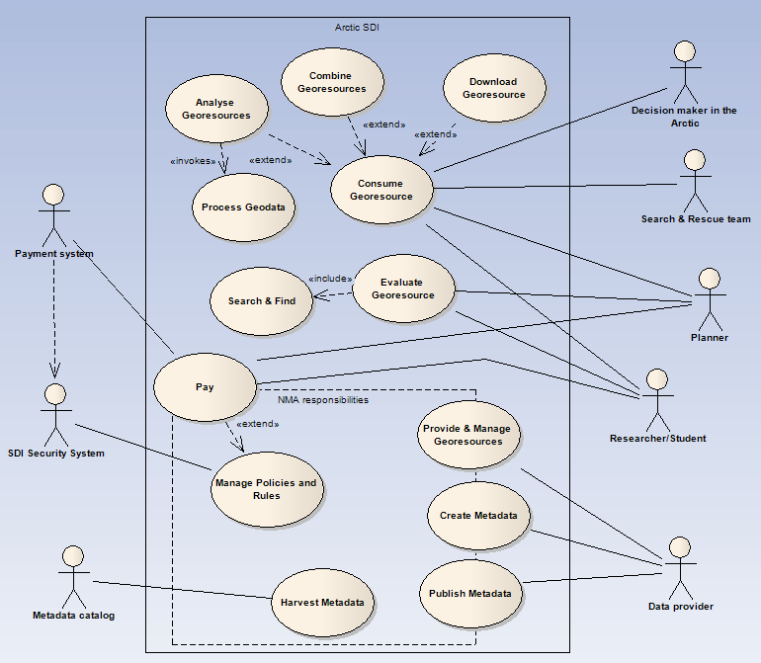

Figure 3 - Actors and use cases in the Arctic SDI

### 2.3.1 Provide & Manage Geo-resources

Providing and managing spatial data in a standardized way is the very foundation for a useful spatial data infrastructure. To cover the need of spatial data in the Arctic, the Arctic Mapping Agencies, but also other data owners need to distribute their data through standardized services. When the Arctic SDI is fully operational many different both governmental and non-governmental bodies will be represented with their data in the SDI.

Providing and managing spatial data in this context is not a simple task. For data to work seamlessly across the Arctic they need to be harmonized or at least formatted in a standardized way so as to ensure that they can be used or consumed in combination by actors within the SDI. For this to fully work the Arctic Mapping Agencies together with the Norwegian Polar Institute need to harmonize their data models. The same applies to other data owners for data to be used and analyzed across borders. This being so large a task it is recommended that it is broken into sub-tasks:

1. Create a common, basic digital background map
2. Create a common data model that each Country can easily translate their output data into

The last step is a future vision where we will have harmonized vector based reference data over the entire Arctic. The possibilities for this does not look so promising today but the pursuit in the Arctic and in other cross boarder context is to standardize the information in the databases so that it can be understood and used in the same way in different tools even though the data come from different countries. If ever happens, this journey will take many years.

### 2.3.2 Create Metadata

As more and more data is added to the SDI, being able to search among all datasets and services becomes more and more important. For this purpose metadata about data and services are created and managed by the data-owners. But for metadata to really work in a search engine they also need to be created in a uniformed way. To achieve this there is an important and non-trivial task of creating a harmonized format of the metadata in the SDI including the use of harmonized keywords so they can work within the same context, spanning the Arctic.

### 2.3.3 Publish Metadata

Once metadata has been created they need to be published to a catalogue so that they can be searched and found in standardized way. The publish use case handles the ability for users to store their metadata documents in the common metadata catalog and by doing so making it searchable in a search engine. The publishing process in this context can be realized in three different ways, either by creating metadata using specific metadata editors and then publish the information directly into the metadata catalog (using the CSW interface), or by uploading the metadata as an XML file. The third possibility is to harvest metadata from other metadata catalogs and publish the metadata to the Arctic SDI metadata catalog.

The last publishing process is very important for Arctic SDI because it is based on the national SDIs’ with their datasets and services. With a specific thesaurus for Arctic SDI, keywords can be added to already existing metadata. The combination of the Arctic SDI thesaurus and the used keywords can then be used when filtering the data in the harvest process from the national SDIs’ to Arctic SDI. All the relevant metadata for the Arctic region will in this way be searchable from one single point.

### 2.3.4 Harvest Metadata

The Harvest metadata use case opens the possibility for other metadata catalogs to harvest the Arctic SDI metadata catalogs in the same way as is described for the third possibility in the publishing process above.

### 2.3.5 Search & Find

This use case makes it possible to search among all metadata in the catalog for relevant geo resources for the users. The Search & Find use case is the first step in an evaluation process. When an interesting resource is found the user can continue to evaluate the resource with the included preview tools.

### 2.3.6 Evaluate Geo-resources

When an interesting Geo-resource is found in the Geoportal, the user can extract the metadata document, read metadata and with other tools in the portal evaluate the resource to find out if it fits the need.

### 2.3.5 Consume Geo-resources

To consume or use the geo-resources is probably the most basic of the all the general use cases. Here an actor (decision maker, planner, etc.) uses data in applications, webpages or in other forms for their special needs.

### 2.3.6 Download Geo-resource

Every now and then an actor needs to do more with data than just use it as a backdrop for their on-line activities. In this case it is necessary for the user to retrieve even the vector data either for usage offline or for doing analysis in his or her environment. In this case the actor needs the possibility to download data. This can be done by downloading predefined datasets or via download services for direct access to data.

### 2.3.7 Combine Geo-resource

Sometimes the user needs to combine spatial data from more than one provider. E.g. this could be combining a background map with an overlay of winds together with migratory birds. This could be done by downloading data and doing the overlay on a local pc, but in this context “Combining Geo-resource” is describing the case of combining data “on the fly” using web services. The user simply defines what data to combine and the service then provide the result directly.

### 2.3.8 Analyze Geo-resource

Just like combining geo-resources, the user sometimes needs to do analysis on the provided spatial data. As for combining geo-resources analyzing the geo-resources is also done server side by accessing a service which provides the result directly.

### 2.3.9 Process Geodata

Lastly a user might need to process data. This could e.g. be the necessity to transform data from one projection to another. In this case the user would send a request to a web processing service, the backend server will transform the dataset and return the result directly.

### 2.3.10 Manage Policies and Rules

In many cases the data being shared is governed by rules and policies as to who can use them, under which restrictions and possible pricing. To ensure that all data is handled correctly there is a need of managing these policies and rules also in the system. This task is an integral part of any data infrastructure and is important if the infrastructure is to encompass even data with certain restrictions. To reach full potential of Arctic SDI, attention shall be paid to data sharing principles and best practices of thematic data among stakeholders and their different types of data, e.g. operational data and re-search data. Only if the data owners are confident that their data is being used in a safe way will make them share their data. One of the most important aspects of policy management is to ensuring the users credentials and then linking this to his or her privileges. In most cases this is handled by the data owners themselves but there might be a need for a central technical solution at least to handle authentication federation and Single-Sign-On in the system.

### 2.3.11 Pay

Payment is a special part of the policies and rules. The special thing about payment is that it needs to connect to an external payment authority that can handle payment transactions. So although this use case is placed on the edge of the tasks managed by the Arctic Mapping Agencies it is in fact something that is run by a third party financial service provider E.g. a bank or so. The Pay use case has been included to clarify the need for a payment system that allows users to order and pay for datasets that are available only on payment.

## Data, technology and standards

**Reference Data** are provided by the involved mapping organizations, covering the arctic region as defined by each organization. In this context, reference data means a least common multiple of map layers, serving as a background map for the entire Arctic region.

Each mapping organization is responsible for providing data through a **Web Map Service (WMS)** that meets the requirements of a common cartographic specification. A WMS is an **Open Geospatial Consortium (OGC)** standard and delivers geo-referenced map *images* from its source. No actual data are transferred, only a cartographic snapshot of the national database it references.

Reference data may be delivered to consuming applications in a number of ways by different types of web services. To provide a seamless background map of the entire Arctic cross borders, the project uses a **Cascading Web Map Service**. This service collects input from the national web map services, and provides applications with a geo-referenced map image of the requested area. To ensure that map images are delivered a fast as possible, pre-caching of map tiles is required.

The OGC interface standard **Web Feature Services (WFS)** could be used in the future to deliver geographical features (actual data). The **Representational State Transfer API** **(REST API)** gives a standardized way for applications to communicate with the reference data services. Metadata for the reference data are published through a standard called **Transactional Catalog Service for the Web (CSW-T)**, which is compliant with the OGC specifications. Metadata for the reference data are published in a common **Metadata Catalog**, providing searchable data set information for application users.

**Thematic Data** are spatial datasets of interest in the Arctic region, organized as thematic layers. Dataset providers could be governmental or interest organizations, companies etc. These datasets and metadata could be delivered and harvested using the same service alternatives as described for the reference data.

For end users, **Arctic SDI Applications** provides access to discover and view the underlying datasets. Different applications with different **Graphical User Interfaces (GUI)** could present the datasets in numerous ways, according to independent needs and hardware/software platform. The searchable metadata catalog will be a central part of the applications, and thematic data from external partners will be combined with the seamless background map from the mapping organizations. **Data processing** and overlay analysis could also be combined with the existing datasets.

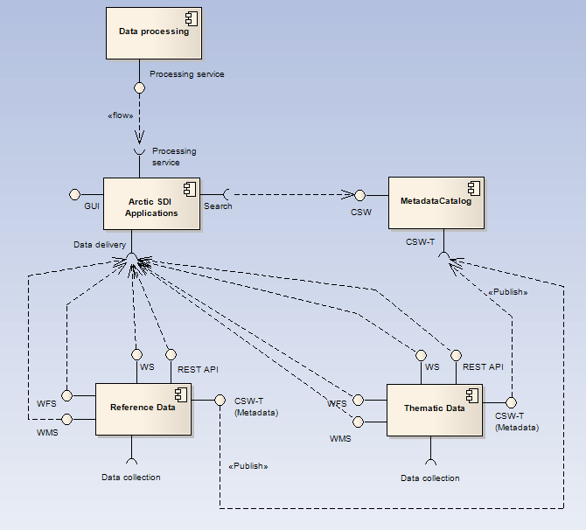

Figure 4 - Overall components and their interfaces

## Deployment

The deployment environments described here is only covering the work of responsibility of the Arctic Mapping Agencies and no other actors in the infrastructure.

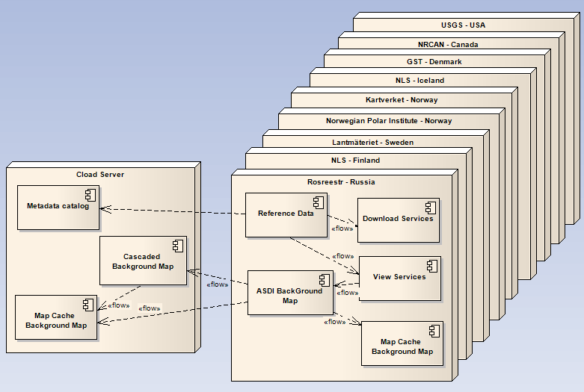 Figure 5 - Physical distribution environments of the Arctic SDI components

On the national level each Mapping Agency is responsible for storing their reference data and to set up view and download services for the distribution of reference data covering the own country as images, raster and vector data. This can include a Map Cache on to improve performance.

A common background map and a metadata catalogue requires a platform to collect the needed information from all Arctic countries to one single point of contact. The recommended solution is to use a server in the cloud, which means a server provided by a commercial supplier as a service on internet. This server will run the Metadata catalogue and the Cascading service, which is the service that builds together the reference data from all countries to a common map of the Arctic region. For the users to get better performance there will also be a predefined cache of maps-tiles on the cloud server. It will be the responsibility of the Arctic SDI to run the cloud services.

Because of the fact that the region covers all the time zones it is important that the services are up and running 24 hours a day, 7 days a week. This is a challenge and especially for the common central services where there currently are no designated operating personnel with round the clock preparedness. What is perhaps more realistic to deliver is services that are running 24 - 7, but if something happens there is no assurance of action until the staff is available during regular office hours.