**Appendix 4**

# Arctic SDI - Governance, Organization and rules of procedure

## Memorandum of Understanding

The foundation for the Arctic SDI is the “Memorandum of Understanding” (MOU) in which the spirit of the cooperation is detailed. The MOU expresses the intention of the signatories to collaborate and describes the objectives, the areas of interest and the forms under which the cooperation will be performed. Through the MOU, the signing participants will designate appropriate representatives to identify cooperative activities and details of implementations. The MOU is a **legally non-binding** instrument covering a period of five years from the date of signature. It may be amended or extended by written agreement. The MOU is attached in Appendix 3.

## Implementing Arrangements

Not all activities of the Arctic SDI cooperation necessarily need legally binding agreements to provide resources and funding. To implement collaborative activities though, which require specific commitment between signatories or signatories and third parties, signatories of the MOU may enter into an Implementing Arrangement (IA) that can serve as a **legally binding** instrument. An IA provides the necessary framework for legally binding issues such as intellectual property, liability and copyright as well as long term commitment of resources and funding. Depending on the issues not necessarily all of the signatories needs to participate in an IA, however all signatories should provide “tacit approval” (e.g. via email) for the IAs. All IAs are agreements between signatories or signatories and legal third parties and will be added to the Appendix in chronological order.

## Arctic Council and the Senior Arctic Officials

To support the communication and to clarify the future affiliation with the Arctic Council it has been agreed to establish the link to the Senior Arctic Officials through the secretariat of the Arctic Council working group Conservation of Arctic Flora and Fauna (CAFF). Within the Arctic Council Greenland/Denmark has taken the lead to facilitate the Arctic SDI.

## Arctic SDI governance and organization

The governance and organisation of the Arctic SDI consist of the Board, the National Contact Points, Lead Countries, Supporting Countries and the Operational Task Force.

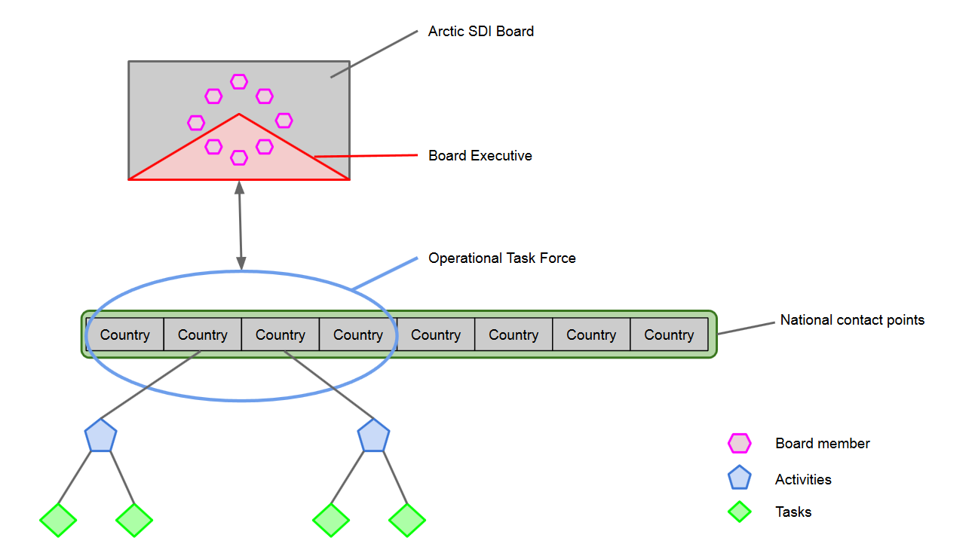

*Figure: Governance and organisation.*

**4.1 The Arctic SDI Board**

The decision-making body of the Arctic SDI cooperation is the **Arctic SDI Board**.

The Board formulates the vision, goals and strategy for the development of the Arctic SDI, organizes the affiliation with the Arctic Council and prepares the necessary Implementing Arrangements. The Board also identifies the tasks of the cooperation, organizes the work and provides the necessary resources, governance and competences to support the implementation of decisions.

The Board consist of one Director General / deputy Director General from each of the MOU signatories which countries are members of the Arctic Council.

The **Chair of the Arctic SDI Board** rotates every second year following the cycle of the Arctic Council chairmanship. The Chair is the board-member representing the National Mapping Agency from the same country that holds the Chair of the Arctic Council. The cycle of the Arctic SDI Board chairmanship begins 1 February of the year where the chair of the Arctic Council changes in May.

|  |  |  |  |
| --- | --- | --- | --- |
| 1 Feb – 31 Jan | **Chair** | Previous Chair | Incoming Chair |
| 2014 2015 | **Canada** | Iceland | USA |
| 2015 2017 | **USA** | Canada | Finland |
| 2017 2019 | **Finland** | USA | Iceland |
| 2019 2021 | **Iceland** | Finland | Russia |
| 2021 2023 | **Russia** | Iceland | Norway |
| 2023 2025 | **Norway** | Russia | Denmark |
| 2025 2027 | **Denmark** | Norway | Sweden |
| 2027 2029 | **Sweden** | Denmark | Canada |

The Board shall meet no less than once a year. The board otherwise decides the frequency of meetings as appropriate.

The chair shall notify the board members of the date, venue and provisional agenda at least 4 month before the meeting is due to commence and at the same time set the deadline for submission of proposals or documents for discussion from the Board Members. The Board can decide on general procedures for the preparations and the conduct of board meetings as well as specific procedures for one specific board meeting. Being an equal cooperation between national agencies all decisions are made in consensus.

An Implementing Arrangement can mandate the Board to make decisions following special rules of procedures.

The board can invite observers to attend the board meetings and to make presentations as well as participate in the discussions under specific agenda items.

**4.2 The Board Executives**

The Board Executives consist of the present Chair, the former Chair and the coming Chair of the Board.

The purpose of the Board Executives is to have a forum for exchange and transfer of experiences and for decision taking in between Board Meetings. The Board Executives can

* be mandated by the Board to make decisions and launch actions concerning specific items in between the board meetings,
* implement a written decision procedure or to convene an extraordinary Board Meeting including the necessary preparatory meetings.

**4.3 National Contact Points**

To prepare board-meetings and promote efficient decision making each Board Member appoints a representative from their institution to serve as the **Arctic SDI National Contact Point**.

The National Contact Points prepares the board meetings by proposing items to the agenda and by clarifying issues and differences in opinions in relation to meeting documents and draft decisions.

The National Contact Points meet prior to the board meetings no later than 2 weeks before the deadline for submitting documents and proposals to the Board. These meetings are chaired by the National Contact Point representing the institution holding the chair of the board.

**4.4 Lead Countries, Supporting Countries and the Operational Task Force**

The present status of the Arctic SDI cooperation is a voluntary cooperation between national mapping agencies. As such the resources necessary are composed by voluntary contributions from the participating institutions with the recognition of different level of engagement.

Unless other commitments are agreed upon in Implementing Arrangements the activities will be performed by **Lead Countries** joined by **Supporting Countries**. This includes both administrative and technical activities and operations as well as development and strategic activities. The activities can be organized in programs, projects or otherwise.

**A Lead Country** has the responsibility for the operation and progress of the activity. The tasks within the activities are divided between the Lead Country and the Supporting Countries and managed through meetings, video meetings and mail.

The Lead Countries refers to the Board. This includes the responsibility to report and submit documents and draft decisions to the Board, including compliance with deadlines and reflecting on the opinions expressed by the National Contact Points in the process of preparing the Board Meeting.

The group of lead countries forms the **Operational Task Force** to ensure the necessary coordination of activities and to facilitate and support the daily operations, secure progress and handle acute challenges through mail, video meetings and ordinary meetings. The Operational Task Force contributes to the preparation of board meetings by coordinating the preparation of documents and proposals prior to board meetings.

It is anticipated that the Lead Country representative predominantly is also serving as the National Contact Point. Thus the majority of the lead country representative normally will be present at the National Contact Points Meetings prior to the Board Meetings. If it this is not the case the Chair of the Contact Points can invite a Lead Country representative to attend when it is deemed necessary to facilitate the preparation of a Board Meeting.