Arctic SDI Plan
Arctic Spatial Data Infrastructure
Draft / Version 1.0 / 31 January 2014

December 2013

www. arctic-sdi.org

Introduction

The Arctic Spatial Data Infrastructure – Arctic SDI - is a pan-arctic geodata cooperation between the 8 National Mapping Agencies of Canada, Finland, Iceland, Norway, Russia, Sweden, USA and Denmark. Denmark also represents the Faroe Islands Home Rule and the Greenland Self-Government.
The Arctic SDI shall to provide politicians, governments, scientists, private enterprises and citizens in the Arctic with access to geographically related arctic data, digital maps and tools.
The main purpose of this document – the Arctic SDI Plan - is to describe the vision, reasons and the history and introduce the concept of the Arctic SDI and the status of the cooperation behind it.

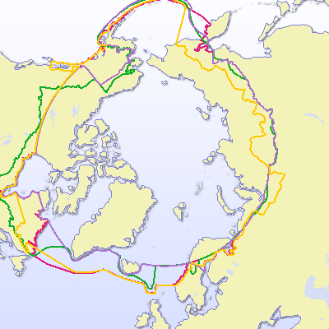
Figure 1. The Arctic SDI is to cover the Arctic regions of the involved participating countries, as defined by the countries themselves. It can be identified and defined in many different ways depending on the parameters used (tree line, climate, Arctic Circle, temperature, flora, fauna, jurisdiction). The examples above are used by some of the Working Groups of the Arctic Council. (© University of the Arctic International Secretariat 2009 in the UArctic Atlas (www.uarctic.org ).

Artic SDI vision and project aim

The Arctic SDI vision was formulated in 2011:
“An Arctic SDI – based on sustainable co-operation between mandated national mapping organisations – will provide for access to spatially related reliable information over the Arctic to facilitate monitoring and decision making”.
The aim of the Arctic SDI is to jointly develop and administrate an Arctic SDI to include:
- Reference data as Web Map Services to establish a common image and vector base for the Arctic context at nominally 1:250,000-scale
- A searchable metadata-catalogue of map-able data resources (base maps and other geo-referenced thematic data and services)
- A Web portal as primary user interface to search the catalogue and enable visual analysis of multiple base maps, thematic maps, and geographic data
- Supporting tools for Data sharing such as Single Sign-On, Licensing tools and support application development
.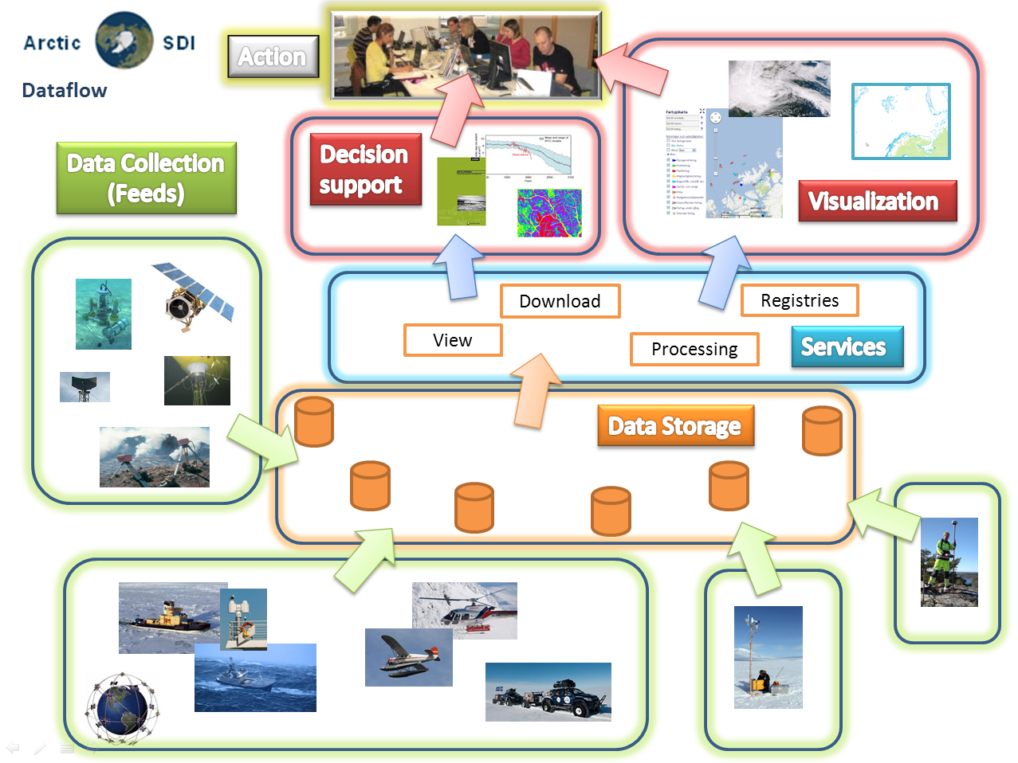

The reasons behind the Arctic SDI

There is an obvious need for a dedicated Arctic SDI, which provides for the development of the necessary standards and framework to promote and encourage more efficient integration of and access to arctic related datasets. It would allow for a more robust management and manipulation of data for research, planning, policy-making and operational purposes and contribute to more informed policy and adaptation strategies in the region.
A well-functioning exchange of spatial referenced data is essential for successfully conservation of the natural environment while allowing for economic development, especially for cross boundary activities such as monitoring climate change, pollution, and changes in Arctic biodiversity, and it is essential for integrated planning when developing the infrastructure and economic activities and not least when planning and performing search and rescue operations.
Improved spatial related data handling has the potential to provide tools that can clarify and explain indigenous peoples land use practices with regards to e.g. hunting, fishing and reindeer herding and thus improve presentation, communication and better understanding of these issues.
The activities of the Arctic Council and its working groups require effective and coordinated data services. Sharing of geographic information between the circumpolar countries and efficient use of that information for presenting thematic data can prevent duplication of work and increase output and efficiency. Thus the first Web Service of The Arctic SDI is the harmonized map covering the entire Arctic Region.
The Arctic SDI is expected to result in the following benefits when operational:
- Users, such as the Arctic Council, the Arctic Council Working Groups, the Arctic research community, government institutions, Indigenous Peoples, NGO’s, private enterprises and individual citizens will have easy access to relevant and updated geographic and thematic information covering the entire circumpolar region – data that can be used for many purposes.
- A distributed regional/arctic infrastructure consisting of interlinked servers with national high quality geographic data will be located in each of the eight arctic countries.
- Possibilities will be created for users to connect to web map services and simultaneously access, view, and explore several types of geographic and thematic information concerning the Arctic Region.
- Daily use of the Arctic SDIs web map and other services by national authorities, schools and universities in the arctic and elsewhere.
- Use of the Arctic SDI services by private enterprises when investigating and planning business opportunities
- Use of the Arctic SDI by both public and private international projects and cross border cooperation.

Short Background history

The first cross bordering geodata cooperation in the arctic was the GIT Barents launched in the 1990’s by the national mapping institutions in Finland, Norway, Russia and Sweden. The purpose was to increase the ability to use spatial information within the Barents Region by producing a common geographic database covering the entire region and to make data available to users by establishing an internet-based infrastructure aligned with the principles of the EU INSPIRE Directive (EU Infrastructure for Spatial Information). The GIT Barents Service (www.gitbarents.com) facilitates cross-border cooperation, primarily in the fields of environmental planning, monitoring and protection, land use, physical planning, transports, natural resource management and development of cross-border tourism.
From 2007 a Spatial Data Infrastructure covering the entire Arctic was frequently discussed at conferences and in Arctic Council Working Groups. At the request from the Nordic Mapping Agencies, the Arctic Council gave its formal support to the Arctic SDI initiative at its Senior Arctic Officials meeting in November 2009.
In October 2011 the Arctic SDI was launched by representatives from all the 8 national mapping agencies of the arctic countries and from the Arctic Council CAFF Working Group. A project management team with resources provided from Norway and Sweden has supported the Board, the Steering Committee and the Technical Working Group. In February 2014 the Arctic SDI Board established the present governance, management and operation of the Arctic SDI.

Arctic SDI – Data, infrastructure and technology

From a technical point of view the vision of the Arctic SDI is for the users to be able to easily access up-to-date spatial data from the National Mapping Agencies and from thematic data producers in the Arctic. The effort is to make this available with as little overhead as possible added to data and services.
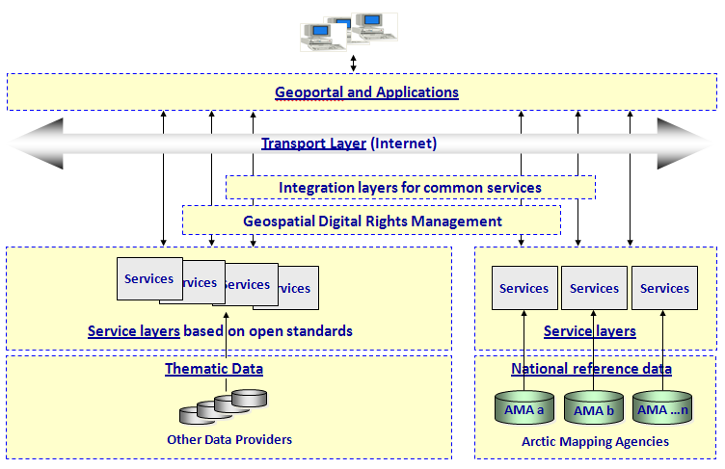
For this purpose it is necessary to establish an enterprise architecture and an infrastructure model and it is necessary to consider questions concerning metadata, data models, use of technology, user requirements for download, data combining, data analyzing and processing, operational policies etc.
The figure illustrates the Arctic SDI Technical Architecture and the detailed considerations can be found in Appendix 1: Data, Infrastructure and Technology.

Arctic SDI Strategy

Arctic SDI strategic framework

The Arctic SDI partnership between the national mapping agencies aims at building the services on the existing and future geospatial infrastructure in each of the 8 institutions, so it - within limited resources – will be possible to create new user demanded cross bordering services that otherwise would be difficult and expensive to build.
When working together in the Arctic SDI context it will be necessary for the eight mapping agencies to coordinate the effort to harmonize and standardize through common data models to ensure efficiency and avoid duplication. Doing so each of the national mapping agencies also depends on the cooperation with the neighboring countries and in the regional context.
At the European level cooperation is a prerequisite within the Infrastructure for Spatial Information in the European Community (INSPIRE-directive). The ongoing EU-funded project European Location Framework (ELF) will deliver a pan-European cloud platform and Web services to build on existing work done in INSPIRE. ELF will enable access to harmonized data in cross border applications.
The United States’ National Spatial Data Infrastructure (NSDI) and the Canadian Geospatial Data Infrastructure (CGDI) contribute data, standards, web services, operational policies and governance models to Arctic SDI.
At the global level the United Nations Economic and Social Council in July 2011 established the United Nations Committee of Experts on Global Geospatial Information Management (UN-GGIM) as an official UN consultative mechanism. A key component of UN-GGIM is to regionalize the initiative through regional Committees, which is now in place for the Americas, Africa and Asia/Pacific and in progress for Europe.
The main purpose of UN-GGIM Committee is to provide a forum for coordination and dialogue among Member States as well as with relevant international organizations and to promote common principles, policies, methods, mechanisms and standards for the interoperability and inter-changeability of geospatial data and services.
The UN-GGIM has on request agreed to create a global map for sustainable development to provide the information base to inform sustainable development, so that the agenda, strategy and monitoring might be based on a body of trusted, reliable and authoritative geospatial data.

Other main objectives are to develop a global geodetic reference system, discuss future trends for geospatial information and develop a global geodata knowledge base.
The Arctic SDI must be seen in the context of domestic realities and complement the UN-GGIM, INSPIRE, ELF, NSDI and CGDI activities.

Arctic SDI reference model

Part of the challenge of developing a Spatial Data Infrastructure is clearly communicating what can be seen as an abstract concept. The Arctic SDI Reference Model graphically depicts an abstract framework of an interlinked set of clearly defined concepts in order to encourage clear communication (adapted from http://en.wikipedia.org/wiki/Reference_model). The reference model will also be used as a management tool to facilitate the development of a common understanding of scope. The Model does not imply responsibilities, priority or resource requirements. The Arctic SDI Reference Model defines categories that provide high level scoping for subsequent development of potential Arctic SDI activities. For example a "Data Program" would include a wide variety of Arctic data sources and interoperable projects. Some owned by mapping agencies, some not; however all linked via Arctic SDI standards and operational policies.

An Arctic SDI Reference Model Glossary can be found in Appendix 2.

Strategy for developing Arctic SDI cooperation and services

Since the vision of the Arctic SDI was formulated in 2011 the cooperation between the 8 National Mapping Agencies has developed and resulted in signing of a Memorandum of Understanding. In parallel global and regional cooperation is developing under the umbrella of the United Nations and other forums.
Building an Arctic Spatial Data Infrastructure requires an ongoing development of the common understanding of the concept and a thorough understanding of the users, their needs and their position in the overall picture of stakeholders. Thus it will be possible to set the strategic direction for what dataset to develop and share and how to define the role of the thematic data providers. It also requires an ongoing development of the targeted infrastructure, technical opportunities and data sharing principles. The Arctic SDI cooperation needs to look into its role in the Arctic Council cooperation and other existing pan Arctic cooperation’s as well as develop models for funding future activities.
In 2014/15 a new Arctic SDI strategy for the period 2015 – 2020 will be developed.

Arctic SDI - Governance, Organization and Operations

Memorandum of Understanding and implementing Arrangements
The foundation for the Arctic SDI is the legally non-binding “Memorandum of Understanding” (MOU), which expresses the intention of the signatories to collaborate. The MOU is attached in Appendix 3.
To implement collaborative activities though, which require specific commitment, signatories of the MOU may enter into an Implementing Arrangement (IA) that can serve as a legally binding instrument that provides the legal framework for intellectual property, liability and copyright as well as resources and funding. All IAs will be added to Appendix 6.

4.1 Arctic Council and the Senior Arctic Officials
To support the communication with the Arctic Council a link to the Senior Arctic Officials has been established through the secretariat of the Arctic Council working group Conservation of Arctic Flora and Fauna (CAFF).

4.2. The Arctic SDI Board and the Board Executive
The decision-making body of the Arctic SDI cooperation is the Arctic SDI Board. The Board consist of one Director General / deputy Director General from each of the MOU signatories which countries are members of the Arctic Council. The Board meets at least once a year.
From 2014 the Chair of the Arctic SDI Board will rotate following the cycle of the Arctic Council chairmanship:
1 Feb – 31 Jan | Chair | Previous Chair | Incoming Chair
2014 2015 | Canada | Iceland | USA
2015 2017 | USA | Canada | Finland
2017 2019 | Finland | USA | Iceland
2019 2021 | Iceland | Finland | Russia
2021 2023 | Russia | Iceland | Norway
2023 2025 | Norway | Russia | Denmark
2025 2027 | Denmark | Norway | Sweden
2027 2029 | Sweden | Denmark | Canada

The Board Executives consist of the present Chair, the former Chair and the coming Chair of the Board. The purpose is to have a forum for exchange and transfer of experiences and for decision taking in between the Board Meetings.
The guiding rules of procedure for the Board can be found in Appendix 4.

4.3. National Contact Points
To prepare board-meetings and promote efficient decision making each Board Member appoints a representative from their institution to serve as the Arctic SDI National Contact Point. The National Contact Points meet prior to Board Meetings. The guiding rules of procedures can be found in Appendix 4.

4.4. Lead Countries, Supporting Countries and the Operational Task Force
The present status of the Arctic SDI cooperation is a voluntary cooperation between national mapping agencies. As such the resources necessary are composed by voluntary contributions from the participating institutions with the recognition of different level of engagement.
Unless other commitments are agreed upon in Implementing Arrangements the activities will be performed by Lead Countries joined by Supporting Countries. This includes both administrative and technical activities and operations as well as development and strategic activities. Lead Countries have the responsibility for the operation and progress of the specific activity and refers directly to the Board.
The group of lead countries forms the Operational Task Force to ensure the necessary coordination of activities and to facilitate and support the daily operations, secure progress and handle acute challenges.
The guiding principles for organizing, managing and reporting can be found in Appendix 4.

Figure: Governance and Organization:
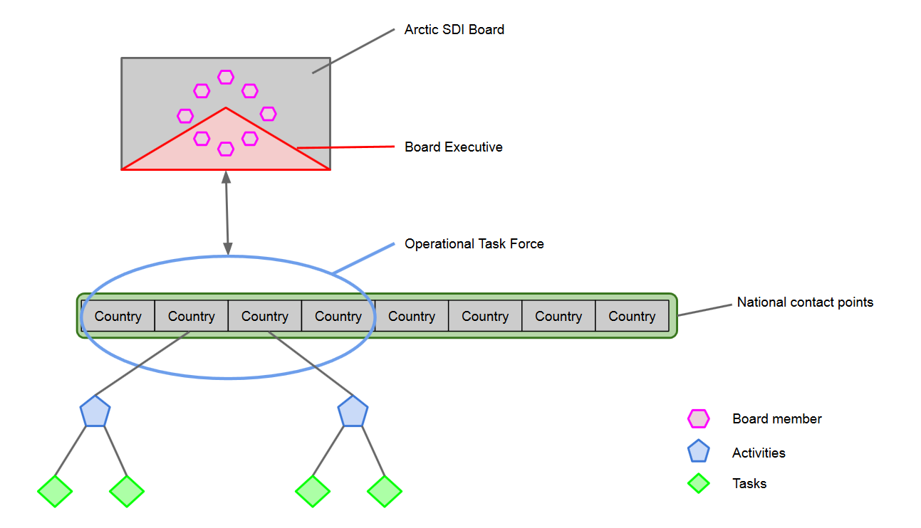

- Activities and division of work
Identified activities:
- Secretariat for the Chair of the Board and Chair of the National Contact Point
- Communication, documentation, Website, Arctic SDI Point of Contact ect.
- Technical Working Group – extracts from agreed Terms of Reference
- Development of legal/administrative operational Policies
- Development of Arctic SDI Strategy 2015 - 2020
- Establish and operate Arctic SDI Web Map Service
- Arctic SDI Web Portal for reference map and thematic data –including a CAFF-proposal to distribute land cover change data.
A more detailed description of the tasks within the activities can be found in Appendix 5.

Identified Lead Countries and Supporting Countries:
Activity | Lead Country | Supporting Countries
Secretariat for the Chair of the Board and Chair of the National Contact Point | Country Chairing the Board | To be decided at Board meeting
Communication, documentation, Website, Arctic SDI Point of Contact ect. | To be decided at Board meeting | To be decided at Board meeting
Technical Working Group | Sweden | All Countries
Development of legal/administrative operational Policies | To be decided at Board meeting | To be decided at Board meeting
Development of Arctic SDI Strategy 2015 – 2020 | To be decided at Board meeting | To be decided at Board meeting
Establish and operate Arctic SDI Web Map Service | To be decided at Board meeting | To be decided at Board meeting
Arctic SDI Web Portal for reference map and thematic data – including the CAFF-proposal | To be decided at Board meeting | To be decided at Board meeting

Appendixes

Arctic SDI – data, infrastructure and technology

Arctic SDI Reference Model Glossary

Memorandum of Understanding (English, French, Russian)

Arctic governance, organization and rules of procedure

Description of activities

Implementing Arrangements

Operational Policies

