**Erratum - Reference Model Figure**

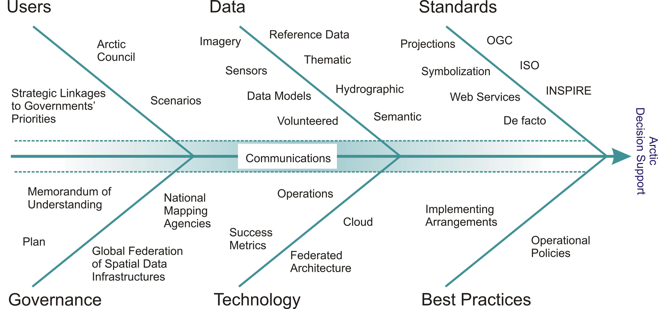

To replace the present figure in the Arctic SDI Plan, section 3.2